Church of the Good Shepherd
Knowing Christ and Making Him Known
Rooted in the Word, Nourished by the Sacraments, Alive in Jesus Christ

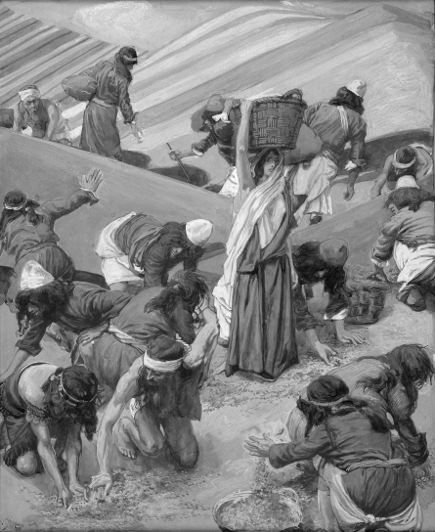

August 15, 2021, A Service of Holy Eucharist
Proper 15, The Twelfth Sunday after Pentecost – 10:30am
http://www.goodshepherdbinghamton.org

Welcome to Church of the Good Shepherd! We are delighted to worship God with you this morning. Everything you need for worship is here in these pages. If you are visiting and would like more information about Good Shepherd, please fill out a guest card at either of the usher tables or call the parish office (723-8032). At Good Shepherd you will find friendly people, engaging sermons, joyful worship, practical teaching, and lots of kids. Welcome!
Weekly Update, August 15, 2021
Ongoing Ministries
Morning Prayer If you're having trouble keeping up with your prayers and bible reading, every weekday morning at 7am, we meet together via Zoom for Morning Prayer.

Join the parish email list then watch your inbox for daily mail with a link to access the meeting.
Daily Prayer is on hiatus until after Labor Day.
Good Shepherd Youth Group meets on Sunday night from 6:00 – 7:30pm at Good Shepherd during the school year. All youth between the ages of 12-18 are welcome to join.

Youth Group is on hiatus for the summer, but will resume in the fall.

Please contact Jonathan Groves if you’d like to be involved in any way. Email: jg.arrowhead@gmail.com.

Tuesday Morning Bible Study meets at 9:05am to walk through different books of the bible, verse by verse. Taught by Matt Kennedy in the main room of the parish hall. This class can be viewed in person or online each week by livestream. For more information, please contact the church office.

Good Shepherd Member Food Pantry has food available. Please contact a member of the staff or the church office if you need access to the pantry.

Friday Morning Men’s Bible Study A group of men gather at 6:30am to share bible study and prayer time together. Men of any age are welcome to attend. This study is currently meeting online and in person. If you are interested in learning more about this study, please email Pastor Matt, Jonathan Groves, or contact the church office.

Thursday Evening Bible Study is currently on hiatus. This is a great place to connect with others and learn more about what God has to say to us through his word.

Shepherd’s Bowl Community Dinner Good Shepherd offers a free nutritious meal to the people of Good Shepherd and the wider community on Thursday evenings from 5-6. If you are able, this is a great time to get to know others while enjoying a free and delicious meal.

Mission Groups aim to glorify God in helping Good Shepherd as a church become more like Christ. If you are looking for a way to get involved, grow in community, and deepen your understanding of God's word, Mission Groups are for you.

All of the groups are on hiatus for the summer but will resume meeting in the fall. If you have any questions or would like to host or lead a group yourself, please talk with Jonathan Groves.

Christian Education for All is normally at 9:15am on Sunday Morning. Adult Education is continuing online and in person at that hour in the parish hall.

The current series is being taught by Matt Kennedy on the Christian Classics. We are studying the 39 Articles of Religion.

Modified Catechesis of the Good Shepherd has resumed meeting during the regular Christian Ed time at 9:15.

Week at a Glance Schedule, August 15, 2021 – August 22, 2021
Sunday
8:00am | Service of Holy Eucharist, no  music
9:15am | Christian Ed for adults and  children (online observance available)
10:30am | Service of Holy Eucharist (online observance available)

Happy Birthday!
August 18 Nicolas Raphael

Happy Anniversary!
August 17 Richard & Stephanie Warner

Tuesday
9:05am |  |  | Tuesday Morning Bible Study

Thursday
5:00pm | Shepherd’s Bowl Community  Dinner
6:00pm | Beginner’s Bible Study

Friday
6:30am | Men’s Breakfast and Bible Study

Sunday
8:00am | Service of Holy Eucharist, no music
9:15am | Christian Ed for adults and children (online observance available)
10:30am | Service of Holy Eucharist (online observance available)

Please Pray For…
Anglican Church of North America In the ACNA Cycle of Prayer, today we pray for the Diocese of the Northeast and MidAtlantic (REC), Bishop R. Charles Gillin, his wife, Jan.
ADOLW Additional Clergy of ADLW; The Ven. Don Helmandollar; The Rev. Godsgift Ighinai; The Rev. Canon John Jorden; The Rev. Joel Lafferty
For the Homebound Betty Cancellieri, Charles Mabula
For the Sick Peyton, Rick, Jason D., Doug & Maureen, Charles, Russ, Bill, Bob, Evelyn Martin, Kathy, Fred, Andrew, Larry Dimmick, Chris, Keith LaGier, Lin and Bruce, Jessica & Taylor John, Sherry and Rob.
Missionaries Pray for Carrie Moorhead-Nelson and her work with InterVarsity Campus Ministries.
Daily Lectionary
Morning | Evening
Monday, August 16
Psalm 111, 112  2 Sam 4  Rom 15 | Psalm 113, 114  Hos 14  John 14:15-end
Tuesday, August 17
Psalm 115  2 Sam 5  Rom 16 | Psalm 116, 117  Joel 1  John 15:1-17
Wednesday, August 18
Psalm 119:1-24  2 Sam 6  Phil 1:1-11 | Psalm 119:25-48  Joel 2 † 1-17,28-32  John 15:18-end
Thursday, August 19
Psalm 119:49-72  2 Sam 7  Phil 1:12-end | Psalm 119:73-88  Joel 3  John 16:1-15
Friday, August 20
Psalm 119:89-104  2 Sam 8  Phil 2:1-11 | Psalm 119:105-128  Amos 1  John 16:16-end
Saturday, August 21
Psalm 119:129-152  2 Sam 9  Phil 2:12-end | Psalm 119:153-176  Amos 2  John 17
Sunday, August 22
Psalm 118  2 Sam 10  Phil 3 | Psalm 120, 121  Amos 3  John 18:1-27

Serving at Good Shepherd August 15, 2021
8am Celebrant: Tony Seel
Reader (8:00): Pastoral Assistant
Usher (8:00): Terry Ray
Usher (10:30): Chris Jones
Reader (10:30): Pastoral Assistant
Altar: Helen Cetton
Shepherd’s Bowl: Martha Rice with Team 3
Tellers: Helen Cetton and Scott Pineau

Serving at Good Shepherd August 22, 2021
8am Celebrant: Tony Seel
Reader (8:00): Terry Ray
Usher (8:00): Terry Ray
Usher (10:30): Scott Pineau
Reader (10:30): Kcaarin Pineau
Altar: Karen Carlton
Shepherd’s Bowl: Jonathan Groves with Team 4
Tellers: Helen Cetton and Chris Jones

Anticipated giving for 2021 $287,681.66
Anticipated YTD Giving $180,487.33
Actual YTD Giving $150,491.62

What’s Going on at Good Shepherd…
Welcome! Chris and Jaime Emmons welcomed their second child, Peter Timothy Emmons on Tuesday, at 9:46pm.
He was 7 lbs, 4 oz and 19.5 inches. Mom, Dad, Ophelia, and baby Pete are all doing well.

As is the custom at Good Shepherd, we would like to bless the family with meals as they adjust to their changing schedules. We’ve set up a Take Them A Meal page, and would ask that you consider providing them with a meal. You can find information on how to do that at this link.

Please keep the Emmons in your prayer as they make the transition to a family of four.
Contacting Jonathan…Jon is from Texas (yes, we now have TWO Texans running the show at Good Shepherd!) Because of this, he has an out-of-town cell phone number. It seems that some people have assumed that his cell number is a spam call and have blocked it. Please be sure to add his cell number to your contact list, and if you might have blocked his number without realizing it, please do unblock it. His phone number is (214) 298-7514.

Coffee Hour As you may have heard, coffee hour has resumed! While we are not serving lunch, there will be coffee and tea available after the 10:30 service in the parish hall each Sunday. If you would like to help with this ministry by making a couple of posts of coffee one Sunday a month, please contact Steph or Carrie Nelson.
Holy Eucharist
Kennedy Family Vacation The Kennedy family has started their annual vacation. They’ll be enjoying some much-needed rest and will return to Good Shepherd after August 22.
Please refrain from contacting them unless there is a medical/physical emergency. Our pastoral assistant, Jonathan Groves will be available for meetings during this time, and the church office will remain open, and can be reached in all the usual ways.
Good Shepherd is excited to welcome The Rev. Tony Seel, Archdeacon Joel Grigg, and Mr. Scott Pineau as interim preachers and officiants while the Kennedys are away.

Shepherd’s Bowl Announcement As of September 2, we will be back to serving dinner indoors at 5:30pm. The doors to the building will be opened at 5pm and will close at 6:30.
Large Print Bulletins are available upon request for both services. If you need a large print bulletin, please contact the office before next Sunday’s services.
Morning Prayer Each weekday, a group gathers via Zoom for a morning prayer service. You do not have to be a member of Good Shepherd to join, but will need to join the parish mailing list by contacting the office.
Morning prayer is on hiatus until after Labor Day.
August 15, 2021 – The Twelfth Sunday after Pentecost

Prelude Little Prelude in F Major attr. J. S. Bach

The Hymn in Procession Praise to the Lord, the Almighty
The people stand and sing, facing the procession
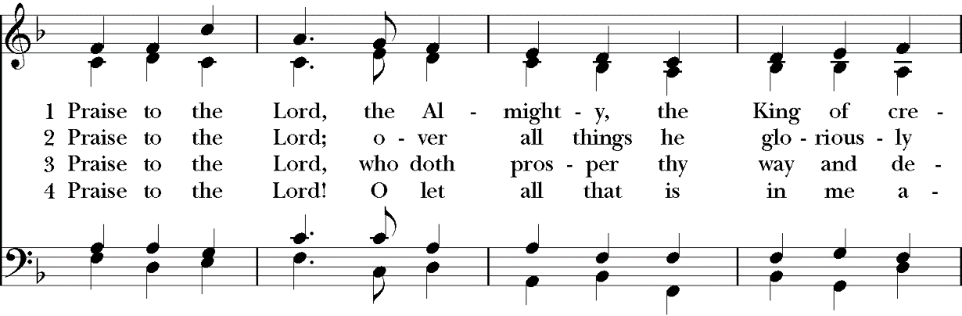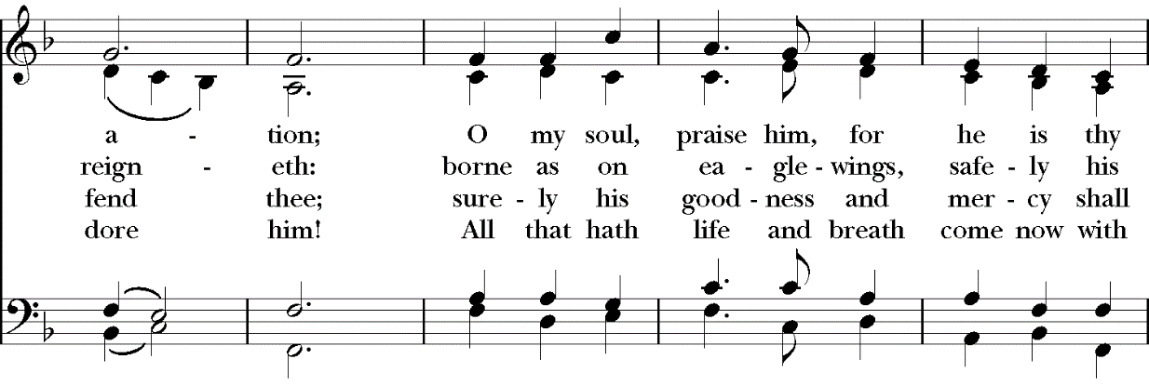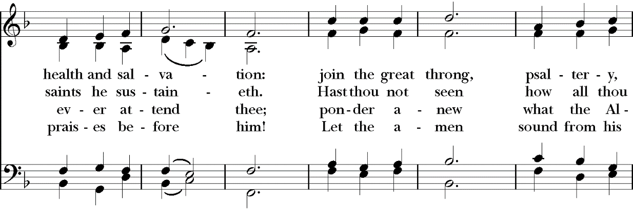
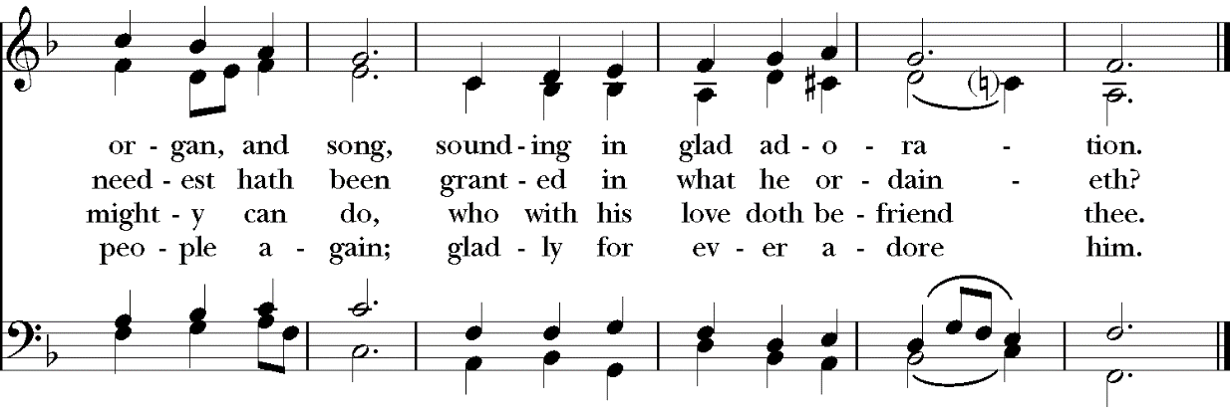

The Acclamation and Collect for Purity
The people remain standing
Celebrant Blessed be God, the Father, the Son and the Holy Spirit.
People And blessed be his kingdom, now and forever. Amen.
Almighty God, to you all hearts are open, all desires known, and from you no secrets are hid: Cleanse the thoughts of our hearts by the inspiration of your Holy Spirit, that we may perfectly love you, and worthily magnify your holy Name; through Christ our Lord. Amen.

The Summary of the Law
Jesus said: You shall love the Lord your God with all your heart and with all your soul and with all your mind. This is the great and first commandment. And a second is like it: You shall love your neighbor as yourself. On these two commandments depend all the Law and the Prophets.

The Gloria Glory Be to God Maher|Minter|Townend
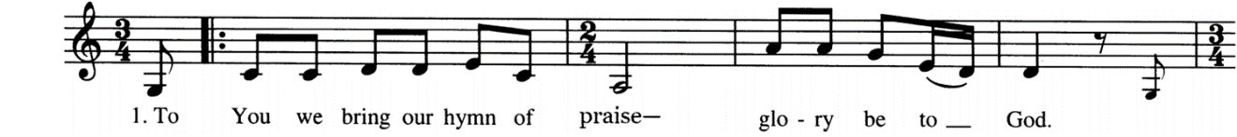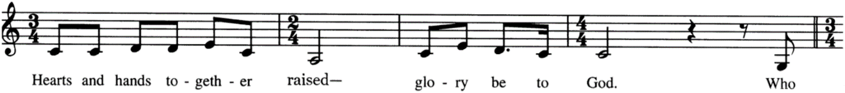
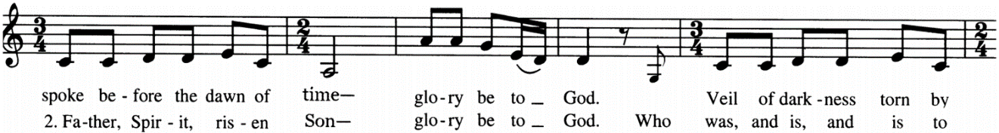
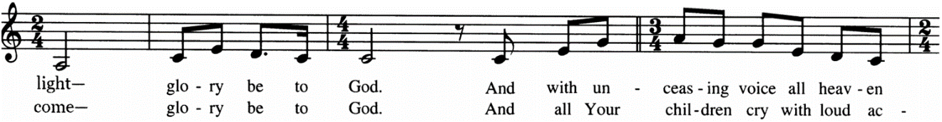
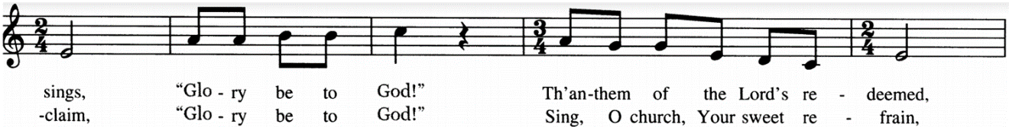
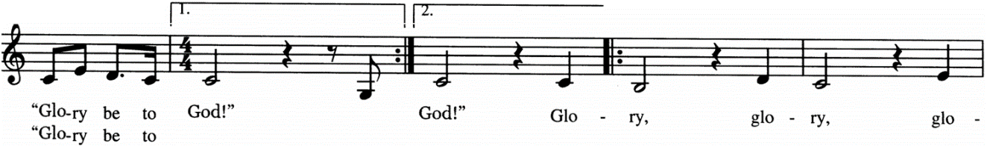
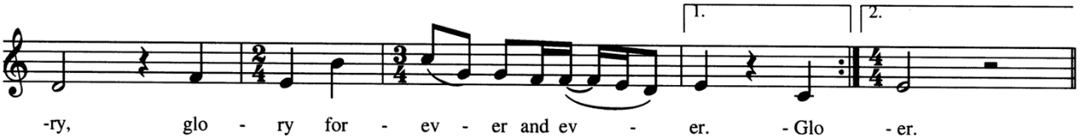

The Collect of the Day
Celebrant The Lord be with you.
People And with your spirit.
Celebrant Let us pray.

Keep your Church, O Lord, by your perpetual mercy; and because without you the frailty of our nature causes us to fall, keep us from all things hurtful, and lead us to all things profitable for our salvation; through Jesus Christ our Lord, who lives and reigns with you and the Holy Spirit, one God, for ever and ever. Amen.

The Ministry of the Word

The people may be seated for the readings

The First Lesson

Proverbs 9:1-6 Pew Bible pg. 533, LP pg. 632

Reader The Word of the Lord.
People Thanks be to God.

Psalm 147
₁ Praise the LORD, for it is a good thing to sing praises unto our God; *
indeed, a joyful and pleasant thing it is to be thankful.
₂ The LORD builds up Jerusalem, *
and gathers together the outcasts of Israel.
₃ He heals those who are broken in heart, *
and binds up their wounds.
₄ He counts the number of the stars, *
and calls them all by their names.
₅ Great is our Lord, and great is his power; *
indeed, his wisdom is infinite.
₆ The LORD lifts up the meek, *
and brings the ungodly down to the ground.
₇ O sing unto the LORD with thanksgiving; *
sing praises with the harp unto our God,
₈ Who covers the heavens with clouds, and prepares rain for the earth, *
and makes the grass to grow upon the mountains, and plants for the use of men,
₉ Who gives food to the cattle *
and feeds the young ravens that call upon him.
₁₀ He has no pleasure in the strength of a horse; *
neither does he delight in any man’s strength.
₁₁ But the LORD'S delight is in those who fear him *
and put their trust in his mercy.
₁₂ Praise the LORD, O Jerusalem; *
praise your God, O Zion.
₁₃ For he has made strong the bars of your gates *
and has blessed your children within you.
₁₄ He makes peace in your borders *
and fills you with the finest of wheat.
₁₅ He sends forth his commandment upon the earth, *
and his word runs very swiftly.
₁₆ He gives snow like wool *
and scatters the white frost like ashes.

₁₇ He casts forth his ice like crumbs; *
who is able to abide his frost?
₁₈ He sends out his word and melts them; *
he blows with his wind, and the waters flow.
₁₉ He declares his word unto Jacob, *
his statutes and ordinances unto Israel.
₂₀ He has not dealt so with other nations; *
neither have they knowledge of his laws. Praise the LORD.

The Second Lesson
Ephesians 5:3-14 Pew Bible pg. 978, LP pg. 1162
Reader The Word of the Lord.
People Thanks be to God.

The Gradual In the Lord, I’ll Be Ever Thankful (El Senyor) Taize
The people stand and sing, facing the procession
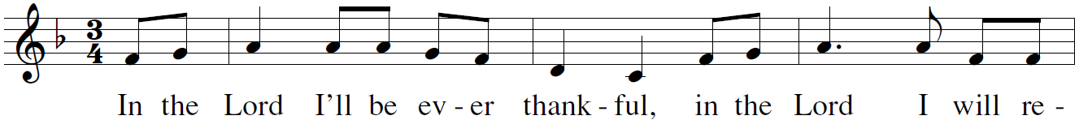
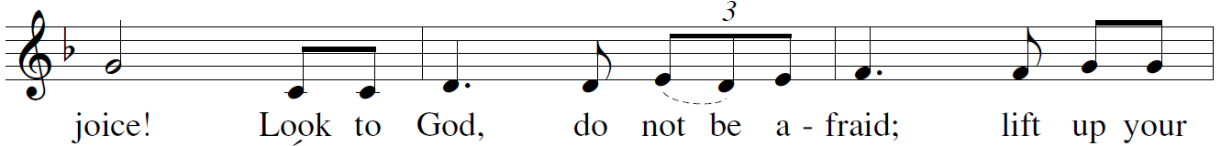
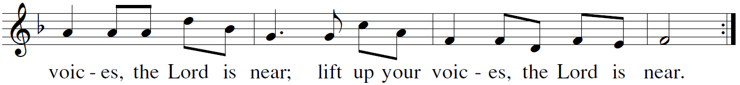

The Gospel
The people stand facing the procession

Celebrant The Holy Gospel of our Lord Jesus Christ according to St. John.
People Glory to You, Lord Christ.
John 6:53-59
Celebrant The Gospel of the Lord.
People Praise to you, Lord Christ.

The Sermon Mr. Scott Pineau
The Nicene Creed
The people stand, if able
Celebrant Let us confess our faith in the words of the Nicene Creed:
We believe in one God, the Father, the Almighty, maker of heaven and earth, of all that is, visible and invisible.

We believe in one Lord, Jesus Christ, the only-begotten Son of God, eternally begotten of the Father, God from God, Light from Light, true God from true God, begotten, not made, of one Being with the Father. Through him all things were made. For us and for our salvation he came down from heaven: was incarnate from the Holy Spirit and the Virgin Mary, and was made man.

For our sake he was crucified under Pontius Pilate; he suffered death and was buried. On the third day he rose again in accordance with the Scriptures; he ascended into heaven and is seated at the right hand of the Father. He will come again in glory to judge the living and the dead, and his kingdom will have no end.

We believe in the Holy Spirit, the Lord, the giver of life, who proceeds from the Father and the Son. Who, with the Father and the Son, is worshiped and glorified, who has spoken through the Prophets.

We believe in one holy catholic and apostolic Church. We acknowledge one baptism for the forgiveness of sins. We look for the resurrection of the dead, and the life of the world to come. Amen.

The Prayers of the People
Let us pray for the Church and for the world, saying,
“hear our prayer.”

For the peace of the whole world, and for the well-being and unity of the people of God.

Reader Lord, in your mercy:
People Hear our prayer.

For Foley Beach, our Archbishop, Julian Dobbs and William Love, our Bishops, David Bena and Daniel Herzog, our retired bishops, for Jerry and Ife at St. Andrews Endicott and Holy Trinity Syracuse, for Tyler at New Covenant School in South Carolina, and for all the clergy and people of our Diocese and Congregation.

Reader Lord, in your mercy:
People Hear our prayer.

For all those who proclaim the Gospel at home and abroad; and for all who teach and disciple
others.

Reader Lord, in your mercy:
People Hear our prayer.

For our brothers and sisters in Christ who are persecuted for their faith.

Reader Lord, in your mercy:
People Hear our prayer.

For our nation, for those in authority, and for all in public service especially President Biden, Governor Cuomo, Senator Akshar, and Mayor David.
Reader Lord, in your mercy:
People Hear our prayer.

For all those who are in trouble, sorrow, need, sickness, or any other adversity.

Reader Lord, in your mercy:
People Hear our prayer.

We bless your holy Name for all your servants who departed this life in your faith and fear, praying you would grant us grace to follow their good examples, that with them we might partake in your heavenly kingdom.

I invite you to add your own additional prayers and thanksgivings at this time.

Heavenly Father, grant these our prayers for the sake of Jesus Christ, our only Mediator and Advocate, who lives and reigns with you in the unity of the Holy Spirit, one God, now and for ever. Amen.

The Confession of Sin
Celebrant Let us confess our sins against God and our neighbors.
The people kneel if able and pray together
Almighty God, Father of our Lord Jesus Christ, maker of all things, judge of all people: We acknowledge and bewail our manifold sins and wickedness, which we from time to time most grievously have committed, by thought, word, and deed, against your divine Majesty, provoking
most justly your wrath and indignation against us. We do earnestly repent, and are heartily sorry for these our misdoings; the remembrance of them is grievous unto us, the burden of them is intolerable.
Have mercy upon us, have mercy upon us, most merciful Father; for your Son our Lord Jesus Christ’s sake, forgive us all that is past; and grant that we may ever hereafter serve and please you in newness of life, to the honor and glory of your Name; through Jesus Christ our Lord. Amen.

Celebrant stands and says
Almighty God, our heavenly Father, who in his great mercy has promised forgiveness of sins to all those who sincerely repent and with true faith turn to him, have mercy upon you, pardon and deliver you from all your sins, confirm and strengthen you in all goodness, and bring you to everlasting life; through Jesus Christ our Lord. Amen.

The Comfortable Words
The Celebrant says
Hear the Word of God to all who truly turn to him.

Come to me, all who labor and are heavy laden, and I will give you rest.
~Matthew 11:28
The Peace
Celebrant The peace of the Lord be always with you.
People And with your spirit.
Then the Celebrants and People may greet one another in the name of the Lord.

Announcements

Birthdays and Anniversaries

The Offertory Sentence
Celebrant Ascribe to the Lord the glory due his name; bring an offering, and come into his courts!

Offertory Let All Mortal Flesh Keep Silence
The people remain sitting, and sing
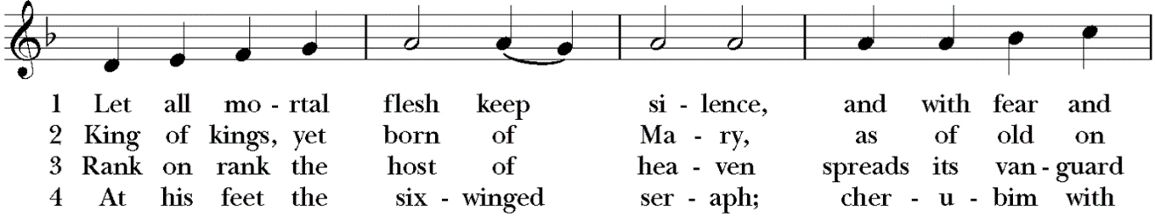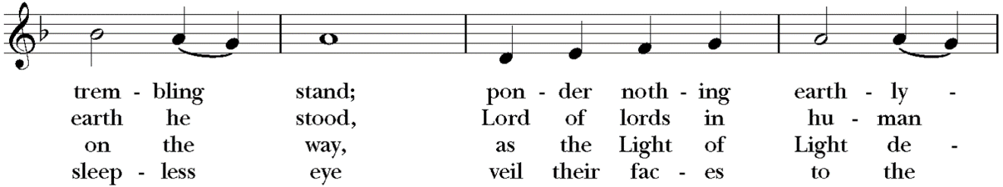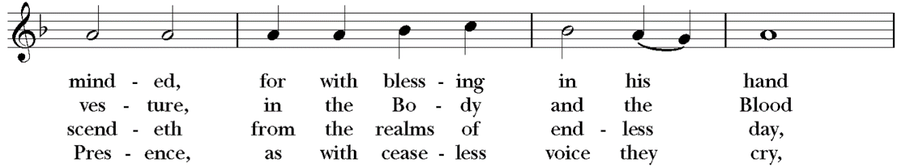
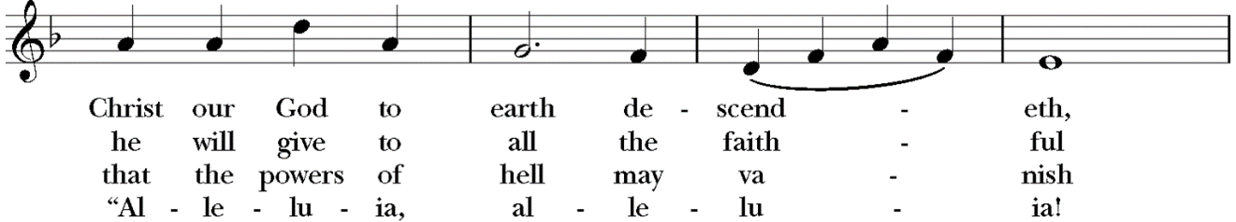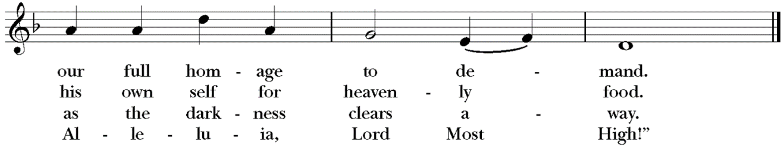

If you are a guest with us today, please do not feel obligated to give an offering. If you are a regular attender at Good Shepherd, you may give your tithe in several ways. An offering plate will be passed and you are welcome to give your offering there. There is also an offering box at the rear of the sanctuary where you may drop your tithe, or you can mail checks to 360 Conklin Avenue, Binghamton, NY, 13903. You can also give online through Breeze or you can text a donation through Breeze at 607-882-6551. Good Shepherd also has a PayPal account. If you choose to give via PayPal you can avoid fees by paying directly from your bank. Be sure to uncheck the box that says, "paying for goods and services" at the bottom or paypal will charge Good Shepherd a fee. As always, thank you for your great generosity and kind support.
The Presentation of the Gifts
The people stand, and sing as able

The Great Thanksgiving
Celebrant The Lord be with you.
People And with your spirit.
Celebrant Lift up your hearts.
People We lift them to the Lord.
Celebrant Let us give thanks to the Lord our God.
People It is just and right so to do.

Then, facing the Holy Table, the Celebrant proceeds
It is right, and a good and joyful thing, always and everywhere to give thanks to you, Father Almighty, Creator of heaven and earth.

Through Jesus Christ our Lord, who on the first day of the week overcame death and the grave, and by his glorious resurrection opened to us the way of everlasting life.

Therefore we praise you, joining our voices with Angels and Archangels and with all the company of heaven, who for ever sing this hymn to proclaim the glory of your Name:

The Sanctus Holy, Holy Maher, Le and Ndolo
The people remain standing and sing
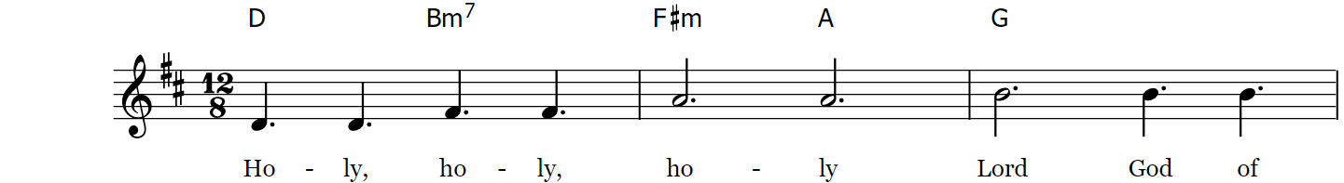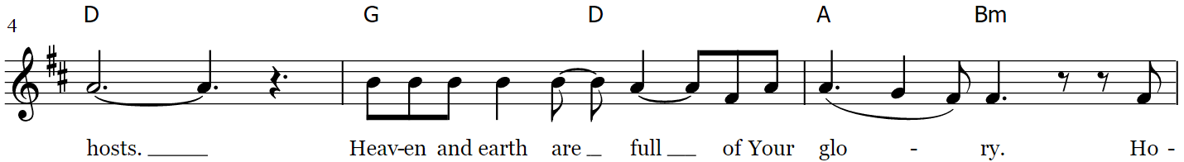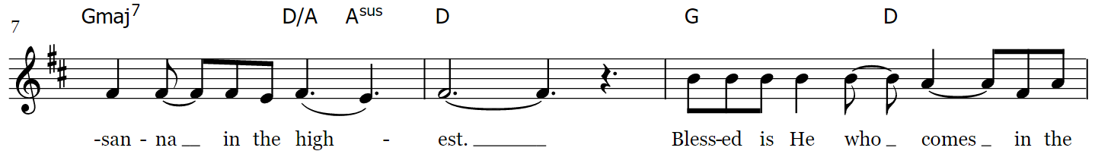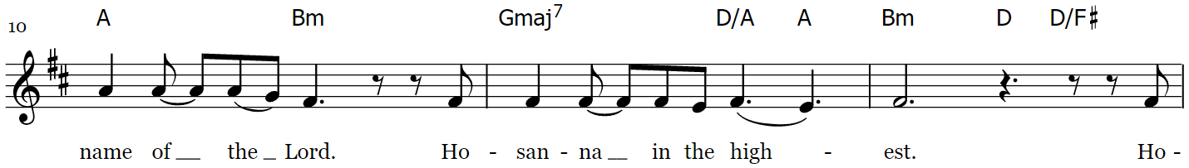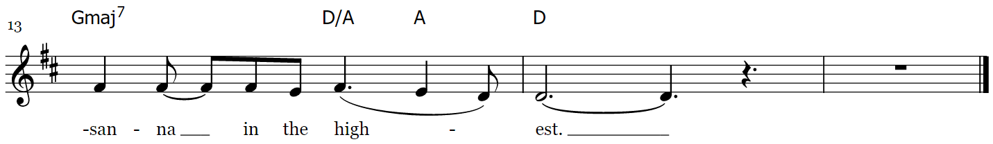

The Prayer of Consecration
The people kneel. The Celebrant continues
All praise and glory is yours, God our heavenly Father, because of your tender mercy, you gave your only Son Jesus Christ to suffer death upon the cross for our redemption; who made there, by his one oblation of himself once offered, a full, perfect, and sufficient sacrifice, oblation, and satisfaction, for the sins of the whole world; and instituted, and in his Holy Gospel commanded us to continue a perpetual memory of his precious death and sacrifice, until his coming again.

And now, O merciful Father; in your great goodness, we ask you to bless and sanctify, with your Word and Holy Spirit, these gifts of bread and wine, that we, receiving them according to your Son our Savior Jesus Christ’s holy institution, in remembrance of his death and passion, may be partakers of his most blessed Body and Blood.

On the night that he was betrayed, our Lord Jesus Christ took bread; and when he had given thanks, he broke it, and gave it to his disciples, saying, “Take, eat; this is my Body which is given for you: Do this in remembrance of me.” Likewise, after supper, Jesus took the cup, and when he had given thanks, he gave it to them, saying, “Drink this, all of you; for this is my Blood of the New Covenant, which is shed for you, and for many, for the forgiveness of sins: Whenever you drink it, do this in remembrance of me.” Therefore we proclaim the mystery of faith

Celebrant and People say together

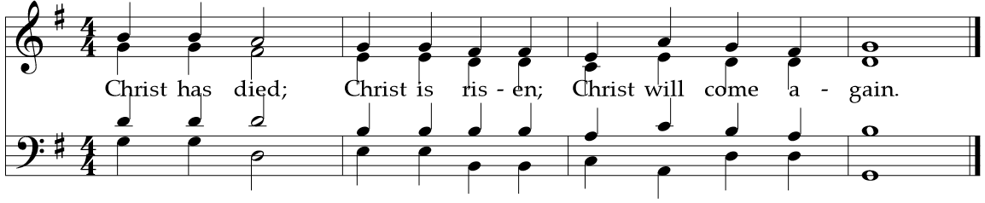
And here we offer and present to you, O Lord, ourselves, our souls and bodies, to be a reasonable, holy, and living sacrifice; humbly pleading that all those who shall partake of this Holy Communion may worthily receive the most precious Body and Blood of your Son Jesus Christ; that, by the Holy Spirit, we may be filled with your grace and heavenly benediction, and made one body with him, so that he may dwell in us, and we in him. By him, and with him, and in him, in the unity of the Holy Spirit, all honor and glory is yours, Almighty Father, now and forever.

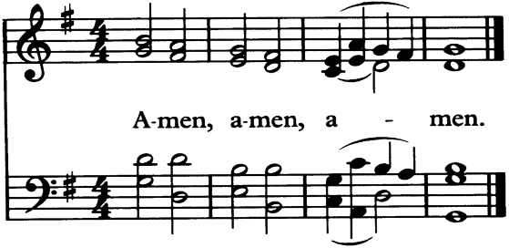
And now, as our Savior Christ has taught us, we are bold to pray:

The Lord’s Prayer
The people remain kneeling, and say
Our Father, who art in heaven, hallowed be thy Name.
Thy kingdom come, thy will be done, on earth as it is in heaven.
Give us this day our daily bread.
And forgive us our trespasses, as we forgive those who trespass against us.
And lead us not into temptation, but deliver us from evil.
For thine is the kingdom, and the power, and the glory,
forever and ever. Amen.

The Fraction

The people remain kneeling and say

Celebrant Alleluia. Christ our Passover Lamb has been sacrificed, once for all upon the Cross.

People Therefore let us keep the feast. Alleluia.

The Prayer of Humble Access
Celebrant and people say together
We do not presume to come to this your Table, O merciful Lord, trusting in our own righteousness, but in your manifold and great mercies. We are not worthy so much as to gather up the crumbs under your Table. But you are the same Lord whose property is always to have mercy. Grant us, therefore, gracious Lord, so to eat the flesh of your dear Son Jesus Christ, and to drink his blood, that we may evermore dwell in him, and he in us. Amen.

The Agnus Dei Lamb of God Mahar, Ndolo, Le
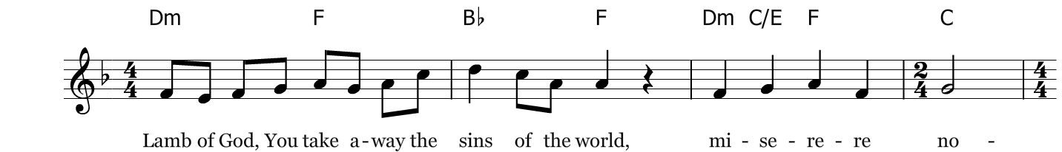
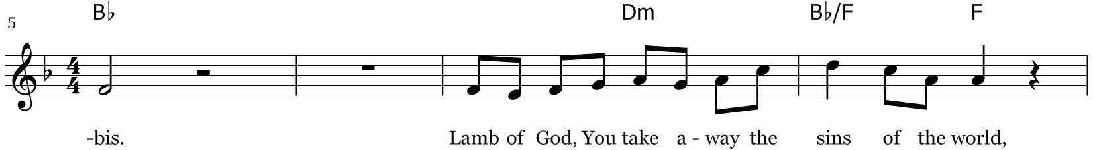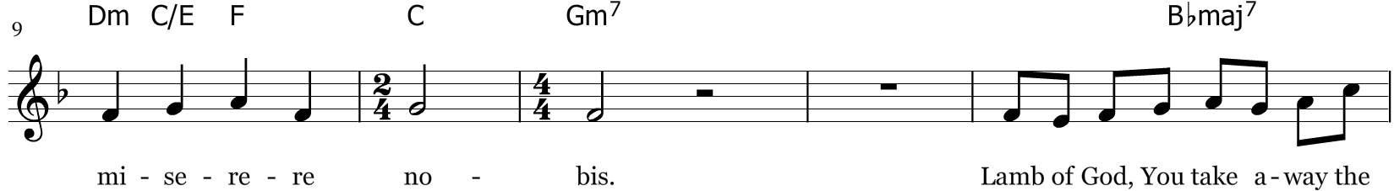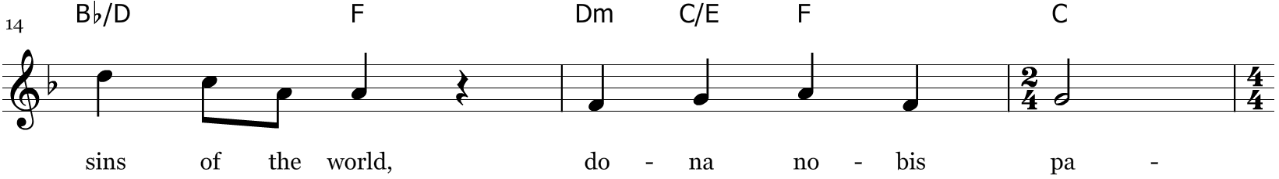
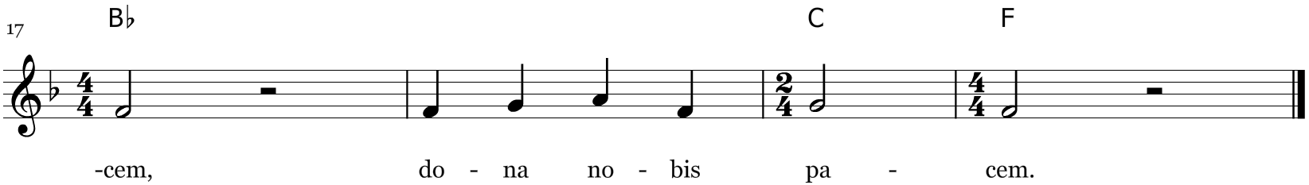
*miserere nobis=have mercy on us *dona nobis pacem = grant us peace

The Communion of the People
All Christians baptized in any denomination and in good standing with their home church are welcome to take Communion. If you are unable to take communion for any reason, you are warmly invited to the rail for a prayer and blessing: just place your hands across your chest and one of the pastors will bless and pray for you. If you are in a wheelchair or are unable to come forward for any reason, please let an usher know and we will bring the Sacrament to you in your pew. Gluten free wafers are available upon request when you come forward.

The Invitation
Celebrant
The Gifts of God for the people of God. Take them in remembrance that Christ died for you, and feed on him in your hearts, by faith, with thanksgiving.

Communion Music Behold the Lamb
The people may sing, seated or kneeling
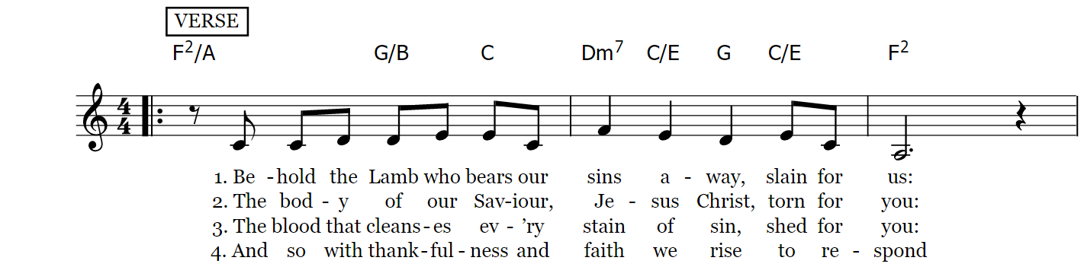
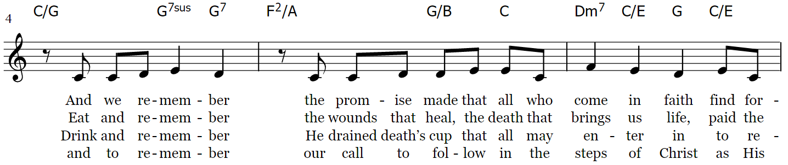
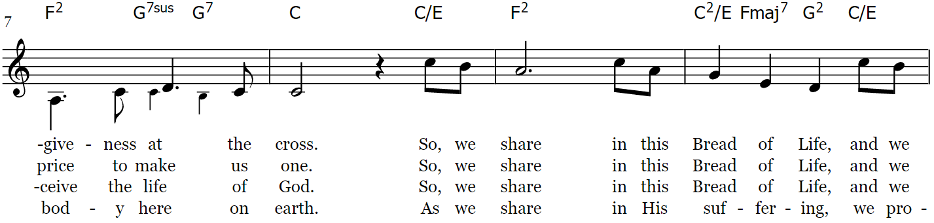
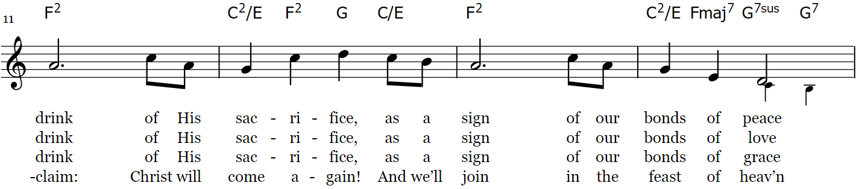
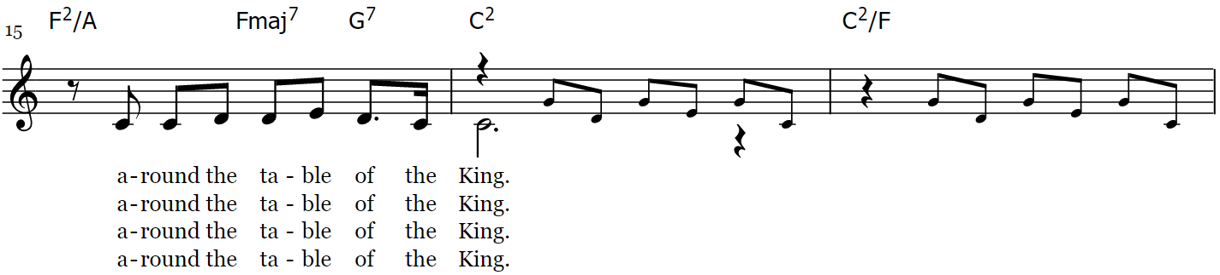

The Post Communion Prayer
Almighty and ever-living God, we thank you for feeding us, in these holy mysteries, with the spiritual food of the most precious Body and Blood of your Son our Savior Jesus Christ; and for assuring us, through this Sacrament, of your favor and goodness towards us; and that we are true members of the mystical body of your Son, the blessed company of all faithful people; and are also heirs, through hope, of your everlasting kingdom. And we humbly ask you, heavenly Father,
to assist us with your grace, that we may continue in that holy fellowship, and do all such good works as you have prepared for us to walk in; through Jesus Christ our Lord, to whom with you and the Holy Spirit, be all honor and glory, now and forever. Amen.

The Blessing
Celebrant
The peace of God, which passes all understanding, keep your hearts and minds in the knowledge and love of God, and of his Son Jesus Christ our Lord; and the blessing of God Almighty, the Father, the Son, and the Holy Spirit, be among you, and remain with you always. Amen.

The Hymn in Recession The Church’s One Foundation
The people stand if able, and sing
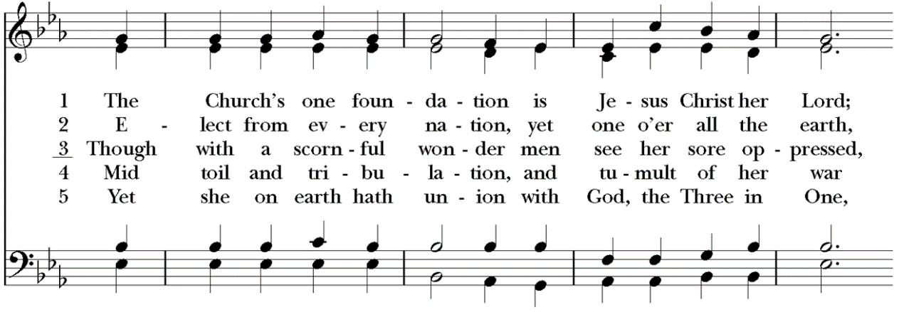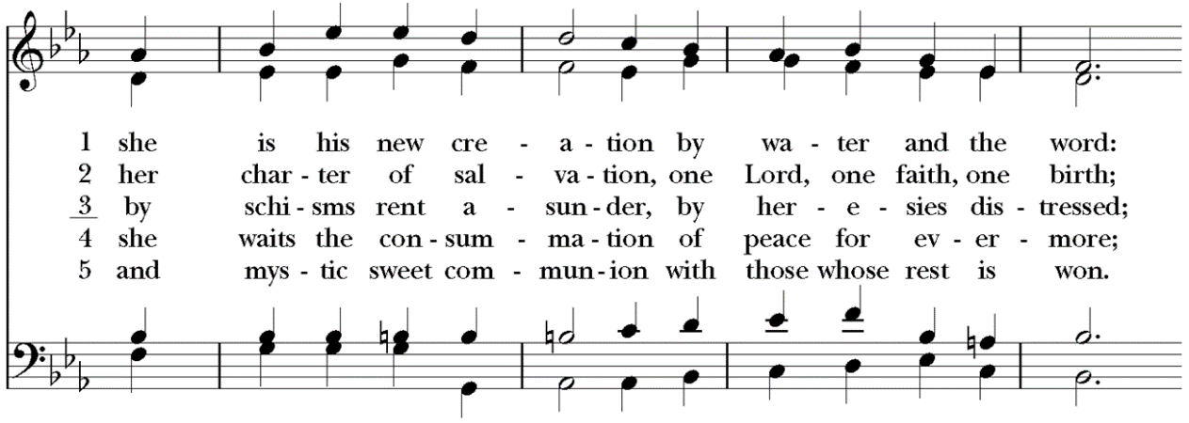
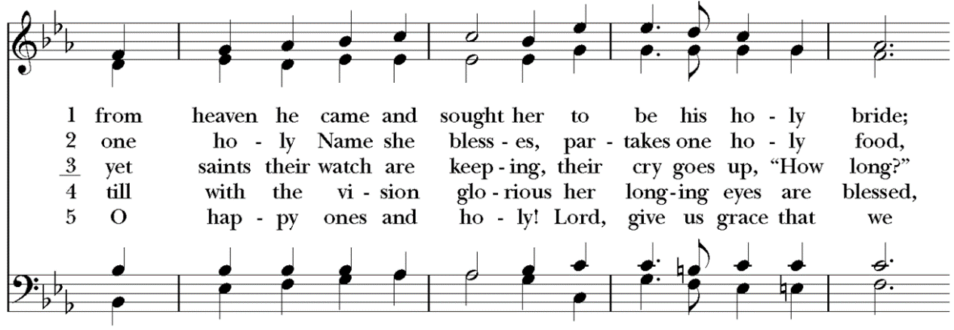
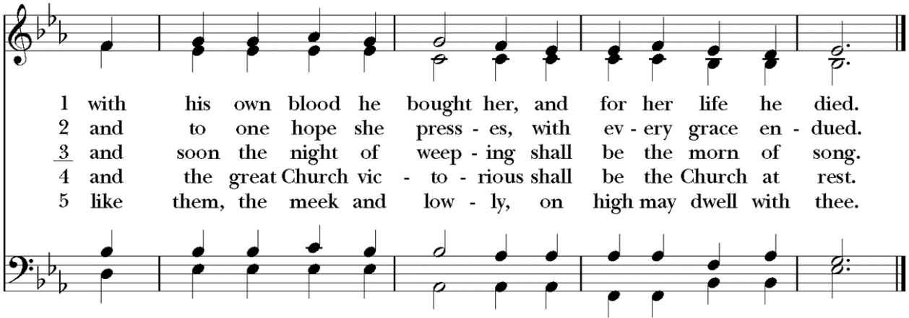

The Dismissal
Celebrant Let us go forth, rejoicing in the power of the Holy Spirit. Alleluia, alleluia.
People Thanks be to God. Alleluia, alleluia.

Postlude Fugue in g minor J. S. Bach

Thank you for worshiping at Anglican Church of The Good Shepherd this morning!

Did you have trouble reading the bulletin this morning? Large Print copies of the bulletin are available upon request. Please contact the office for more information.

We would be so grateful if you would deposit your used bulletins in one of the recycling bins located near the exits of the sanctuary or parish hall as you pass by.

Acknowledgments
Cover Image
“The Gathering of the Manna” by James Tissot
This is a faithful photographic reproduction of a two-dimensional, public domain work of art. Such reproductions are in the public domain in the United States. This work is in the public domain because copyright term of life of the author plus 100 years or less has been exceeded.
US Public Domain Tag: {{PD-US-expired}}
It can be found at this web address:
< https://commons.wikimedia.org/wiki/File:Tissot_The_Gathering_of_the_Manna_(color).jpg>

Scripture and Liturgy
All Liturgy is from The Book of Common Prayer and Administration of the Sacraments with Other Rites and Ceremonies of the Church according to the use of the Anglican Church in North America (2019) together with The New Coverdale Psalter (A.D.2013.). With the exception of the New Coverdale Psalter, the content of the Book of Common Prayer (2019) is not under copyright, and all not-for-profit reproduction of the content by churches and non-profit organizations is permitted. The New Coverdale Psalter is copyright © 2019 by the Anglican Church in North America, but this is not intended to discourage the use and duplication of the text by churches for purposes of worship.
Quotations of Scripture normally follow The Holy Bible, English Standard Version (ESV®) except for the Psalms, Canticles, and citations marked with the symbol ( t ) which indicates traditional prayer book language. The Holy Bible, English Standard Version® is copyright © 2016 by Crossway, a publishing ministry of Good News Publishers, and is used by permission. All rights reserved.
Music
Hymns: All hymns below are reprinted from The Hymnal, 1982 and The Hymnal 1982, Service Music, © 1985 by The Church Pension Fund. Used by permission. All rights reserved.

Prelude: “Little Prelude in F Major” From eight little preludes and fugues attributed to Johann Sebastian Bach - Public Domain

Processional: “Praise To The Lord The Almighty” CCLI Song # 43073. Catherine Winkworth | Joachim Neander. Public Domain. For use solely with the SongSelect Terms of Use. All rights reserved. www.ccli.com. CCLI License # 3237915
Gloria: “Glory be to God” CCLI Song # 5120509 Kelly Minter | Matt Maher | Stuart Townend © 2007
spiritandsong.com (Admin. by Capitol CMG Publishing) Thankyou Music (Admin. by Capitol CMG Publishing) For use solely with the SongSelect Terms of Use. All rights reserved. www.ccli.com CCLI License # 3237915
Gradual: “In the Lord, I'll Be Ever Thankful” Taize Contributors: Jacques Berthier, Taizé Tune: © 1986, 1991, Les Presses de Taizé, GIA Publications, Inc., agent Text: © 1986, 1991, Les Presses de Taizé, GIA Publications, Inc., agent. Permission to reprint, broadcast, and/or stream this music obtained from OneLicense with License # A-724677. All rights reserved.
Offertory: “Let All Mortal Flesh Keep Silence” Words: Liturgy of St. James; para. Gerard Moultrie (1829-1885)
Music: Picardy, French carol, 17th cent.; melody from Chansons populaires des Provinces de France, 1860; harm. after The English Hymnal, 1906 Meter: 87. 87. 87
Doxology: “Praise God from Whom All Blessings Flow” "Praise God from whom all blessings flow" Words: Public Domain, written in 1674 by Thomas Ken, (1637-1711) Music: Old 100th, melody from Pseaumes octante trois de David, 1551, alt.; harm. after Louis Bourgeois (1510?-1561?)
Sanctus: “Holy, Holy” CCLI Song # 6127240 Ike Ndolo | Matt Maher | Tam Le © 2011 Thankyou Music (Admin.
by Capitol CMG Publishing) Valley Of Songs Music (Admin. by Capitol CMG Publishing) Worship Together Music (Admin. by Capitol CMG Publishing) Remaining portion is unaffiliated For use solely with the SongSelect® Terms of Use. All rights reserved. www.ccli.com CCLI License # 3237915
Memorial Acclamation: “Memorial Acclamation” Danish 3 Fold. Public Domain.
The Great Amen: “The Holy Eucharist, Amen” Danish 3 Fold. Public Domain.
Agnus Dei: “Lamb of God” CCLI Song # 6127367 Ike Ndolo | Matt Maher | Tam Le © 2011 Thankyou Music (Admin. by Capitol CMG Publishing) Valley Of Songs Music (Admin. by Capitol CMG Publishing) Worship Together Music (Admin. by Capitol CMG Publishing) Remaining portion is unaffiliated For use solely with the SongSelect® Terms of Use. All rights reserved. www.ccli.com CCLI License # 3237915
Communion: “Behold The Lamb” CCLI Song # 5003372 Keith Getty | Kristyn Getty | Stuart Townend © 2007 Thankyou Music (Admin. by Capitol CMG Publishing) For use solely with the SongSelect Terms of Use. All rights reserved. www.ccli.com CCLI License # 3237915
Recessional: “The Church’s One Foundation” Words: Samuel John Stone (1839-1900) Music: Aurelia, Samuel Sebastian Wesley (1818-1876) Meter: 76. 76. D
Postlude: “Fugue in g minor” J. S. Bach; public domain

