Church of the Good Shepherd
Knowing Christ and Making Him Known
Rooted in the Word, Nourished by the Sacraments, Alive in Jesus Christ

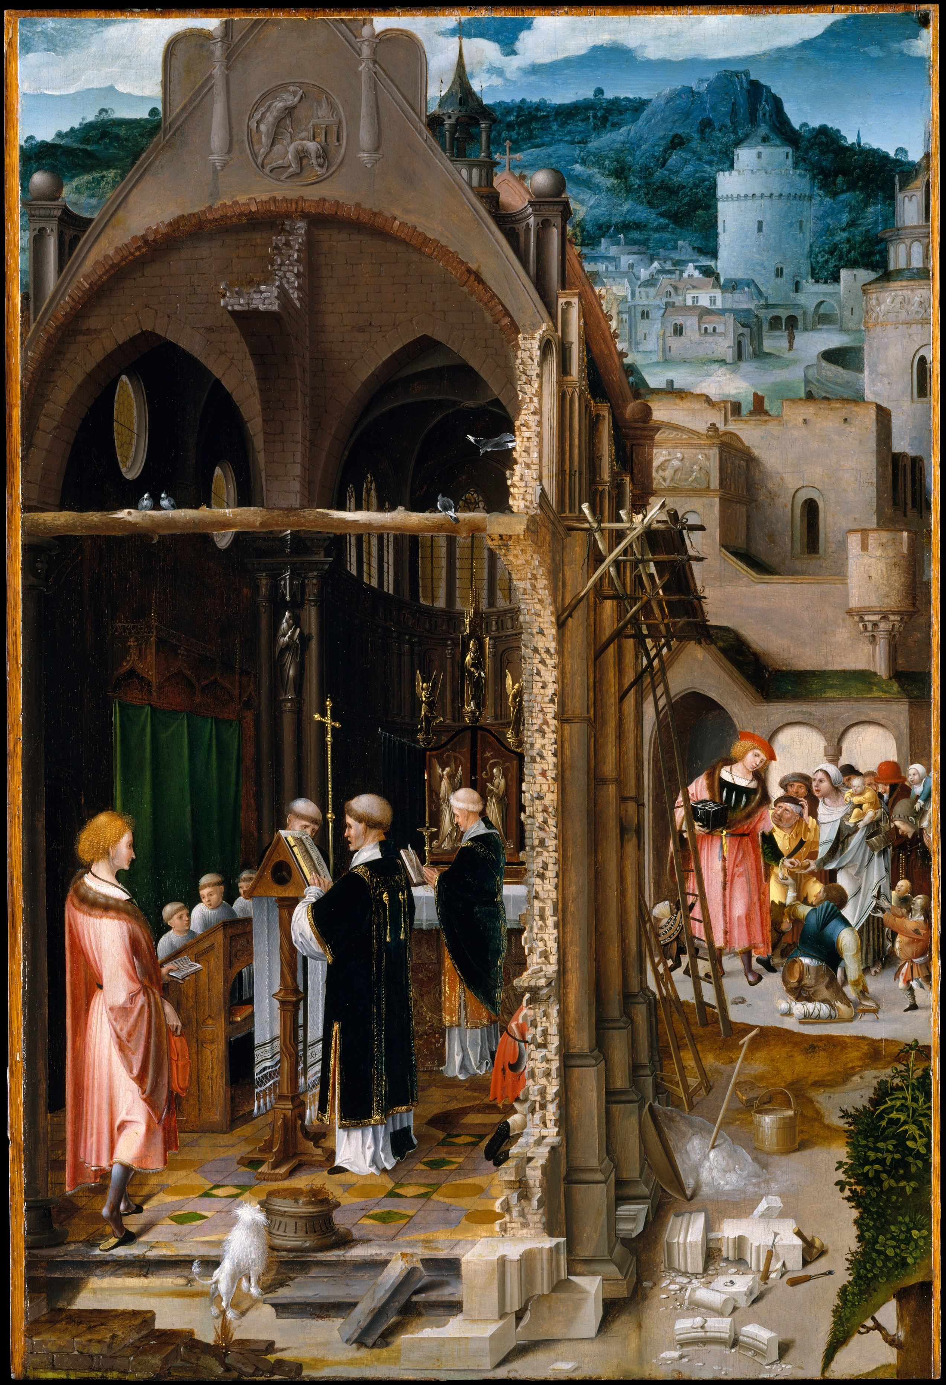

http://www.goodshepherdbinghamton.org
August 7, 2022 – 10:30am
Proper 14, The Ninth Sunday after Pentecost
Welcome to Church of the Good Shepherd! We are delighted to worship God with you this morning. Everything you need for is here in these pages. If you are visiting and would like more information about Good Shepherd, please fill out a guest card at either of the usher tables or call the parish office (723-8032). At Good Shepherd you will find friendly people, engaging sermons, joyful worship, practical teaching, and lots of kids. Welcome!
August 7, 2022
The Ninth Sunday after Pentecost

Prelude Fantasia in g minor Pachelbel

The Procession How Firm a Foundation, Ye Saints of the Lord
The people stand and sing
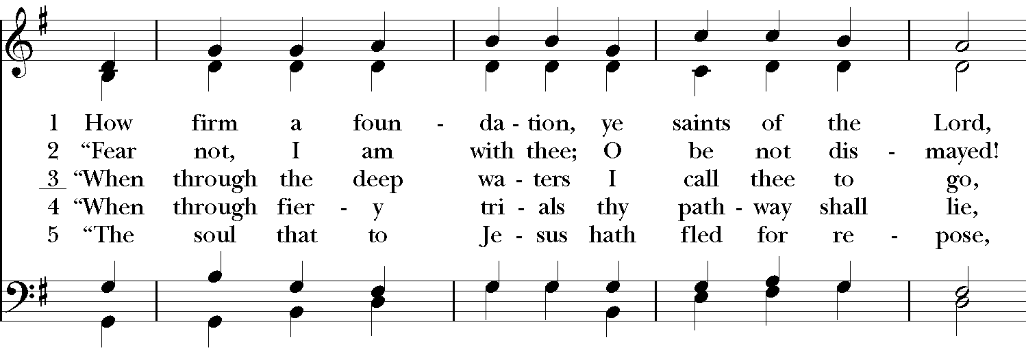
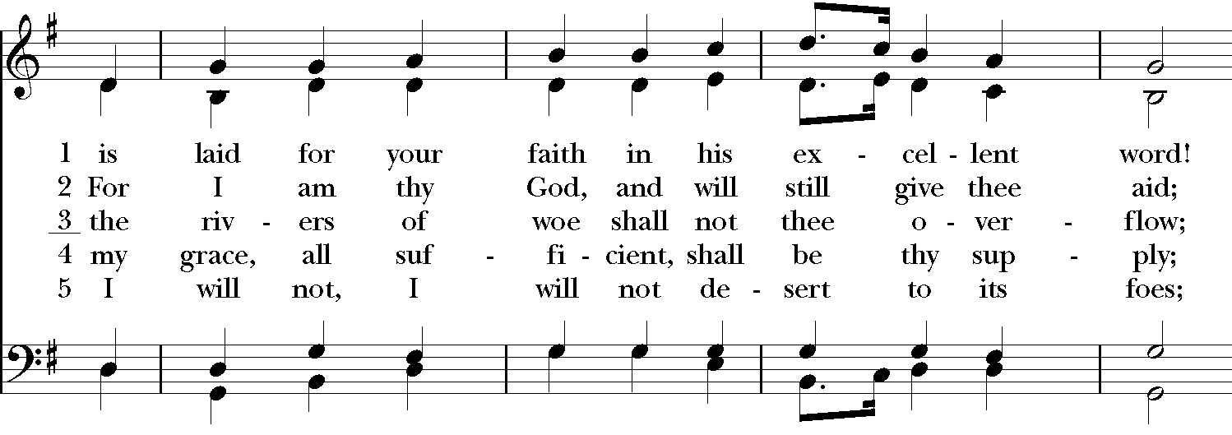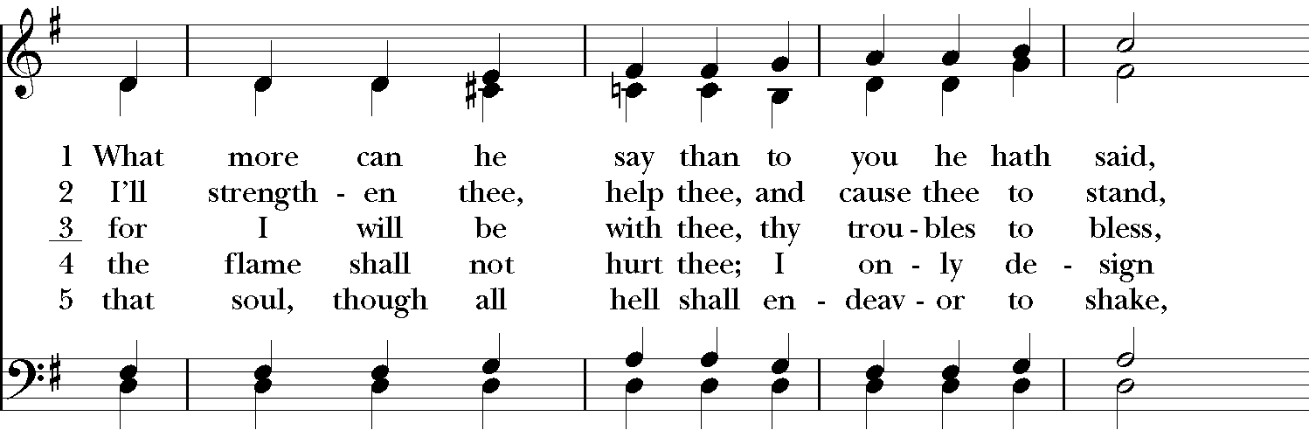

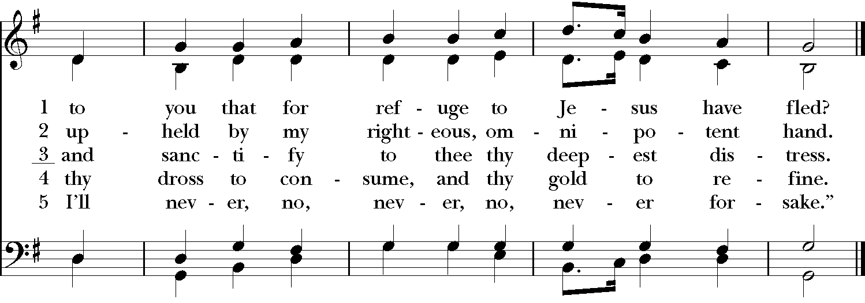

The Acclamation and Collect for Purity
The people remain standing
Celebrant Blessed be God, the Father, the Son and the Holy Spirit.
People And blessed be his kingdom, now and forever. Amen.

Almighty God, to you all hearts are open, all desires known, and from you no secrets are hid: Cleanse the thoughts of our hearts by the inspiration of your Holy Spirit, that we may perfectly love you, and worthily magnify your holy Name; through Christ our Lord. Amen.

The Summary of the Law
Jesus said: You shall love the Lord your God with all your heart and with all your soul and with all your mind. This is the great and first commandment. And a second is like it: You shall love your neighbor as yourself. On these two commandments depend all the Law and the Prophets.

The Gloria Glory Be to God
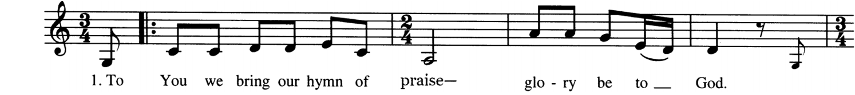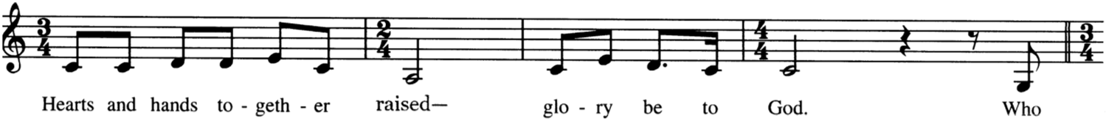
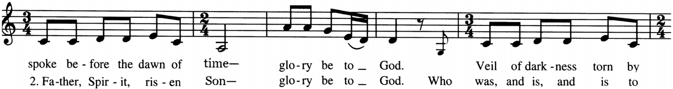
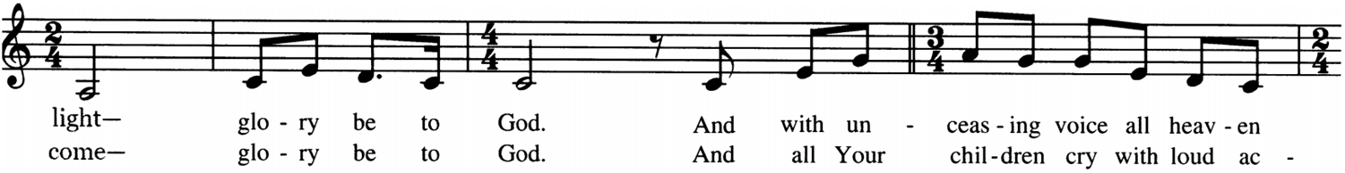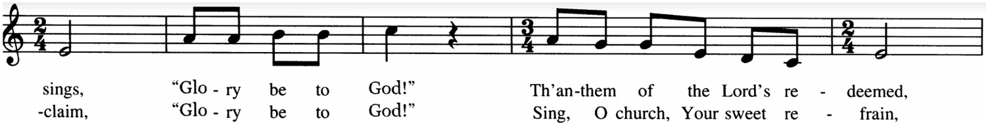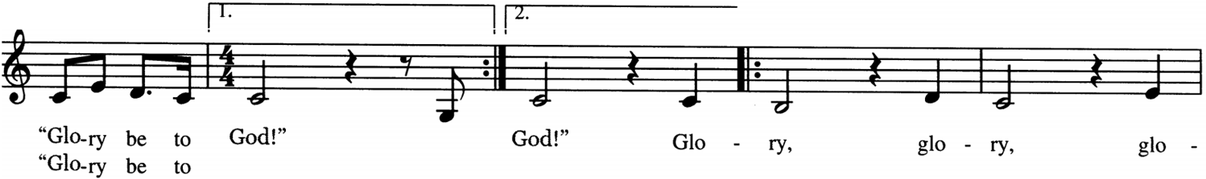
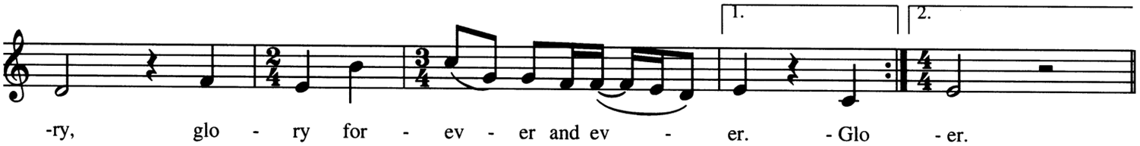

The Collect of the Day
Celebrant The Lord be with you.
People And with your spirit.
Celebrant Let us pray.

Almighty God, give us the increase of faith, hope, and love; and, that we may obtain what you have promised, make us love what you command; through Jesus Christ our Lord, who lives and reigns with you and the Holy Spirit, one God, for ever and ever. Amen.

The Lessons
The people sit for the reading of the lessons.

The First Lesson

Genesis 15:1-6 Pew Bible pg. 10, LP pg. 12

Reader The Word of the Lord.
People Thanks be to God.

Psalm 33:10-21
10 The LORD brings the counsel of the nations to naught; *
he makes the devices of the peoples to be of no effect, and casts out the counsels of princes.
11 The counsel of the LORD shall endure for ever, *
and the thoughts of his heart from generation to generation.
12 Blessed is the nation whose God is the LORD, *
and blessed are the people he has chosen for himself to be his inheritance.
13 The LORD looks down from heaven and beholds all the children of men; *
from the habitation of his dwelling he considers all those who dwell on the earth.
14 He fashions all the hearts of them *
and understands all their works.
15 There is no king who can be saved by a mighty host; *
neither is any mighty man delivered by great strength.
16 A horse is considered a vain hope to save a man; *
neither shall it deliver anyone by its great strength.
17 Behold, the eye of the LORD is upon those who fear him, *
and upon those who put their trust in his mercy,
18 To deliver their soul from death, *
and to feed them in the time of famine.
19 Our soul has patiently waited for the LORD, *
for he is our help and our shield.
20 Our heart shall rejoice in him, *
because we have hoped in his holy Name.
21 Let your merciful kindness, O LORD, be upon us, *
as we have put our trust in you.

The Second Lesson
Hebrews 11:1-16 Pew Bible pg.1007, LP pg. 1195
Reader The Word of the Lord.
People Thanks be to God.

The Gradual The Steadfast Love
The people stand and sing, facing the procession
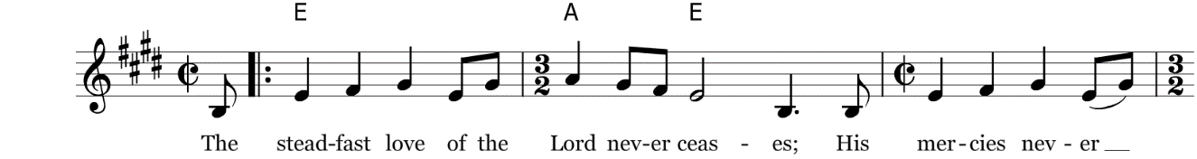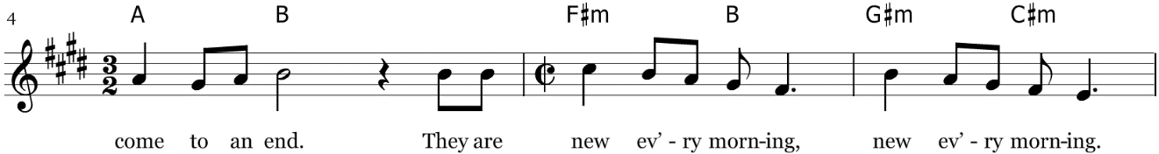
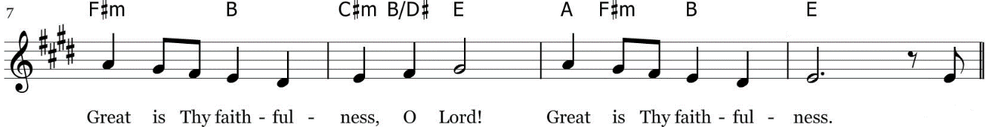

The Gospel
Celebrant The Holy Gospel of our Lord Jesus Christ according to Luke.
People Glory to You, Lord Christ.

Luke 12:32-40
Celebrant The Gospel of the Lord.
People Praise to you, Lord Christ.

The Sermon The Rev. Matthew Kennedy

The Nicene Creed
The people stand, if able
Celebrant Let us confess our faith in the words of the Nicene Creed:
We believe in one God, the Father, the Almighty, maker of heaven and earth, of all that is, visible and invisible.

We believe in one Lord, Jesus Christ, the only-begotten Son of God, eternally begotten of the Father, God from God, Light from Light, true God from true God, begotten, not made, of one Being with the Father. Through him all things were made. For us and for our salvation he came down from heaven: was incarnate from the Holy Spirit and the Virgin Mary, and was made man.

For our sake he was crucified under Pontius Pilate; he suffered death and was buried. On the third day he rose again in accordance with the Scriptures; he ascended into heaven and is seated at the right hand of the Father. He will come again in glory to judge the living and the dead, and his kingdom will have no end.

We believe in the Holy Spirit, the Lord, the giver of life, who proceeds from the Father and the Son. Who, with the Father and the Son, is worshiped and glorified, who has spoken through the Prophets.

We believe in one holy catholic and apostolic Church. We acknowledge one baptism for the forgiveness of sins. We look for the resurrection of the dead, and the life of the world to come. Amen.
The Prayers of the People
Let us pray for the Church and for the world, saying, “hear our prayer.”

For the peace of the whole world, and for the well-being and unity of the people of God.

Reader Lord, in your mercy
People Hear our prayer.

For Foley Beach, Julian Dobbs and William Love, our Bishops, for Matt, Jonathan, Anne, and Micah, and for all who minister at Good Shepherd, for Jerry and Ife, and for all the clergy and people of our Province and diocese, especially for the people and clergy of the Anglican Province of Myanmar.

Reader Lord, in your mercy
People Hear our prayer.

For all those who proclaim the Gospel at home and abroad; and for all who teach and disciple
others, especially for the teachers and children of the Kuinde Preschool.

Reader Lord, in your mercy
People Hear our prayer.

For our brothers and sisters in Christ who are persecuted for their faith. This week we pray for four Christian families that were forced from their village in Vietnam under religious persecution.

Reader Lord, in your mercy
People Hear our prayer.

For our nation, for those in authority, and for all in public service especially President Biden, Governor Hochul, Senator Akshar, and Mayor Kraham.

Reader Lord, in your mercy
People Hear our prayer.

For all those who are in trouble, sorrow, need, sickness, or any other adversity.

Reader Lord, in your mercy
People Hear our prayer.

We bless your holy Name for all your servants who departed this life, praying you would grant us grace to follow their good examples, that with them we might partake in your heavenly kingdom.

I invite you to add your own additional prayers and thanksgivings at this time.

Heavenly Father, grant these our prayers for the sake of Jesus Christ, our only Mediator and Advocate, who lives and reigns with you in the unity of the Holy Spirit, one God, now and for ever. Amen.

The Confession of Sin
Celebrant Let us confess our sins against God and our neighbors.
The people kneel if able and pray together
Almighty God, Father of our Lord Jesus Christ, maker of all things, judge of all people: We acknowledge and bewail our manifold sins and wickedness, which we from time to time most grievously have committed, by thought, word, and deed, against your divine Majesty, provoking
most justly your wrath and indignation against us. We do earnestly repent, and are heartily sorry for these our misdoings; the remembrance of them is grievous unto us, the burden of them is intolerable.

Have mercy upon us, have mercy upon us, most merciful Father; for your Son our Lord Jesus Christ’s sake, forgive us all that is past; and grant that we may ever hereafter serve and please you in newness of life, to the honor and glory of your Name; through Jesus Christ our Lord. Amen.

Celebrant stands and says
Almighty God, our heavenly Father, who in his great mercy has promised forgiveness of sins to all those who sincerely repent and with true faith turn to him, have mercy upon you, pardon and deliver you from all your sins, confirm and strengthen you in all goodness, and bring you to everlasting life; through Jesus Christ our Lord. Amen.

The Comfortable Words
The Celebrant says
Hear the Word of God to all who truly turn to him.
Come to me, all who labor and are heavy laden, and I will give you rest.
~Matthew 11:28
Celebrant The peace of the Lord be always with you.
People And with your spirit.

Then the Celebrant and People may greet one another in the name of the Lord.

Announcements

Birthdays and Anniversaries

The Offertory Sentence
Celebrant Ascribe to the Lord the glory due his name; bring an offering, and come into his courts!

Offertory Music Come People of the Risen King

The people remain seated and sing
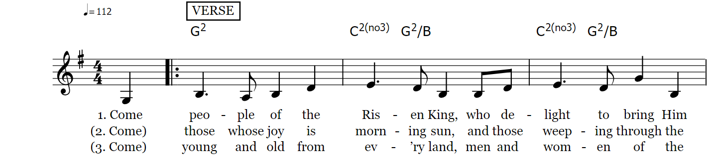
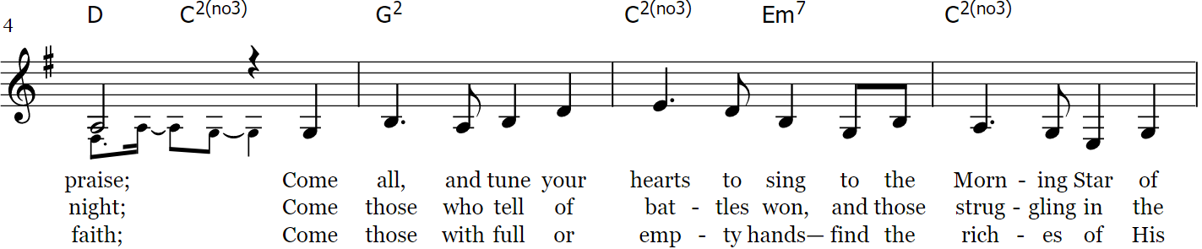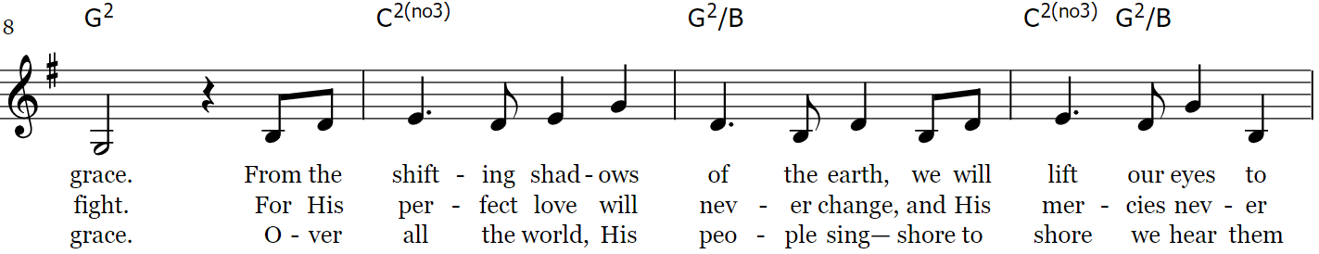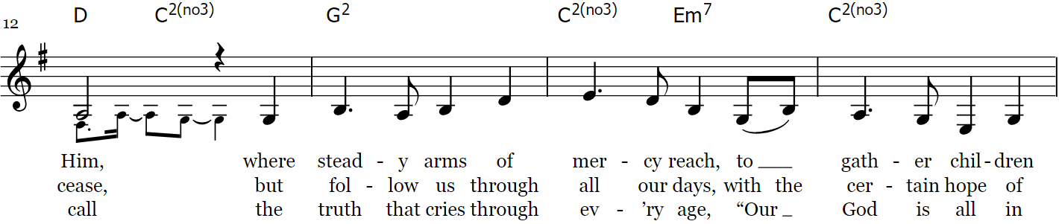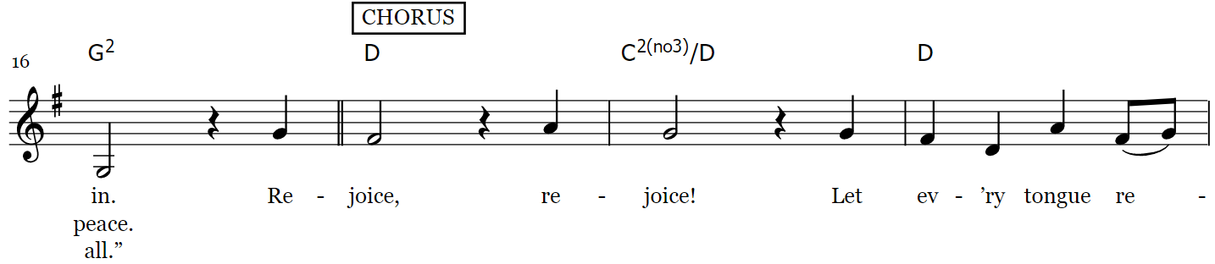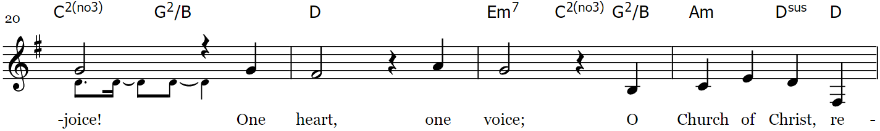
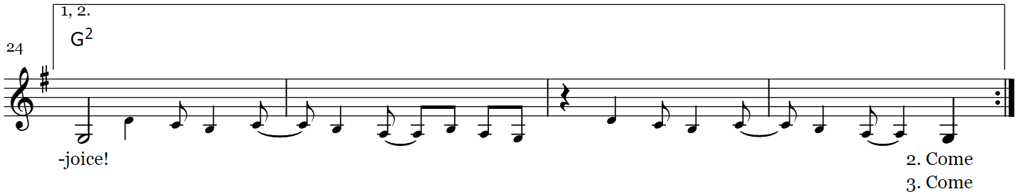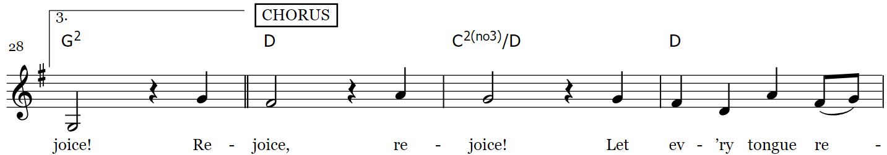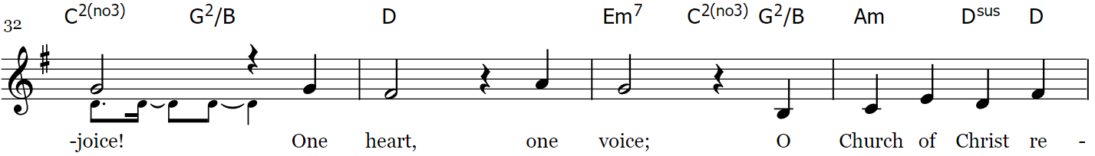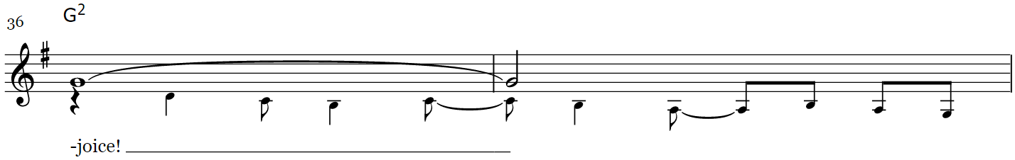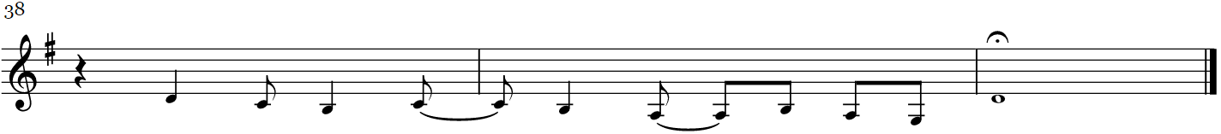

If you are a guest with us today, please do not feel obligated to give an offering. If you are a regular attender at Good Shepherd, you may give your tithe in several ways. An offering plate will be passed and you are welcome to give your offering there. There is also an offering box at the rear of the sanctuary where you may drop your tithe, or you can mail checks to 360 Conklin Avenue, Binghamton, NY, 13903. You can also give online through Breeze or you can text a donation through Breeze at 607-882-6551. Good Shepherd also has a PayPal account. If you choose to give via PayPal you can avoid fees by paying directly from your bank. Be sure to uncheck the box that says, "paying for goods and services" at the bottom or paypal will charge Good Shepherd a fee. As always, thank you for your great generosity and kind support.

The Presentation of the Gifts
The people stand, if able, and sing
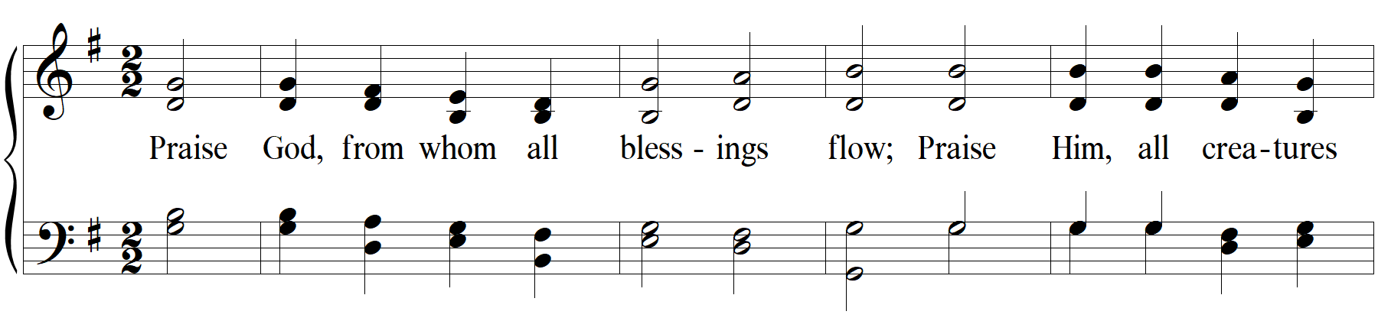
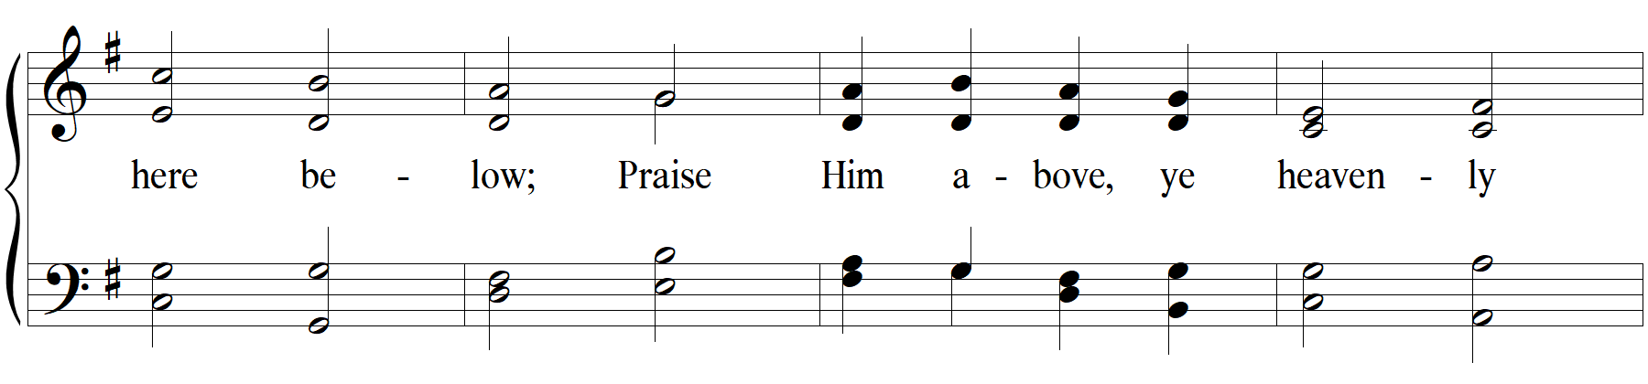
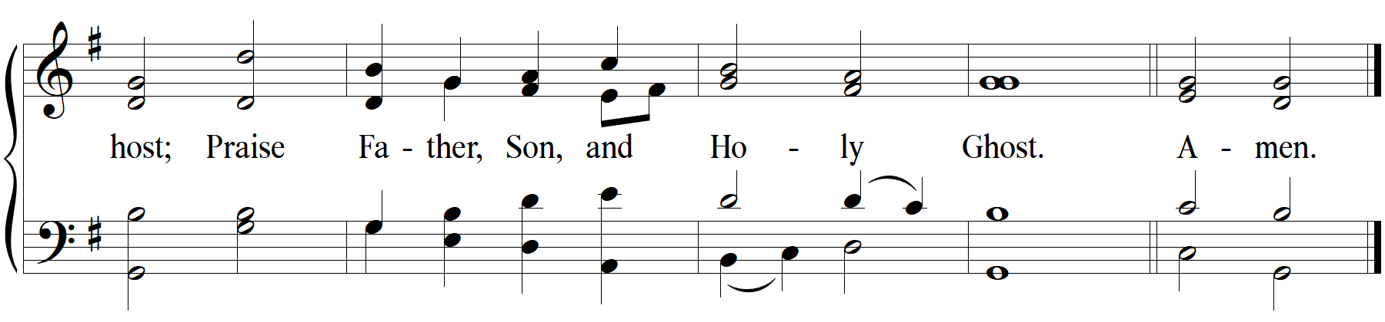

The Great Thanksgiving
Celebrant The Lord be with you.
People And with your spirit.
Celebrant Lift up your hearts.
People We lift them to the Lord.
Celebrant Let us give thanks to the Lord our God.
People It is just and right so to do.
Then, facing the Holy Table, the Celebrant proceeds
It is right, and a good and joyful thing, always and everywhere to give thanks to you, Father Almighty, Creator of heaven and earth.

Through Jesus Christ our Lord, who on the first day of the week overcame death and the grave, and by his glorious resurrection opened to us the way of everlasting life.

Therefore we praise you, joining our voices with Angels and Archangels and with all the company of heaven, who for ever sing this hymn to proclaim the glory of your Name:

The Sanctus Holy, Holy Maher, Le and Ndolo
The people remain standing and sing
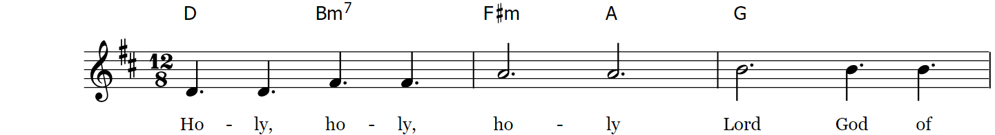
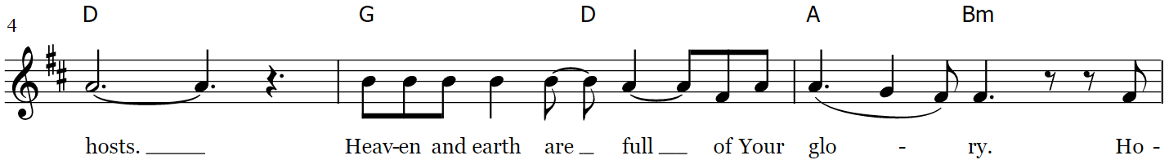
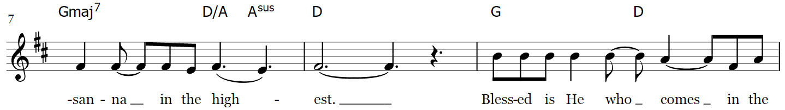
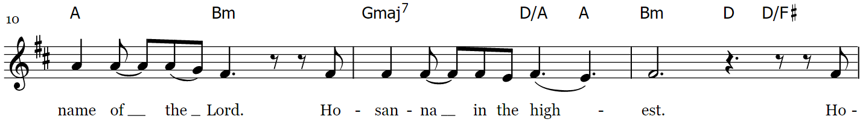
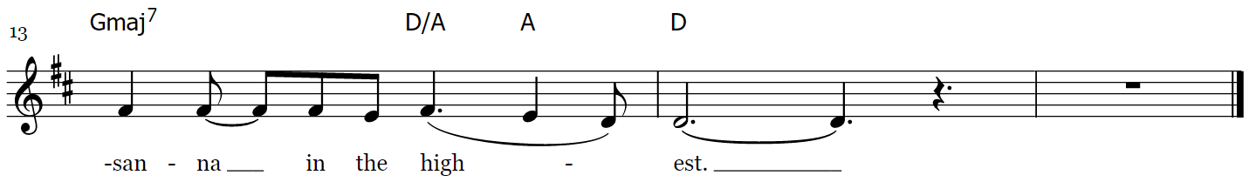

The Prayer of Consecration
The people kneel. The Celebrant continues
All praise and glory is yours, God our heavenly Father, because of your tender mercy, you gave your only Son Jesus Christ to suffer death upon the cross for our redemption; who made there, by his one oblation of himself once offered, a full, perfect, and sufficient sacrifice, oblation, and satisfaction, for the sins of the whole world; and instituted, and in his Holy Gospel commanded us to continue a perpetual memory of his precious death and sacrifice, until his coming again.

And now, O merciful Father; in your great goodness, we ask you to bless and sanctify, with your Word and Holy Spirit, these gifts of bread and wine, that we, receiving them according to your Son our Savior Jesus Christ’s holy institution, in remembrance of his death and passion, may be partakers of his most blessed Body and Blood.

On the night that he was betrayed, our Lord Jesus Christ took bread; and when he had given thanks, he broke it, and gave it to his disciples, saying, “Take, eat; this is my Body which is given for you: Do this in remembrance of me.” Likewise, after supper, Jesus took the cup, and when he had given thanks, he gave it to them, saying, “Drink this, all of you; for this is my Blood of the New Covenant, which is shed for you, and for many, for the forgiveness of sins: Whenever you drink it, do this in remembrance of me.” Therefore we proclaim the mystery of faith

Celebrant and People sing together

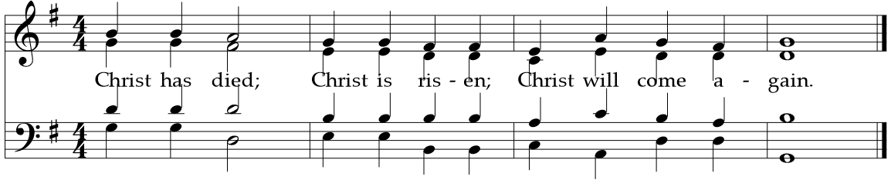

And here we offer and present to you, O Lord, ourselves, our souls and bodies, to be a reasonable, holy, and living sacrifice; humbly pleading that all those who shall partake of this Holy Communion may worthily receive the most precious Body and Blood of your Son Jesus Christ; that, by the Holy Spirit, we may be filled with your grace and heavenly benediction, and made one body with him, so that he may dwell in us, and we in him. By him, and with him, and in him, in the unity of the Holy Spirit, all honor and glory is yours, Almighty Father, now and forever.
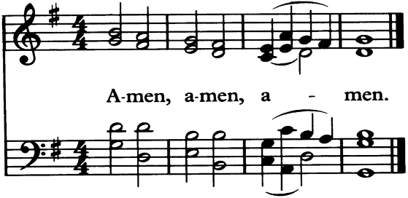

And now, as our Savior Christ has taught us, we are bold to pray:

The Lord’s Prayer
The people remain kneeling, and say
Our Father, who art in heaven, hallowed be thy Name.
Thy kingdom come, thy will be done, on earth as it is in heaven.
Give us this day our daily bread.
And forgive us our trespasses, as we forgive those who trespass against us.
And lead us not into temptation, but deliver us from evil.
For thine is the kingdom, and the power, and the glory,
forever and ever. Amen.

The Fraction
The people remain kneeling and say

Celebrant Alleluia, Christ our Passover Lamb has been sacrificed, once for all upon the
Cross.

People Therefore let us keep the feast, Alleluia.

The Prayer of Humble Access
Celebrant and people say together
We do not presume to come to this your Table, O merciful Lord, trusting in our own righteousness, but in your manifold and great mercies. We are not worthy so much as to gather up the crumbs under your Table. But you are the same Lord whose property is always to have mercy. Grant us, therefore, gracious Lord, so to eat the flesh of your dear Son Jesus Christ, and to drink his blood, that we may evermore dwell in him, and he in us. Amen.

The Agnus Dei Lamb of God
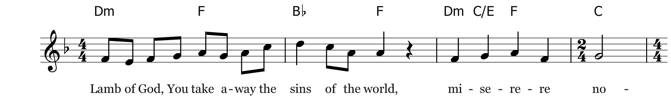
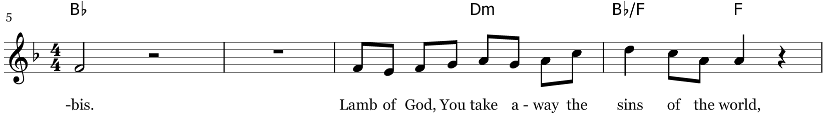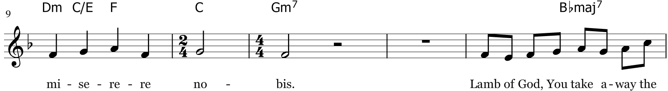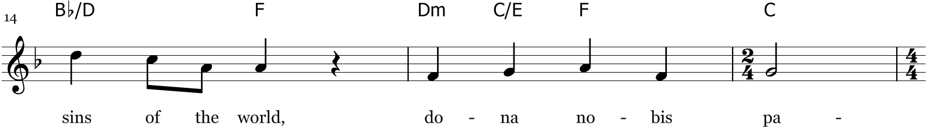
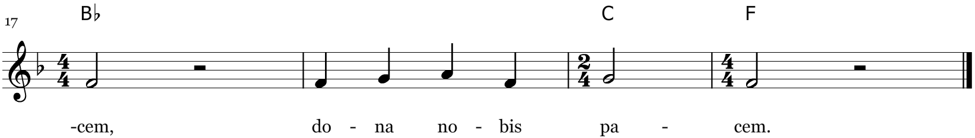
*miserere nobis=have mercy on us *dona nobis pacem = grant us peace

The Communion of the People
All Christians baptized in any denomination and in good standing with their home church are welcome to take Communion. If you are unable to take communion for any reason, you are warmly invited to the rail for a prayer and blessing: just place your hands across your chest and one of the pastors will bless and pray for you. If you are in a wheelchair or are unable to come forward for any reason, please let an usher know and we will bring the Sacrament to you in your pew. Gluten free wafers are available upon request when you come forward.

The Invitation
Celebrant
The Gifts of God for the people of God. Take them in remembrance that Christ died for you, and feed on him in your hearts, by faith, with thanksgiving.

Communion Music Amazing Grace, My Chains are Gone
The people, sitting or kneeling
Verse 1  Amazing grace how sweet the sound  That saved a wretch like me  I once was lost but now I'm found  Was blind but now I see |  | Verse 3  The Lord has promised good to me  His word my hope secures  He will my shield and portion be  As long as life endures
Verse 2  'Twas grace that taught my heart to fear  And grace my fears relieved  How precious did that grace appear  The hour I first believed  Chorus  My chains are gone I've been set free  My God my Savior has ransomed me  And like a flood His mercy rains  Unending love amazing grace |  | Verse 4  The earth shall soon dissolve like snow  The sun forbear to shine  But God who called me here below  Will be forever mine  Will be forever mine  You are forever mine

How Great Thou Art
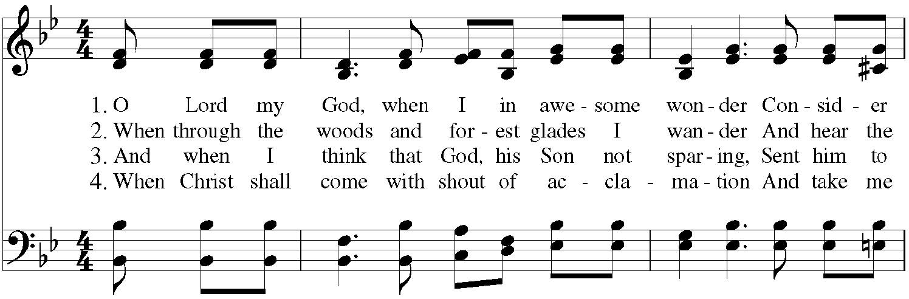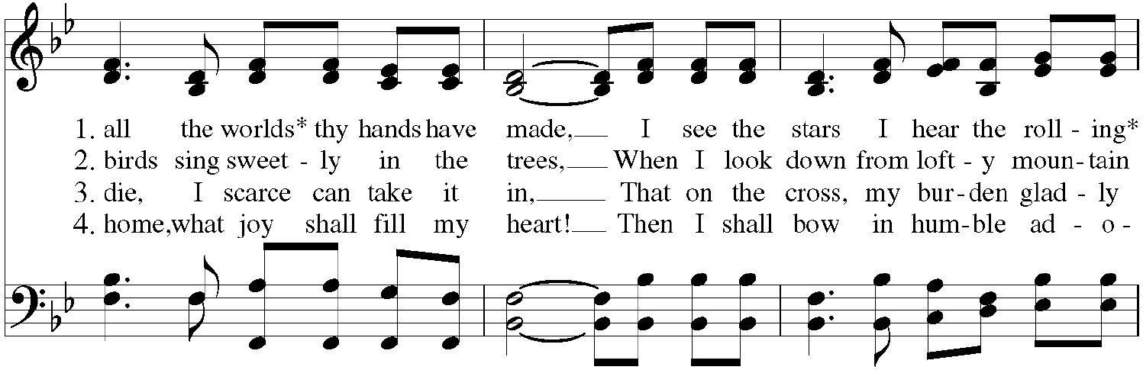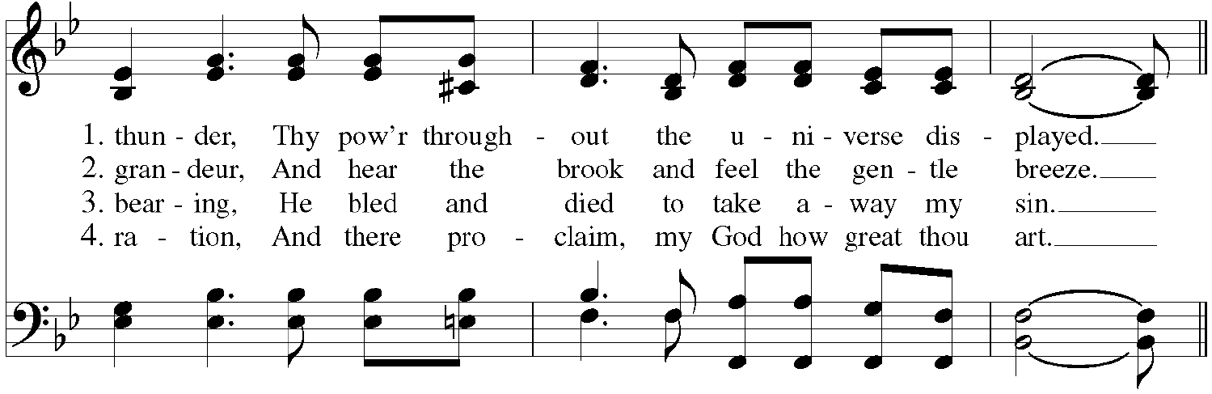
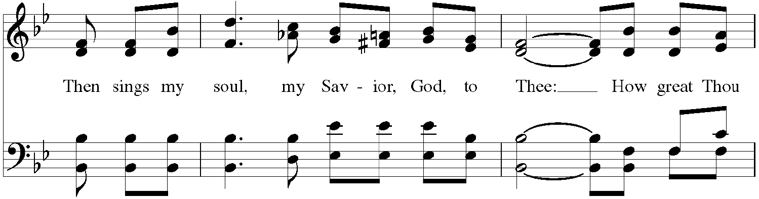
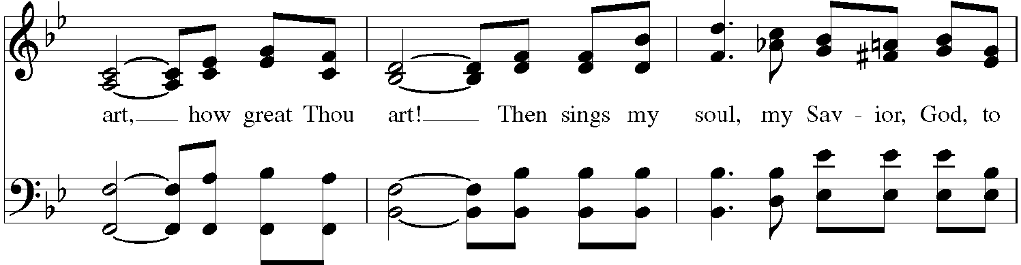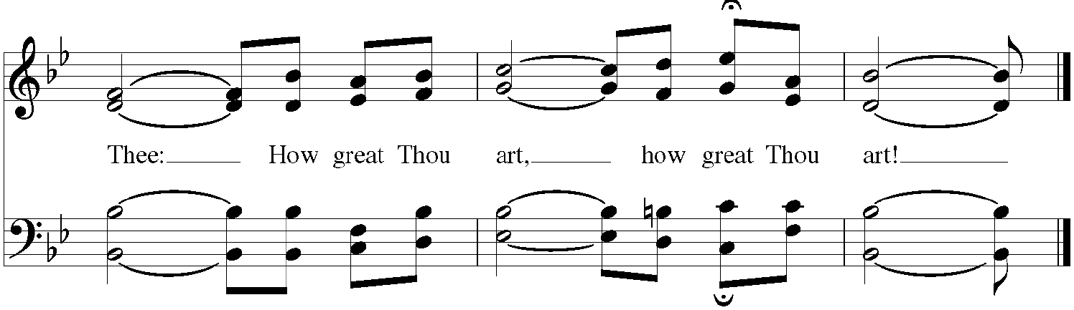

The Post-Communion Prayer
The people kneel
Celebrant Let us Pray.

Celebrant and People
Almighty and ever-living God, we thank you for feeding us, in these holy mysteries, with the spiritual food of the most precious Body and Blood of your Son our Savior Jesus Christ; and for assuring us, through this Sacrament, of your favor and goodness towards us; and that we are true members of the mystical body of your Son, the blessed company of all faithful people; and are also heirs, through hope, of your everlasting kingdom. And we humbly ask you, heavenly Father,
to assist us with your grace, that we may continue in that holy fellowship, and do all such good works as you have prepared for us to walk in; through Jesus Christ our Lord, to whom with you and the Holy Spirit, be all honor and glory, now and forever. Amen.

The Blessing
Celebrant
The peace of God, which passes all understanding, keep your hearts and minds in the knowledge and love of God, and of his Son Jesus Christ our Lord; and the blessing of God Almighty, the Father, the Son, and the Holy Spirit, be among you, and remain with you always. Amen.
The Hymn in Recession If Thou but Suffer God to Guide Thee
The people stand, if able, and sing
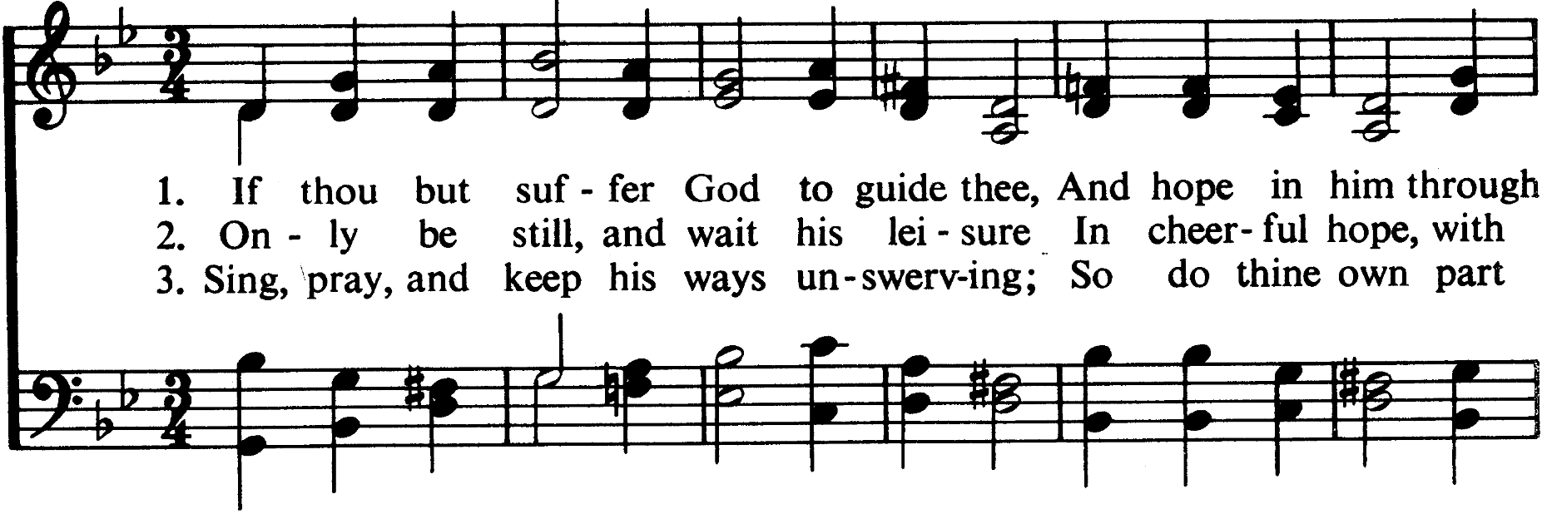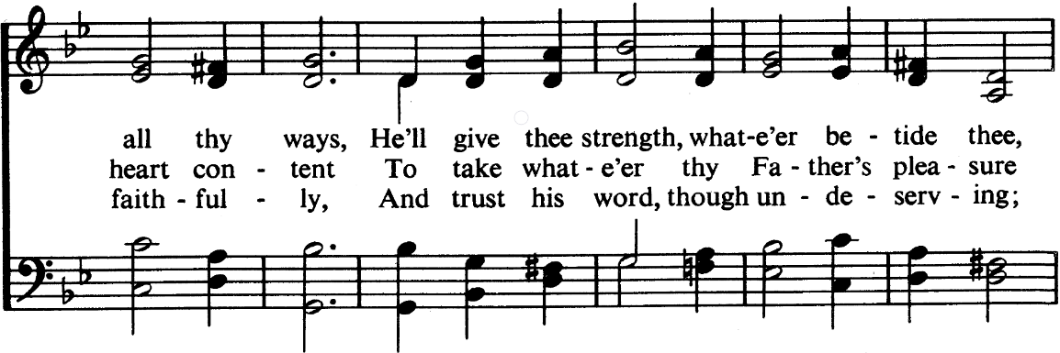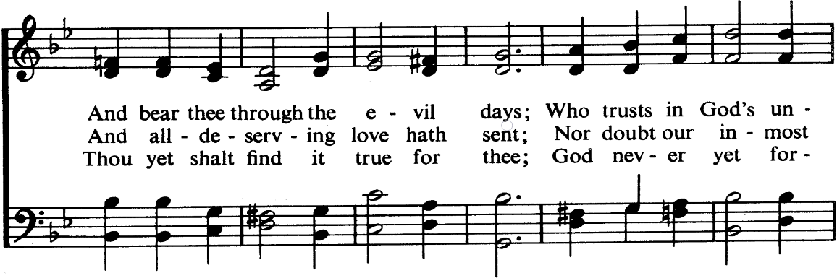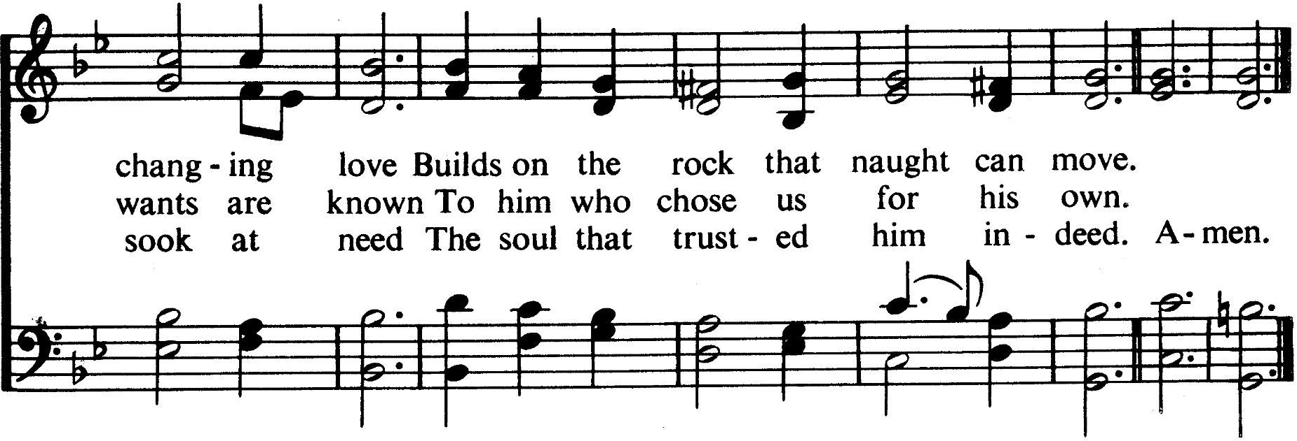
The Dismissal
Celebrant Let us go forth, rejoicing in the power of the Holy Spirit. Alleluia, alleluia.
People Thanks be to God. Alleluia, alleluia.

Postlude Fugue in g Minor (Little) J.S. Bach

Thank you for worshiping at Church of The Good Shepherd this morning!

Did you have trouble reading the bulletin this morning? Large Print copies are available upon request. Please contact the office for more information.

We would be so grateful if you would deposit your used bulletins in one of the recycling bins located near the exits of the sanctuary or parish hall as you pass by.

Acknowledgements

“A Sermon on Charity (possibly the Conversion of Saint Anthony)” artist unknown
This file is made available under the Creative Commons CC0 1.0 Universal Public Domain Dedication.
The person who associated a work with this deed has dedicated the work to the public domain by waiving all of their rights to the work worldwide under copyright law, including all related and neighboring rights, to the extent allowed by law. You can copy, modify, distribute and perform the work, even for commercial purposes, all without asking permission.
It can be viewed at:
<https://commons.wikimedia.org/wiki/File:A_Sermon_on_Charity_(possibly_the_Conversion_of_Saint_Anthony)_MET_DT208762.jpg>

Liturgy
All Liturgy is from The Book of Common Prayer and Administration of the Sacraments with Other Rites and Ceremonies of the Church according to the use of the Anglican Church in North America (2019) together with The New Coverdale Psalter (A.D.2013.).

With the exception of the New Coverdale Psalter, the content of the Book of Common Prayer (2019) is not under copyright, and all not-for-profit reproduction of the content by churches and non-profit organizations is permitted. The New Coverdale Psalter is copyright © 2019 by the Anglican Church in North America, but this is not intended to discourage the use and duplication of the text by churches for purposes of worship.
Quotations of Scripture normally follow The Holy Bible, English Standard Version (ESV®) except for the Psalms, Canticles, and citations marked with the symbol ( t ) which indicates traditional prayer book language. The Holy Bible, English Standard Version® is copyright © 2016 by Crossway, a publishing ministry of Good News Publishers, and is used by permission. All rights reserved.

Music
Hymns: All hymns below are reprinted from The Hymnal, 1982 and The Hymnal 1982, Service Music, © 1985 by The Church Pension Fund. Used by permission. All rights reserved.
Prelude: "Fantasia in g minor" Johann Pachelbel (public domain)
Processional: “How Firm a Foundation, Ye Saints of the Lord” Words: "K." in John Rippon’s Selection, 1787, (Attributed to either George Keith or Robert Keen) alt. Music: LYONS, attributed to either Johann Michael Haydn (1737-1806) or Joseph Martin Kraus (1756-1792); arranged by Franz Joseph Haydn (1732-1809); Public Domain
Gloria: “Glory be to God” CCLI Song # 5120509 Kelly Minter | Matt Maher | Stuart Townend © 2007
spiritandsong.com (Admin. by Capitol CMG Publishing) Thankyou Music (Admin. by Capitol CMG Publishing) All rights reserved. www.ccli.com CCLI License # 3237915; CCLI Streaming License #20222443
Gradual: “The Steadfast Love” CCLI Song # 21590 Edith McNeill © 1974, 1975 Celebration. All rights reserved. www.ccli.com CCLI License # 3237915; CCLI Streaming License #20222443
Offertory: “Come People of the Risen King” CCLI Song # 5232617 Keith Getty | Kristyn Getty | Stuart Townend © 2007 Thankyou Music (Admin. by Capitol CMG Publishing). All rights reserved. www.ccli.com CCLI License # 3237915; CCLI Streaming License #20222443
Doxology: “Praise God from Whom All Blessings Flow” Words: Public Domain, written in 1674 by Thomas Ken, (1637-1711) Music: Old 100th, melody from Pseaumes octante trois de David, 1551, alt.; harm. after Louis Bourgeois (1510?-1561?) [Public Domain]
Sanctus: “Holy, Holy” Ike Ndolo | Matt Maher | Tam Le © 2011 Thankyou Music (Admin. by Capitol CMG Publishing) Valley Of Songs Music (Admin. by Capitol CMG Publishing) Worship Together Music (Admin. by Capitol CMG Publishing) Ike Ndolo Music (Admin. by Essential Music Publishing LLC) For use solely with the SongSelect® Terms of Use. All rights reserved. www.ccli.com CCLI License # 3237915; CCLI Streaming License #20222443
Memorial Acclamation: “Memorial Acclamation” Danish 3 Fold. [Public Domain.]
The Great Amen: “The Holy Eucharist, Amen” Danish 3 Fold. [Public Domain.]
Agnus Dei: “Lamb of God” Ike Ndolo | Matt Maher | Tam Le © 2011 Thankyou Music (Admin. by Capitol CMG Publishing) Valley Of Songs Music (Admin. by Capitol CMG Publishing) Worship Together Music (Admin. by Capitol CMG Publishing) Ike Ndolo Music (Admin. by Essential Music Publishing LLC) For use solely with the SongSelect® Terms of Use. All rights reserved. www.ccli.com CCLI License # 3237915; CCLI Streaming License #20222443
Communion: “Amazing Grace (My Chains are Gone)” CCLI Song # 4768151 Chris Tomlin | John Newton | Louie Giglio © 2006 sixsteps Music (Admin. by Capitol CMG Publishing) Vamos Publishing (Admin. by Capitol CMG Publishing) worshiptogether.com songs (Admin. by Capitol CMG Publishing) All rights reserved. www.ccli.com CCLI License # 3237915; CCLI Streaming License #20222443
"How Great Thou Art" CCLI Song # 14181 Music and Words by Stuart Wesley Keene Hine, © Copyright 1949 and 1953 Stuart Hine Trust CIO Stuart K. Hine Trust (Administration: USA All rights by Capitol CMG Publishing, except print rights for USA, North, Central and South America administered by Hope Publishing. All other non USA Americas rights by the Stuart Hine Trust. Rest of World – Integritymusic.com.) For use solely with the SongSelect® Terms of Use. All rights reserved. www.ccli.com CCLI License # 3237915 (vv1&2 a paraphrase of Psalm 8)
Recessional: “If Thou But Suffer God To Guide Thee” Words and Music: Georg Neumark (1641); Translator: Catherine Winkworth (1855, 1863); Public Domain
Postlude: “Fugue in g Minor (Little)” J. S. Bach (public domain)

Weekly Update, August 7, 2022
Women’s Bible Study This study is meeting at 4:30 pm on Friday afternoons in the Parish Hall. Anne Kennedy is leading, and they are currently studying the book of Proverbs. Children are welcome—as in, we hope to have some childcare available. If you’d like to join by zoom, please join the church email list and look for a link in the weekly update email.

Ongoing Ministries
Tuesday Morning Bible Study meets at 9:05am to walk through different books of the bible, verse by verse. Taught by a member of the pastoral staff in the main room of the parish hall. This class can be viewed in person or online each week by livestream.

This class is currently working on a study focusing on the parables of Christ.

Good Shepherd Member Food Pantry has food available. The pantry is open on Sunday and Thursday. Please contact a member of the staff or the church office if you need access to the pantry.

Shepherd’s Bowl Community Dinner Good Shepherd offers a free nutritious meal to the people of Good Shepherd and the wider community on Thursday evenings from 5:30-6:30. If you are able, this is a great time to get to know others and enjoy a free and delicious meal.

Christian Education for All is at 9:15am on Sunday Morning.

Adult Class How to Read and Study the Bible

This Sunday we will talk about how to read and study the gospels.

Children’s Class During these summer months, children have been hearing a new story each week from the life of Jesus.

This week we will learn that Jesus teaches we should love our enemies. We will also continue practicing the first 5 questions from the Westminster Shorter Catechism. If you would like to follow along throughout the week, we are learning them through the songs by Holly Dutton on Spotify!

Thursday Evening Bible Study This is a great place to connect with others and learn more about what God has to say to us through his word. The class is taught by Mr. Terry Ray, and they are beginning a study on the book of Psalms.

Friday Morning Men’s Bible Study Each week a men gather at 6:30am to share bible study and prayer time together. Men of any age are welcome to attend. If you are interested in learning more about this study, please email Pastor Matt, Jonathan Groves, or contact the church office.

This class is currently studying the book of 2 Peter.

Mission Groups Mission Groups exist to glorify God by building up the body of believers through relationships, discipleship, application of scripture and prayer in small groups.

If you are looking for a way to get involved, grow in community, and deepen your understanding of God's word, Mission Groups are for you. If you have any questions or would like to host or lead a group yourself, please talk with Jonathan Groves.

Good Shepherd Youth Group meets on Sunday night from 6:00 – 7:30pm at Good Shepherd. All youth between the ages of 12-18 are welcome to join and study the book of Hebrews. Please contact Jonathan Groves if you’d like to be involved in any way. Email: jg.arrowhead@gmail.com.

What’s Going on at Good Shepherd…
Book Study of Generation to Generation
Stephanie and I (Anne) are excited about our forthcoming book group on Edwin Friedman’s Generation to Generation. Matt and I spent most of our time camping going back through the material and remembering all the helpful tools Friedman offers for life in the church and the family. Matt is planning to come to the group, as he is able, and help us out.

The first week Steph and I will introduce some of the concepts in the first chapter (though not all—please don’t be intimidated by the technical detail, so much comes clearer after those first two introductory chapters) and talk about how the class will work. The first meeting will be on August 13 at 4, on zoom (we’ll send the link to those who ask for it—please email Anne or Steph, or text or call them). The classes will be recorded for those who won’t be able to make it. Looking forward to seeing you on zoom!
Employment Opportunity Good Shepherd is looking to hire a custodian in a part time capacity. This is a 10-12 hour time commitment each week. If you or anyone you know might be interested in this position, please reach out to Micah.

Did you Hear? Mary Schuster and Nick Restino got married yesterday! Congratulations Mr. and Mrs. Restino, and thanks to all who helped to make their day so special.

Potluck Next Sunday is the first of the month, which means it’s time for another potluck! This month’s theme will be Asian Foods. Please consider bringing your favorite Indian, Thai, Chinese, Japanese, and Korean dishes to share, but come and enjoy lunch even if you don’t!

Potlucks are a great way to introduce friends and family to the community of Good Shepherd, so please do invite them to join us!

Church Picnic This year’s church picnic is scheduled for Sunday, September 11. The last church picnic was held in 2019, and we’d really love to make the first one since then special.

We hope to put together a committee to help plan and execute the picnic. If you are interested in being part of that process, please contact Micah or Steph.

More information to come as we get closer to the date!
Youth Group Lake Outing The Carlton family has graciously invited the youth group, their families, and anyone who volunteered with the youth group this year to their cottage on August 31st from 3-8pm. The day will include swimming, grilling, and (possibly) a campfire!
Please contact Jon Groves for more info and to RSVP.

Week at a Glance Schedule, August 7, 2022– August 14, 2022
Saturday

Serving at Good Shepherd August 7, 2022
8am Celebrant: Matt Kennedy
8am Preacher: Matt Kennedy
8am Assistant: Anne Kennedy
8am Reader: Terry Ray
8am Usher: Terry Ray
10:30am Celebrant: Matt Kennedy
10:30am Preacher: Matt Kennedy
10:30am Assistant: Anne Kennedy
10:30am Reader: Scott Pineau
10:30am Crucifer: Tal Pineau
10:30am Acolytes: Cadence Radman & Addie Pineau
10:30am Usher: Fred Urda
Tellers: Niklas Boeker, Nick Restino
Altar Guild: Mary Schuster
Nursery: Kariah and Gwendolyn
Shepherds Bowl: Martha Rice with Team 2
Potluck: Asian Foods

Serving at Good Shepherd August 14, 2022
8am Celebrant: Matt Kennedy
8am Preacher: Micah Lovell
8am Assistant: Jonathan Groves
8am Reader: Terry Ray
8am Usher: Terry Ray
10:30am Celebrant: Matt Kennedy
10:30am Preacher: Micah Lovell
10:30am Assistant: Jonathan Groves
10:30am Reader: Christine Osgood
10:30am Crucifer: Aedan Kennedy
10:30am Acolytes: Abigail Radman, Gwendolyn Kennedy
10:30am Usher: Ben Murphy
Tellers: Tom Dinnel & Eric Radman
Altar Guild: Christine Osgood
Nursery: Jaime & Annabeth Hull
Shepherds Bowl: Martha Rice with Team 3

Anticipated giving for 2022 (Jan-Nov) $234,513.00
Anticipated YTD (2022) Giving $154,678.84
Actual YTD Giving (2022) $161,316.49
Sunday
8:00am | Service of Holy Eucharist, no  music
9:15am | Christian Ed for adults and  children (online observance available)
10:30am | Service of Holy Eucharist (online observance available)
12:30pm | Coffee Hour

Happy Birthday!
August 13 Kcaarin Pineau

Happy Anniversary!
August 8 Darrell & Carolyn Dean
August 11 Fr Matt & Anne Kennedy
August 13 Bob & Cookie Finch

Thursday
5:30pm | Shepherd’s Bowl Community  Dinner
6:00pm | Beginner’s Bible Study

Friday
6:30am | Men’s Breakfast and Bible Study
4:30pm | Women’s Bible Study

Daily Lectionary
Year II
60 Day Psalter Cycle
Monday  August 8 | Psalm 94  Hos 6  John 10:1-21
Tuesday  August 9 | Psalm 97, 98  Hos 7  John 10:22-end
Wednesday  August 10 | Psalm 102  Hos 8  John 11:1-44
Thursday  August 11 | Psalm 104  Hos 9  John 11:45-end
Friday  August 12 | Psalm 105  Hos 10  John 12:1-19
Saturday  August 13 | Psalm 106  Hos 11  John 12:20-end
Sunday  August 14 | Psalm 107:23-43  Hos 12  John 13

Sunday
8:00am | Service of Holy Eucharist, no  music
9:15am | Christian Ed for adults and  children (online observance available)
10:30am | Service of Holy Eucharist (online observance available)
12:30pm | Coffee Hour

Monday

Tuesday
9:05am | Tuesday Morning Bible Study

Wednesday

Please Pray For…
ACNA Cycle of Prayer: In the ACNA Cycle of Prayer, today we pray for the Anglican Province of Myanmar and The Most Rev. Stephen Than Myint Oo, Archbishop.
Anglican Diocese of the Living Word All Saints Anglican Church, Pensacola, Florida • The Rev. Matt Mahan • Brothers of St. Elizabeth of Hungary Maine
For the Homebound Betty Cancellieri, and Charles Mabula.
For the Sick Peyton, Rick, Jason D., Doug & Maureen, Charles, Bill, Bob, Evelyn Martin, Andrew, Larry Dimmick, Chris, Sherry and Rob, Bob and Cookie, Joe, Keith, April, and Phil.
Missionaries Pray for the teachers and children of the Kuinde Preschool.

