Church of the Good Shepherd
Knowing Christ and Making Him Known
Rooted in the Word, Nourished by the Sacraments, Alive in Jesus Christ

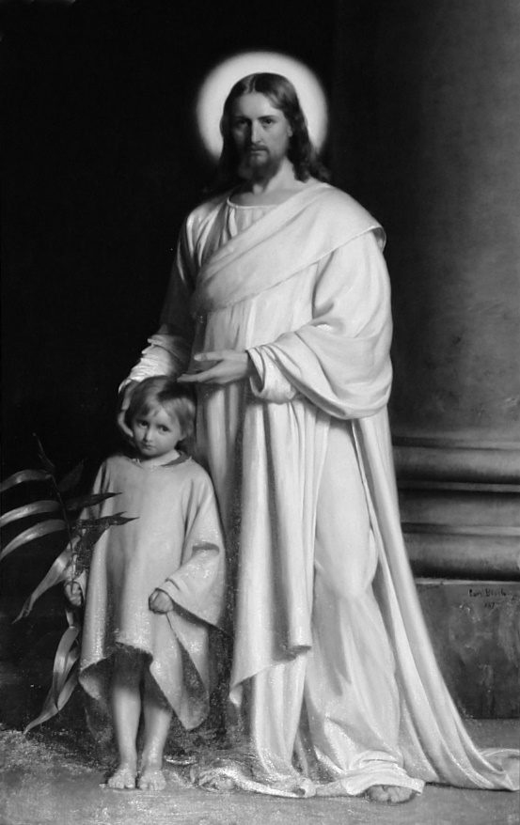

September 19, 2021, A Service of Holy Eucharist
Proper 20, The Seventeenth Sunday after Pentecost – 10:30am
http://www.goodshepherdbinghamton.org

Welcome to Church of the Good Shepherd! We are delighted to worship God with you this morning. Everything you need for worship is here in these pages. If you are visiting and would like more information about Good Shepherd, please fill out a guest card at either of the usher tables or call the parish office (723-8032). At Good Shepherd you will find friendly people, engaging sermons, joyful worship, practical teaching, and lots of kids. Welcome!
Holy Eucharist
September 19, 2021 – The Seventeenth Sunday after Pentecost
Prelude Adagio in a minor J. S. Bach

Processional When Morning Guilds the Skies
The people stand if able and sing
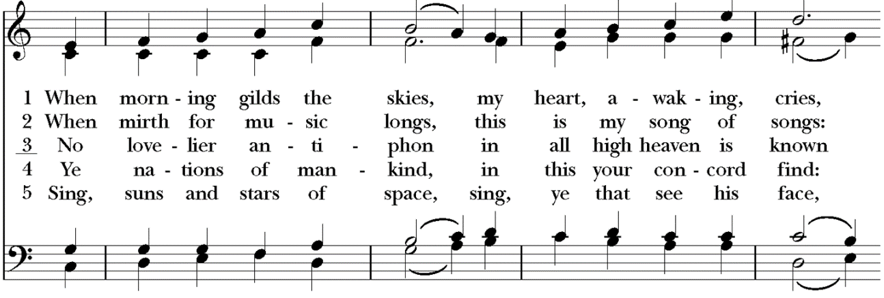
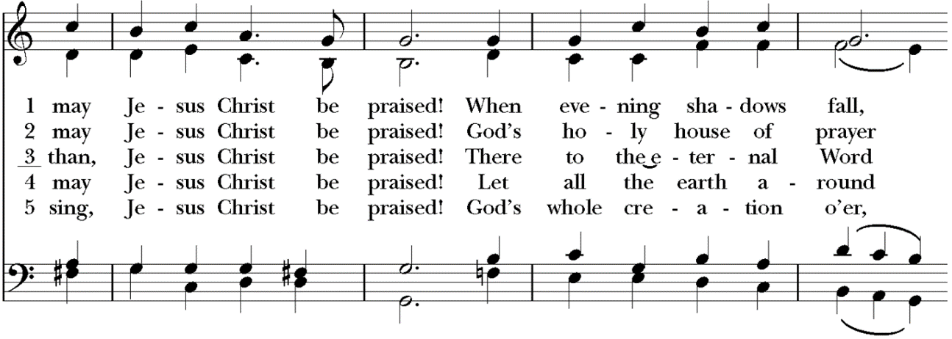
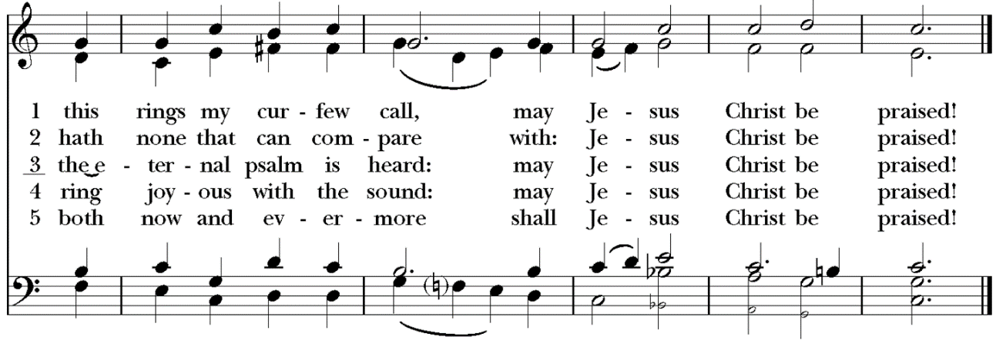
The Acclamation and Collect for Purity
The people remain standing
Celebrant Blessed be God, the Father, the Son and the Holy Spirit.
People And blessed be his kingdom, now and forever. Amen.

Almighty God, to you all hearts are open, all desires known, and from you no secrets are hid: Cleanse the thoughts of our hearts by the inspiration of your Holy Spirit, that we may perfectly love you, and worthily magnify your holy Name; through Christ our Lord. Amen.

The Summary of the Law
Jesus said: You shall love the Lord your God with all your heart and with all your soul and with all your mind. This is the great and first commandment. And a second is like it: You shall love your neighbor as yourself. On these two commandments depend all the Law and the Prophets.

The Gloria Glory to You
The people remain standing
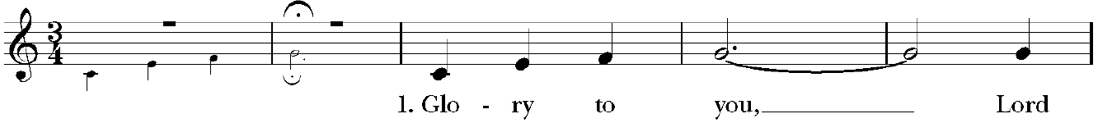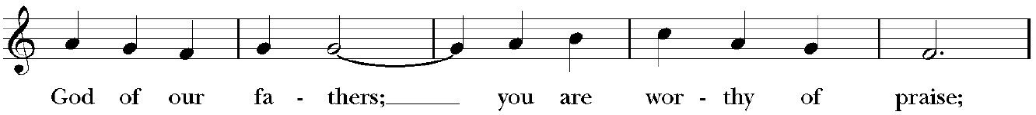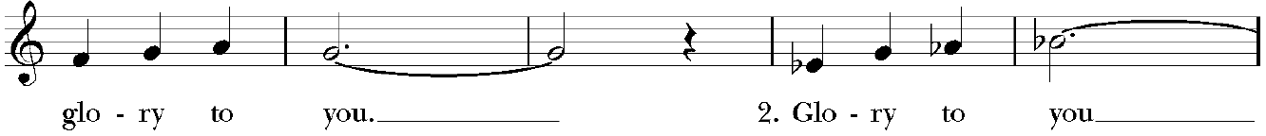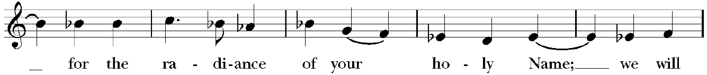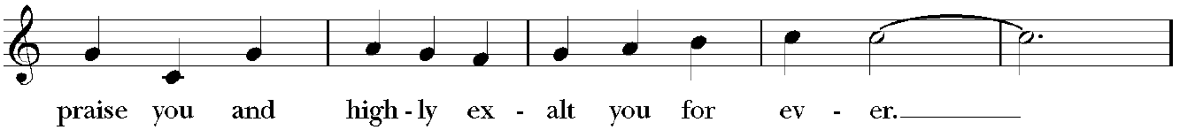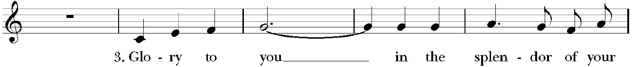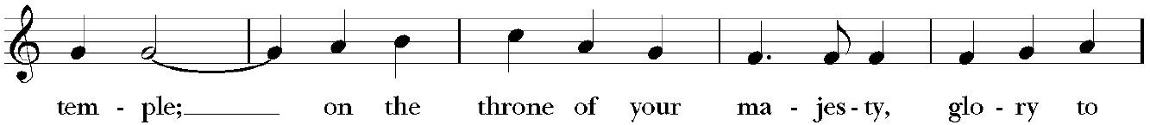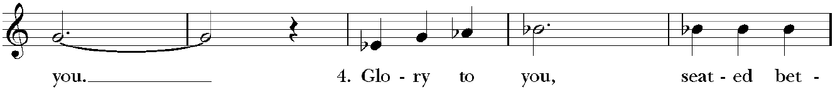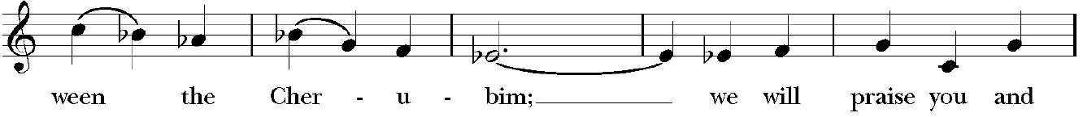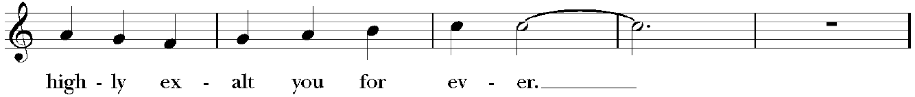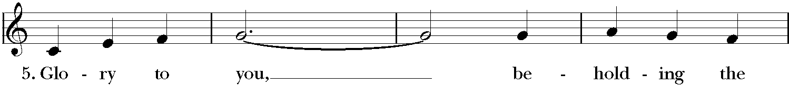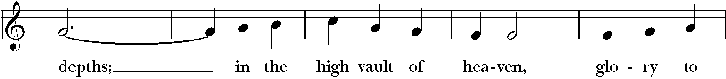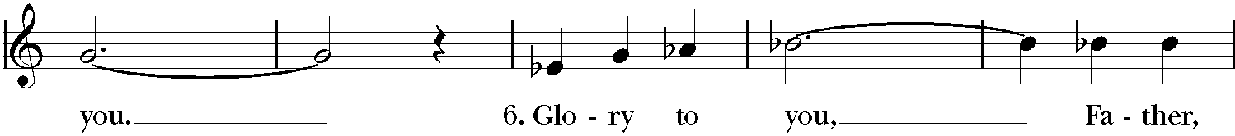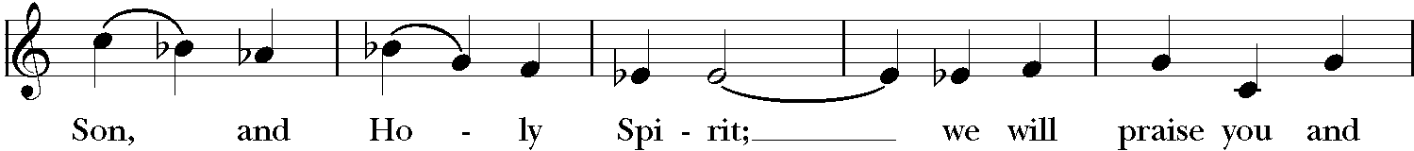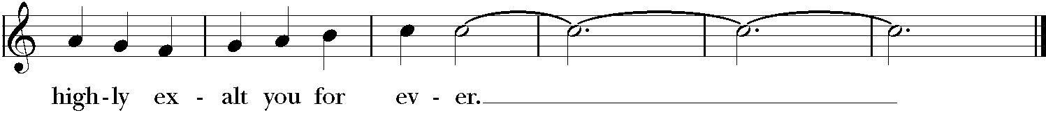

The Collect of the Day
Celebrant The Lord be with you.
People And with your spirit.
Celebrant Let us pray.

O Lord, you have taught us that without love, all our deeds are worth nothing: Send your Holy Spirit and pour into our hearts that most excellent gift of charity, the true bond of peace and of all virtues, without which whoever lives is counted dead before you; grant this for the sake of your Son Jesus Christ, who lives and reigns with you and the Holy Spirit, one God, for ever and ever. Amen.

The Ministry of the Word

The people may be seated for the readings

The First Lesson

Isaiah 64:1-8 Pew Bible pg. 623, LP pg. 740
Reader The Word of the Lord.
People Thanks be to God.

Psalm 54
The Second Lesson
Philippians 1:1-6 Pew Bible pg. 980, LP pg. 1164
Reader The Word of the Lord.
People Thanks be to God.

The Gradual Sing to God (Singh den Herrm) Taize/Berthier
The people stand and sing, facing the procession
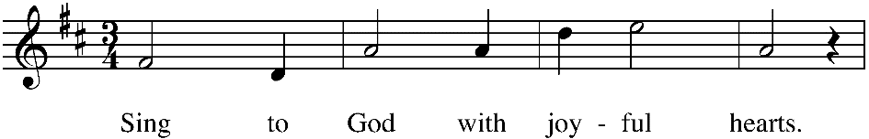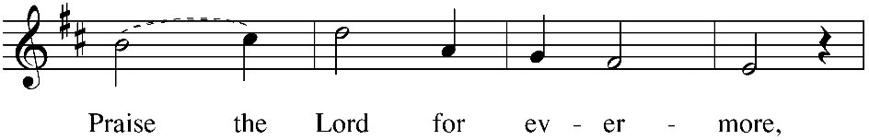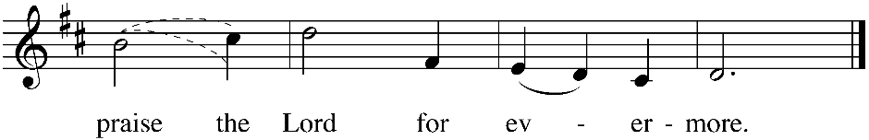

The Gospel
The people stand for the reading of the gospel

Celebrant The Holy Gospel of our Lord Jesus Christ according to St. Mark.
People Glory to You, Lord Christ.
Mark 9:30-37
Celebrant The Gospel of the Lord.
People Praise to you, Lord Christ.

The Sermon The Rev. Matt Kennedy

The Nicene Creed
The people stand, if able
Celebrant Let us confess our faith in the words of the Nicene Creed:
We believe in one God, the Father, the Almighty, maker of heaven and earth, of all that is, visible and invisible.

We believe in one Lord, Jesus Christ, the only-begotten Son of God, eternally begotten of the Father, God from God, Light from Light, true God from true God, begotten, not made, of one Being with the Father. Through him all things were made. For us and for our salvation he came down from heaven: was incarnate from the Holy Spirit and the Virgin Mary, and was made man.

For our sake he was crucified under Pontius Pilate; he suffered death and was buried. On the third day he rose again in accordance with the Scriptures; he ascended into heaven and is seated at the right hand of the Father. He will come again in glory to judge the living and the dead, and his kingdom will have no end. We believe in the Holy Spirit, the Lord, the giver of life, who proceeds from the Father and the Son. Who, with the Father and the Son, is worshiped and glorified, who has spoken through the Prophets.

We believe in one holy catholic and apostolic Church. We acknowledge one baptism for the forgiveness of sins. We look for the resurrection of the dead, and the life of the world to come. Amen.

The Prayers of the People
Let us pray for the Church and for the world, saying, “hear our prayer.”

For the peace of the whole world, and for the well-being and unity of the people of God.
Reader Lord, in your mercy:
People Hear our prayer.

For Foley Beach, Julian Dobbs and William Love, our Bishops, for Jerry and Ife, and for all the clergy and people of our Province, and diocese. We pray this morning for the Global Anglican Future Conference and its General Secretary, Archbishop Ben Kwashi and his wife, Gloria. In our diocese, we pray for All Souls Anglican Church in New Jersey; The Rev. Canon Henry Jansma and his wife Deacon Barbara Jansma; and for the Global Fellowship of Confessing Anglicans and GAFCON.

Reader Lord, in your mercy:
People Hear our prayer.

For all those who proclaim the Gospel at home and abroad; and for all who teach and disciple
others, especially for Tyler at New Covenant School, and for Carrie Moorhead-Nelson and her work with InterVarsity Campus Ministries.

Reader Lord, in your mercy:
People Hear our prayer.

For our brothers and sisters in Christ who are persecuted for their faith. We thank you for the safe recovery of a girl abducted by Boko Haram in Nigeria seven years ago, and pray for the remaining 83 Bethel students that are still missing.

Reader Lord, in your mercy:
People Hear our prayer.

For our nation, for those in authority, and for all in public service especially President Biden, Governor Hochul, Senator Akshar, and Mayor David.

Reader Lord, in your mercy:
People Hear our prayer.

For all those who are in trouble, sorrow, need, sickness, or any other adversity.

Reader Lord, in your mercy:
People Hear our prayer.

We bless your holy Name for all your servants who departed this life, praying you would grant us grace to follow their good examples, that with them we might partake in your heavenly kingdom.

I invite you to add your own additional prayers and thanksgivings at this time.

Heavenly Father, grant these our prayers for the sake of Jesus Christ, our only Mediator and Advocate, who lives and reigns with you in the unity of the Holy Spirit, one God, now and for ever. Amen.

The Confession of Sin
Celebrant Let us confess our sins against God and our neighbors.

The people kneel if able and pray together
Almighty God, Father of our Lord Jesus Christ, maker of all things, judge of all people: We acknowledge and bewail our manifold sins and wickedness, which we from time to time most grievously have committed, by thought, word, and deed, against your divine Majesty, provoking
most justly your wrath and indignation against us. We do earnestly repent, and are heartily sorry for these our misdoings; the remembrance of them is grievous unto us, the burden of them is intolerable. Have mercy upon us, have mercy upon us, most merciful Father; for your Son our Lord Jesus Christ’s sake, forgive us all that is past; and grant that we may ever hereafter serve and please you in newness of life, to the honor and glory of your Name; through Jesus Christ our Lord. Amen.

Celebrant stands and says
Almighty God, our heavenly Father, who in his great mercy has promised forgiveness of sins to all those who sincerely repent and with true faith turn to him, have mercy upon you, pardon and deliver you from all your sins, confirm and strengthen you in all goodness, and bring you to everlasting life; through Jesus Christ our Lord. Amen.

The Comfortable Words
The Celebrant says
Hear the Word of God to all who truly turn to him.
Come to me, all who labor and are heavy laden, and I will give you rest.
~Matthew 11:28
The Peace
Celebrant The peace of the Lord be always with you.
People And with your spirit.
Then the Celebrants and People may greet one another in the name of the Lord.

Announcements
All the announcements for this week are at the end of the bulletin. Please take a look!

Birthdays and Anniversaries

The Offertory Sentence
Celebrant Ascribe to the Lord the glory due his name; bring an offering, and come into his courts!

The Offertory Now Thank We All our God
The people stand, if able, and sing
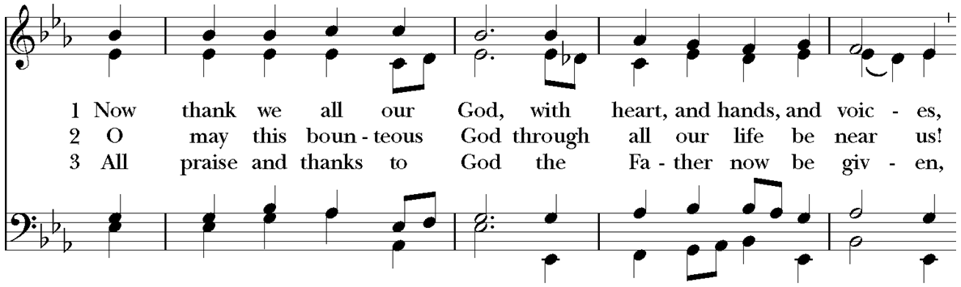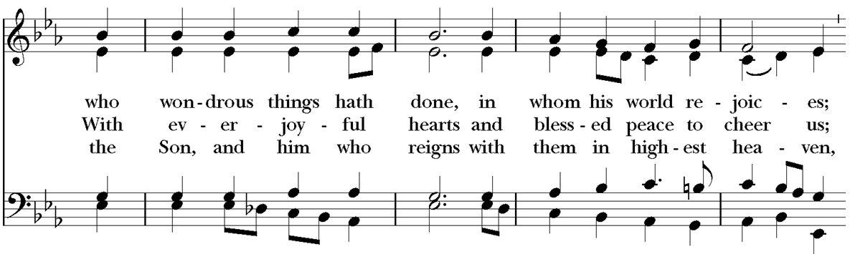
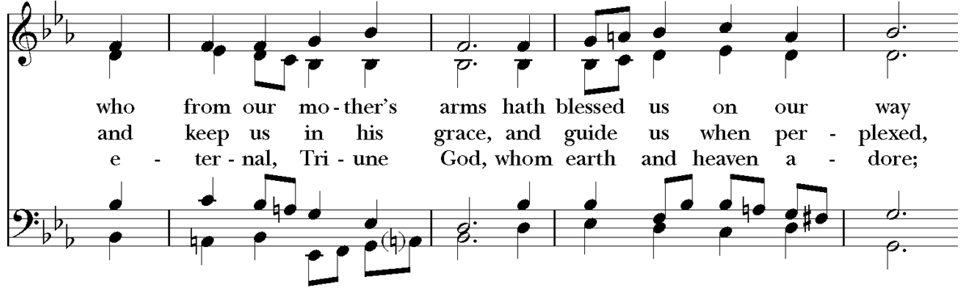
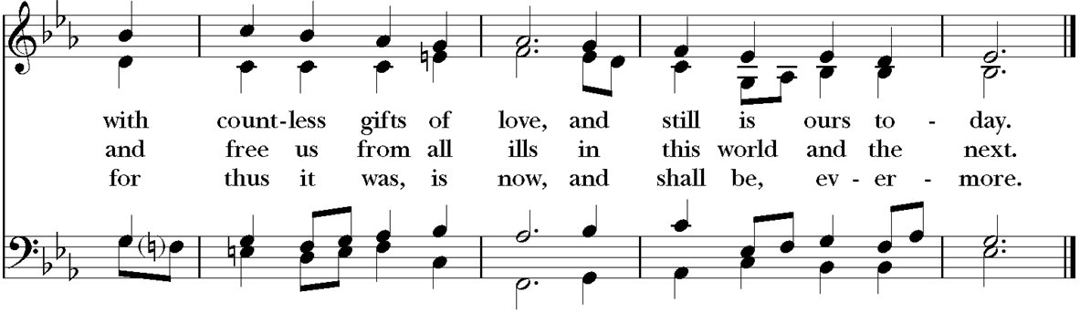

If you are a guest with us today, please do not feel obligated to give an offering. If you are a regular attender at Good Shepherd, you may give your tithe in several ways. An offering plate will be passed and you are welcome to give your offering there. There is also an offering box at the rear of the sanctuary where you may drop your tithe, or you can mail checks to 360 Conklin Avenue, Binghamton, NY, 13903. You can also give online through Breeze or you can text a donation through Breeze at 607-882-6551. Good Shepherd also has a PayPal account. If you choose to give via PayPal you can avoid fees by paying directly from your bank. Be sure to uncheck the box that says, "paying for goods and services" at the bottom or paypal will charge Good Shepherd a fee. As always, thank you for your great generosity and kind support.

The Presentation of the Gifts
The people stand, and sing if able

The Great Thanksgiving
Celebrant The Lord be with you.
People And with your spirit.
Celebrant Lift up your hearts.
People We lift them to the Lord.
Celebrant Let us give thanks to the Lord our God.
People It is just and right so to do.

Then, facing the Holy Table, the Celebrant proceeds
It is right, and a good and joyful thing, always and everywhere to give thanks to you, Father Almighty, Creator of heaven and earth. Through Jesus Christ our Lord, who on the first day of the week overcame death and the grave, and by his glorious resurrection opened to us the way of everlasting life. Therefore we praise you, joining our voices with Angels and Archangels and with all the company of heaven, who for ever sing this hymn to proclaim the glory of your Name:

The Sanctus Holy, Holy Maher, Le and Ndolo
The people remain standing and sing
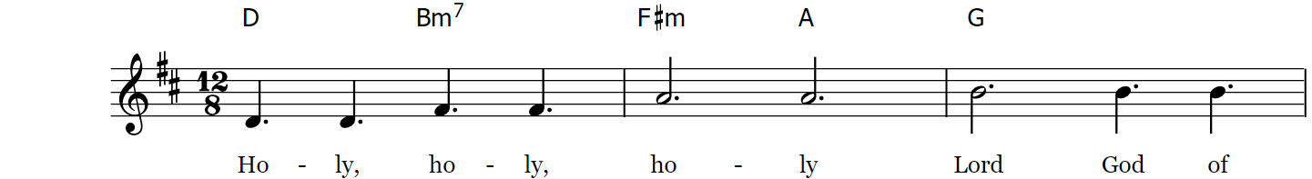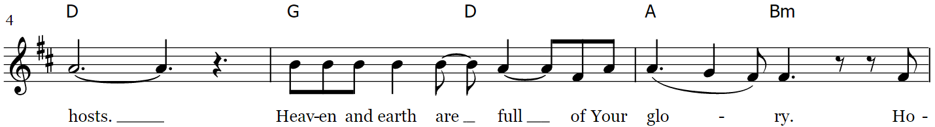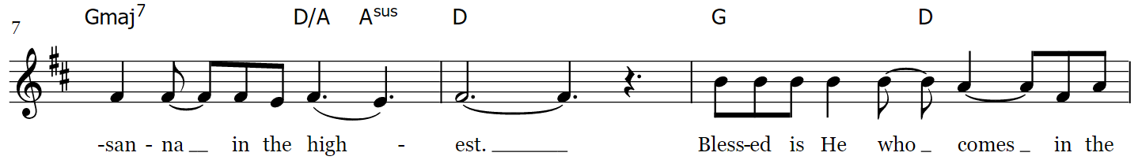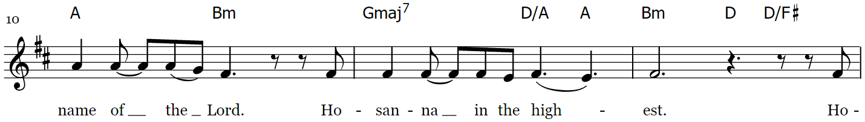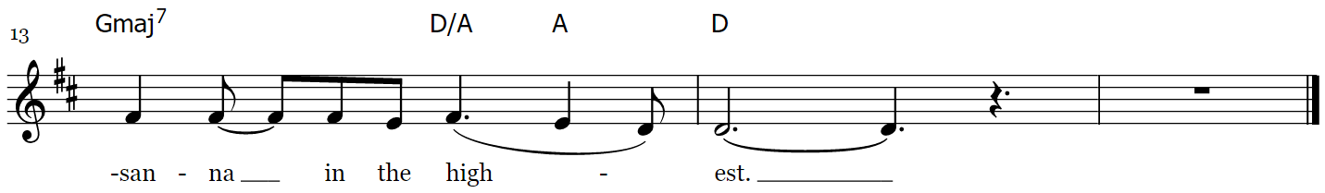

The Prayer of Consecration
The people kneel. The Celebrant continues
All praise and glory is yours, God our heavenly Father, because of your tender mercy, you gave your only Son Jesus Christ to suffer death upon the cross for our redemption; who made there, by his one oblation of himself once offered, a full, perfect, and sufficient sacrifice, oblation, and satisfaction, for the sins of the whole world; and instituted, and in his Holy Gospel commanded us to continue a perpetual memory of his precious death and sacrifice, until his coming again.

And now, O merciful Father; in your great goodness, we ask you to bless and sanctify, with your Word and Holy Spirit, these gifts of bread and wine, that we, receiving them according to your Son our Savior Jesus Christ’s holy institution, in remembrance of his death and passion, may be partakers of his most blessed Body and Blood.

On the night that he was betrayed, our Lord Jesus Christ took bread; and when he had given thanks, he broke it, and gave it to his disciples, saying, “Take, eat; this is my Body which is given for you: Do this in remembrance of me.” Likewise, after supper, Jesus took the cup, and when he had given thanks, he gave it to them, saying, “Drink this, all of you; for this is my Blood of the New Covenant, which is shed for you, and for many, for the forgiveness of sins: Whenever you drink it, do this in remembrance of me.” Therefore we proclaim the mystery of faith

Celebrant and People sing together

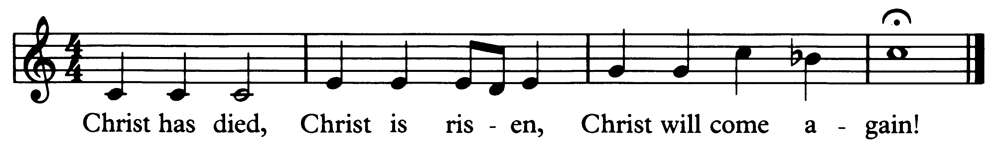

And here we offer and present to you, O Lord, ourselves, our souls and bodies, to be a reasonable, holy, and living sacrifice; humbly pleading that all those who shall partake of this Holy Communion may worthily receive the most precious Body and Blood of your Son Jesus Christ; that, by the Holy Spirit, we may be filled with your grace and heavenly benediction, and made one body with him, so that he may dwell in us, and we in him. By him, and with him, and in him, in the unity of the Holy Spirit, all honor and glory is yours, Almighty Father, now and forever.
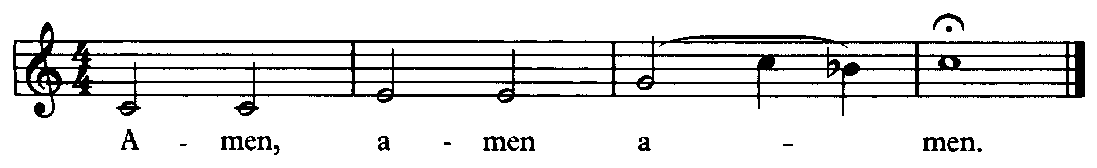
And now, as our Savior Christ has taught us, we are bold to pray:

The Lord’s Prayer Osgood
The people remain kneeling, and sing
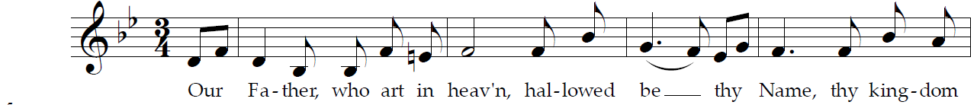

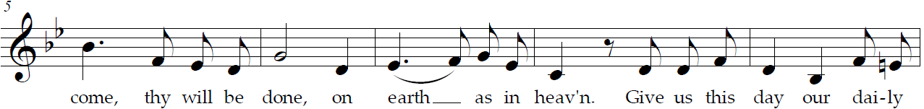
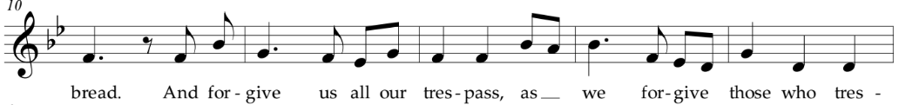
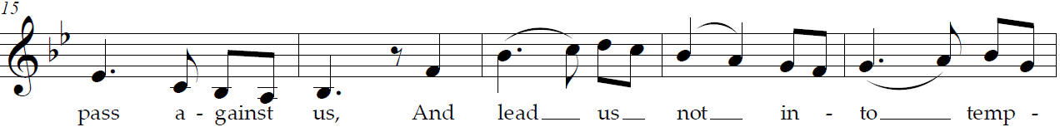
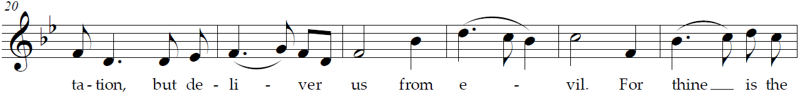
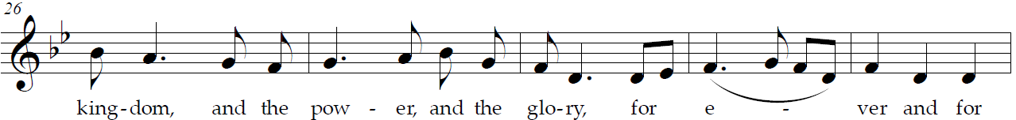
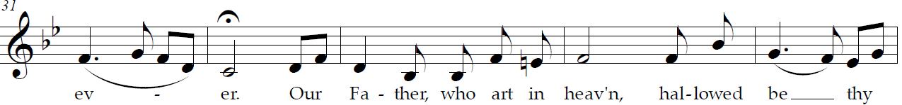
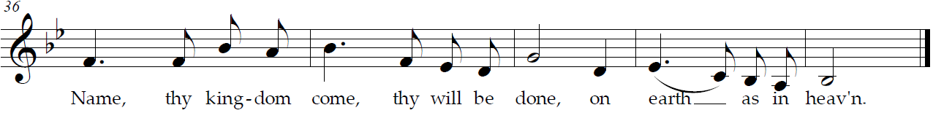

The Fraction
The people remain kneeling and say
Celebrant Alleluia. Christ our Passover Lamb has been sacrificed, once for all upon the Cross.

People Therefore let us keep the feast. Alleluia.

The Prayer of Humble Access
Celebrant and people say together
We do not presume to come to this your Table,
O merciful Lord, trusting in our own righteousness,
but in your manifold and great mercies.
We are not worthy so much as to gather up the crumbs under your Table.
But you are the same Lord whose property is always to have mercy.
Grant us, therefore, gracious Lord,
so to eat the flesh of your dear Son Jesus Christ,
and to drink his blood, that we may evermore dwell in him, and he in us. Amen.

The Agnus Dei Lamb of God Mahar, Ndolo, Le
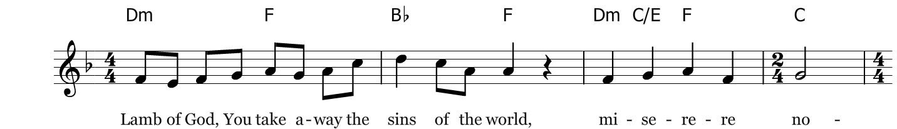
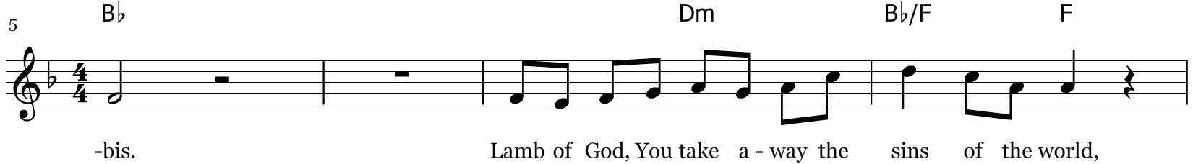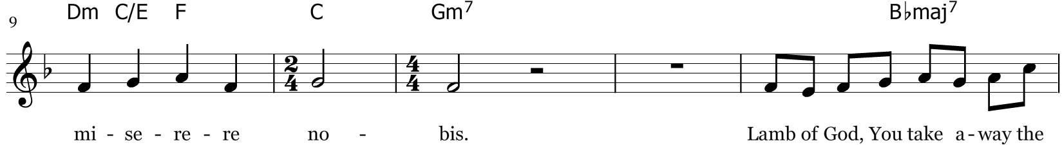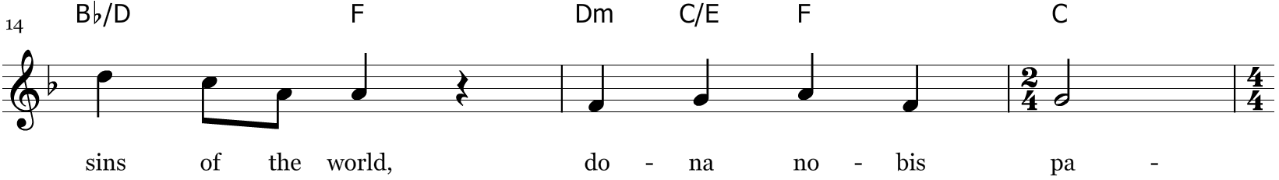
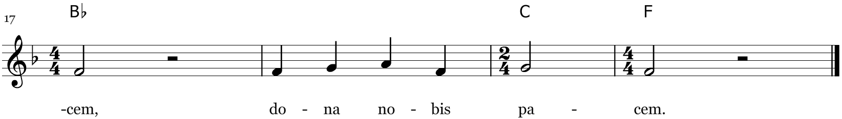*miserere nobis=have mercy on us *dona nobis pacem = grant us peace

The Communion of the People
All Christians baptized in any denomination and in good standing with their home church are welcome to take Communion. If you are unable to take communion for any reason, you are warmly invited to the rail for a prayer and blessing: just place your hands across your chest and one of the pastors will bless and pray for you. If you are in a wheelchair or are unable to come forward for any reason, please let an usher know and we will bring the Sacrament to you in your pew. Gluten free wafers are available upon request when you come forward.

The Invitation
Celebrant
The Gifts of God for the people of God. Take them in remembrance that Christ died for you, and feed on him in your hearts, by faith, with thanksgiving.

Communion Music One Church
The people sing
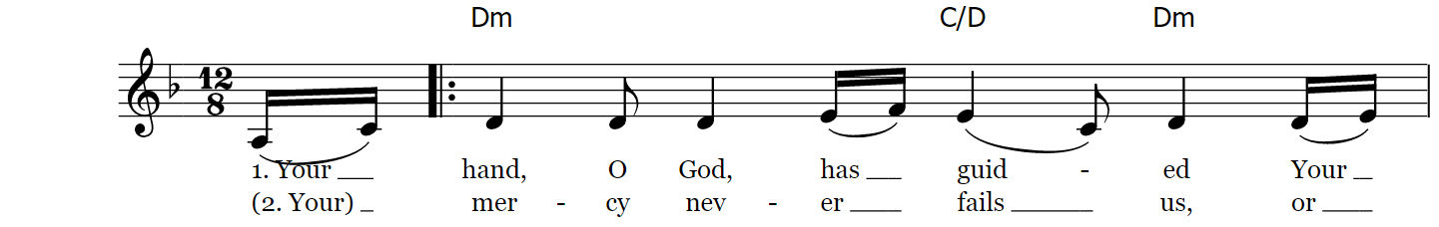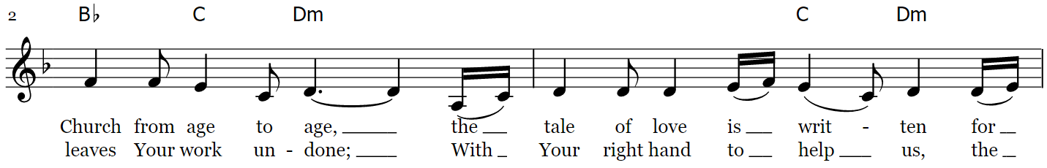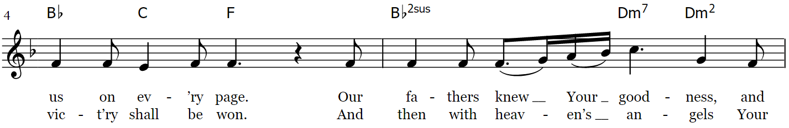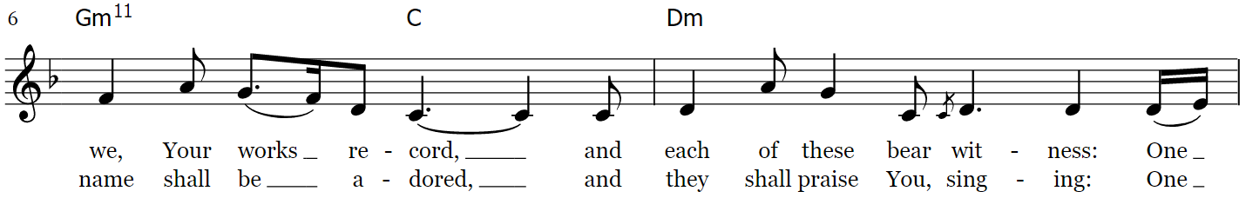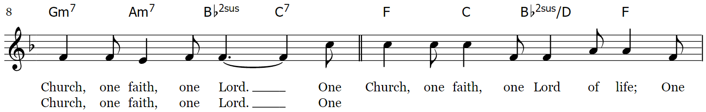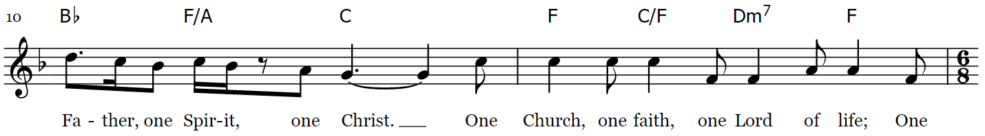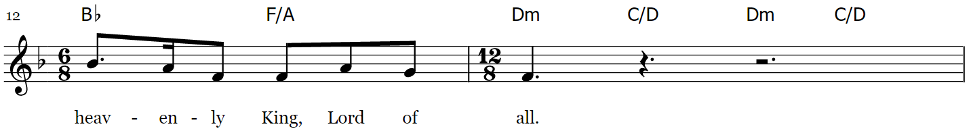
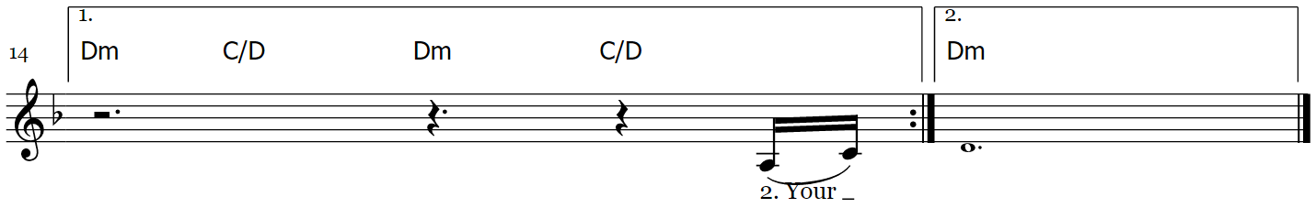

The Post Communion Prayer
Almighty and ever-living God, we thank you for feeding us, in these holy mysteries, with the spiritual food of the most precious Body and Blood of your Son our Savior Jesus Christ; and for assuring us, through this Sacrament, of your favor and goodness towards us; and that we are true members of the mystical body of your Son, the blessed company of all faithful people; and are also heirs, through hope, of your everlasting kingdom. And we humbly ask you, heavenly Father,
to assist us with your grace, that we may continue in that holy fellowship, and do all such good works as you have prepared for us to walk in; through Jesus Christ our Lord, to whom with you and the Holy Spirit, be all honor and glory, now and forever. Amen.

The Blessing
Celebrant
The peace of God, which passes all understanding, keep your hearts and minds in the knowledge and love of God, and of his Son Jesus Christ our Lord; and the blessing of God Almighty, the Father, the Son, and the Holy Spirit, be among you, and remain with you always. Amen.

The Hymn in Recession My Hope is Built on Nothing Less
The people stand if able, and sing

The Dismissal
Celebrant Let us go forth, rejoicing in the power of the Holy Spirit. Alleluia, alleluia.
People Thanks be to God. Alleluia, alleluia.

Postlude Prelude, Fugue and Chicone in C Dietrich Buxtehude

Thank you for worshiping at Anglican Church of The Good Shepherd this morning!

Did you have trouble reading the bulletin this morning? Large Print copies are available upon request. Please contact the office for more information.

We would be so grateful if you would deposit your used bulletins in one of the recycling bins located near the exits of the sanctuary or parish hall as you pass by.

Weekly Update, September 19, 2021
Ongoing Ministries
Zoom Morning Prayer resumed on Tuesday, September 7 at 7am. Watch for a zoom link! It will run the way it did before the summer hiatus:
Monday-Friday
7am-7:40am
Dailyoffice2019.com
Good Shepherd Youth Group Good Shepherd Youth Group exists to equip students to "grow in the grace and knowledge of our Lord and Savior Jesus Christ," (2 Peter 3:18).

The youth meet on Sunday nights from 6:00 - 7:30 PM at Good Shepherd, and all youth between the ages of 12-18 are welcome to join. Please contact Jonathan Groves if you’d like to be involved in any way. Email: jg.arrowhead@gmail.com.

Tuesday Morning Bible Study meets at 9:05am in the Parish Hall. Matt Kennedy works through different books of the bible, verse by verse. This class can be viewed in person or online each week by livestream. For more information, please contact the church office.

Good Shepherd Member Food Pantry has food available. Please contact a member of the staff or the church office if you need access to the pantry.

Mission Groups Mission Groups exist to bring glory to God as we help each other become more like Christ for the sake of His kingdom and church. If you are looking for a way to get involved, grow in community, and deepen your understanding of God's word, Mission Groups are for you.

Locations and times will be posted soon. Please contact Jonathan Groves if you would like to participate in a group.

Christian Education for All is normally at 9:15am on Sunday Morning. Adult Education is continuing online and in person at that hour in the parish hall.

The current series is being taught by Matt Kennedy on the Christian Classics. We are studying the 39 Articles of Religion.

Modified Catechesis of the Good Shepherd has resumed meeting during the regular Christian Ed time at 9:15.

Friday Morning Men’s Bible Study A group of men gather at 6:30am to read the bible pray together. Men of any age are welcome to attend. This study is currently meeting online and in person. Email or text Matt, Jonathan Groves, or contact the church office for more information.

Thursday Evening Bible Study is currently on hiatus but will probably resume this fall. This is a great place to connect with others and learn more about what God has to say to us through his word.

Shepherd’s Bowl Community Dinner
Good Shepherd offers a free dinner to the people of Good Shepherd and the wider community on Thursday evenings from 5:30-6. If you are able, this is a great time to get to know others while enjoying a free and delicious meal.

Week at a Glance Schedule, September 19, 2021—September 26, 2021
Please Pray For…
ACNA Cycle of Prayer: The Global Anglican Future Conference and its General Secretary, Archbishop Ben Kwashi and his wife, Gloria.
Anglican Diocese of the Living Word: All Souls Anglican Church Cherry Hill, New Jersey, The Rev. Canon Henry Jansma and his wife Deacon Barbara Jansma, and for the Global Fellowship of Confessing Anglicans and GAFCON.
For the Homebound Betty Cancellieri, Charles Mabula
For the Sick Peyton, Rick, Jason D., Doug & Maureen, Charles, Russ, Bill, Bob, Evelyn Martin, Kathy, Fred, Andrew, Larry Dimmick, Chris, Jessica & Taylor John, Sherry and Rob.
Missionaries Pray for Carrie Moorhead-Nelson and her work with InterVarsity Campus Ministries.
Sunday
8:00am | Service of Holy Eucharist, no  music
9:15am | Christian Ed for adults and  children (online observance available)
10:30am | Service of Holy Eucharist (online observance available)

Tuesday
9:05am |  |  | Tuesday Morning Bible Study

Wednesday
5:30pm | Children’s Choir practice
6:00pm | Adult Choir practice

Thursday
5:30pm | Shepherd’s Bowl Community  Dinner
6:00pm | Beginner’s Bible Study

Serving at Good Shepherd Sept. 19, 2021
8am Celebrant: Matthew Kennedy
Reader (8:00): Pastoral Assistant
Usher (8:00): Terry Ray
Usher (10:30): Chris Jones
Crucifer: Patrick Carlton
Acolytes: Jonah and Seth Carlton
Reader (10:30): Pastoral Assistant
Altar: Helen Cetton
Shepherd’s Bowl: Martha Rice with Team 3
Tellers: Helen Cetton and Scott Pineau

Friday
6:30am | Men’s Breakfast and Bible Study
3:00pm | Open Play (children of all ages)
4:30pm | Ladies Bible Study

Sunday
8:00am | Service of Holy Eucharist, no music
9:15am | Christian Ed for adults and children (online observance available)
10:30am | Service of Holy Eucharist (online observance available)
6:00-7:30pm | Youth Group

Serving at Good Shepherd Sept. 26, 2021
8am Celebrant: Matthew Kennedy
Reader (8:00): Terry Ray
Usher (8:00): Terry Ray
Usher (10:30): Scott Pineau
Reader (10:30): Kcaarin Pineau
Altar: Karen Carlton
Shepherd’s Bowl: Substitute Team
Tellers: Helen Cetton and Chris Jones

What’s Going on at Good Shepherd…
Acolyte Practice Jon is running an Acolyte Practice for all acolytes (both crucifers and tapers) after the 10:30 service on September 19. If you are interested in being an acolyte, contact Jon, or come straight to the practice.
Daily Lectionary
Morning | Evening
Monday, September 20
Psalm 52, 53, 54  1 Kings 11  Heb 10:1-18 | Psalm 55  Hag 2  Matt 15:1-28
Tuesday, September 21
Psalm 56, 57  Heb 10:19-end  Matt 9:9-13 | Psalm 58, 60  Zech 1  Matt 15:29—16:12
Wednesday, September 22
Psalm 59  1 Kings 12  Heb 11 | Psalm 63, 64  Zech 2  Matt 16:13-end
Thursday, September 23
Psalm 61, 62  1 Kings 13  Heb 12:1-17 | Psalm 65, 67  Zech 3  Matt 17:1-23
Friday, September 24
Psalm 68:1-18  1 Kings 14  Heb 12:18-end | Psalm 68:19-36  Zech 4  Matt 17:24—18:14
Saturday, September 25
Psalm 69:1-18v  2 Chron 12  Heb 13 | Psalm 69:19-38v  Zech 5  Matt 18:15-end
Sunday, September 26
Psalm 66  2 Chron 13  Jas 1 | Psalm 70, 72  Zech 6  Matt 19:1-15

Choir Practice The choir is reconvening!
Please contact Michael if you’re in the choir about the times, and if you’re interested in joining.

Women’s Bible Study is coming back at a new time. We’re going to try out Friday afternoons—4:30 pm in the Parish Hall. Anne is going to lead and she’s leaning toward starting with 1 Peter. Children are welcome—as in, she hopes to have some childcare available. If you’d like to come a little bit early to hang out for Friday Play (all the children play while their mother’s talk to each other), let Anne know (607-766-8143).

Large Print Bulletins are available upon request for both services. If you need a large print bulletin, please contact the office before next Sunday’s services.

Happy Birthday!
September 19 Pauline King
September 19 Molly & Annabeth Hull

Happy Anniversary!
September 20 Eric and Laura Radman
September 25 The consecration of Bp. Dobbs

Anticipated giving for 2021 $287,681.66
Anticipated YTD Giving $208,688.48
Actual YTD Giving $165,704.62

Acknowledgments
Cover Image
“Christ and Child” by Carl Bloch (1834-1890)
This is a faithful photographic reproduction of a two-dimensional, public domain work of art. The work of art itself is in the public domain for the following reason:
This work is in the public domain in its country of origin and other countries and areas where the copyright term is the author's life plus 100 years or fewer.
US Public Domain Tag: {{PD-US-expired}}
It can be viewed at this address:
<https://commons.wikimedia.org/wiki/File:Carl_Bloch_-_Christ_and_Child_(crop).jpg>

Scripture and Liturgy
All Liturgy is from The Book of Common Prayer and Administration of the Sacraments with Other Rites and Ceremonies of the Church according to the use of the Anglican Church in North America (2019) together with The New Coverdale Psalter (A.D.2013.). With the exception of the New Coverdale Psalter, the content of the Book of Common Prayer (2019) is not under copyright, and all not-for-profit reproduction of the content by churches and non-profit organizations is permitted. The New Coverdale Psalter is copyright © 2019 by the Anglican Church in North America, but this is not intended to discourage the use and duplication of the text by churches for purposes of worship. Quotations of Scripture normally follow The Holy Bible, English Standard Version (ESV®) except for the Psalms, Canticles, and citations marked with the symbol ( t ) which indicates traditional prayer book language. The Holy Bible, English Standard Version® is copyright © 2016 by Crossway, a publishing ministry of Good News Publishers, and is used by permission. All rights reserved.

Music
Hymns: All hymns below are reprinted from The Hymnal, 1982 and The Hymnal 1982, Service Music, © 1985 by The Church Pension Fund. Used by permission. All rights reserved.

Prelude: “Adagio in a minor” Johann Sebastian Bach
Processional: “When Morning Guilds the Skies” Words: German, ca. 1800; tr. Robert Seymour Bridges (1844-1930), alt.
Music: Laudes Domini, Joseph Barnby (1838-1896)
Gloria: “Glory to You” Music by John Rutter © 1985 Oxford University Press Permission to reprint, broadcast and/or stream this music obtained from OneLicense with License # A-724677. All rights reserved.
Gradual: “Sing to God (Singt den Herrn)” Taize/Berthier Text: Psalm 96:2, 97:6, 98:1-8; Music: Jacques Berthier, 1923-1994 © 1998, Les Presses de Taizé, GIA Publications, Inc., agent; Permission to reprint, broadcast, and/or stream this music obtained from OneLicense with License # A-724677. All rights reserved.
Psalm: "Psalm 54" Text: Renewed Coverdale Psalter prepared for the Book of Common Prayer, 2019; Music: William Croft (1678-1727) Public Domain
Offertory: “Now Thank We All our God” Words: Martin Rinkart (1586-1649); tr. Catherine Winkworth (1827-1878), alt. Music: Nun danket alle Gott, melody Johann Cruger (1598-1662); harm. William Henry Monk (1823-1889), after Felix Mendelssohn (1809-1947)
Doxology: “Praise God from Whom All Blessings Flow” "Praise God from whom all blessings flow" Words: Public Domain, written in 1674 by Thomas Ken, (1637-1711) Music: Old 100th, melody from Pseaumes octante trois de David, 1551, alt.; harm. after Louis Bourgeois (1510?-1561?)

Sanctus: “Holy, Holy” CCLI Song # 6127240 Ike Ndolo | Matt Maher | Tam Le © 2011 Thankyou Music (Admin.
by Capitol CMG Publishing) Valley Of Songs Music (Admin. by Capitol CMG Publishing) Worship Together Music (Admin. by Capitol CMG Publishing) Remaining portion is unaffiliated For use solely with the SongSelect® Terms of Use. All rights reserved. www.ccli.com CCLI License # 3237915
Memorial Acclamation: “Memorial Acclamation” Elise Eslinger, © 1989 The United Methodist Publishing House
The Great Amen: “The Holy Eucharist, Amen” Elise Eslinger, © 1989 The United Methodist Publishing House
The Lord’s Prayer: “The Lord’s Prayer” Music by Curt Osgood. All rights reserved. Used with permission.
Agnus Dei: “Lamb of God” CCLI Song # 6127367 Ike Ndolo | Matt Maher | Tam Le © 2011 Thankyou Music (Admin. by Capitol CMG Publishing) Valley Of Songs Music (Admin. by Capitol CMG Publishing) Worship Together Music (Admin. by Capitol CMG Publishing) Remaining portion is unaffiliated For use solely with the SongSelect® Terms of Use. All rights reserved. www.ccli.com CCLI License # 3237915
Communion: “One Church” CCLI Song # 3336979 Edward Hayes Plumptre | Keith Getty © 2001 Thankyou Music (Admin. by Capitol CMG Publishing) For use solely with the SongSelect Terms of Use. All rights reserved. www.ccli.com CCLI License # 3237915
Recessional: “My Hope is Built” Text: Edward Mote, 1787-1874, alt; tune: MELITA, John B. Dykes, 1823-1876; public domain
Postlude: “Prelude, Fugue and Chicone in C” Dietrich Buxtehude

