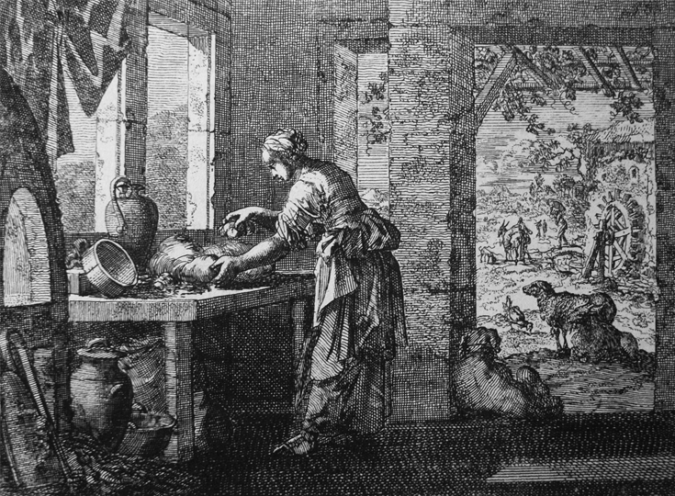
Knowing Christ and Making Him Known
Rooted in the Word, Nourished by the Sacraments, Alive in Jesus Christ
The Church of the Good Shepherd
July 23, 2017 – The Seventh Sunday after Pentecost
10:30am Service
http://www.goodshepherdbinghamton.org
Welcome to Anglican Church of the Good Shepherd! We're delighted to worship God with you this morning. Everything you need for worship is here in these pages and in the Bible in the pew. If you're visiting and would like more information about Good Shepherd, please fill out a guest card from the rack in front of you or call the parish office (723-8032). At Good Shepherd you’ll find friendly people, engaging sermons, joyful worship, practical teaching, and lots of kids. You are warmly invited to Coffee Hour downstairs immediately following both morning services. Welcome!
A Service of Daily Morning Prayer
July 23, 2017 – The Seventh Sunday after Pentecost

Come People of the Risen King Getty|Townend
The people stand, if able, and sing
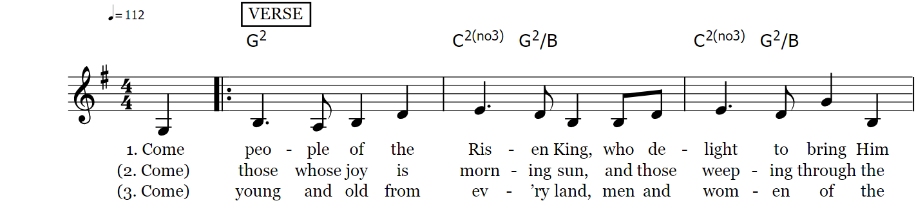
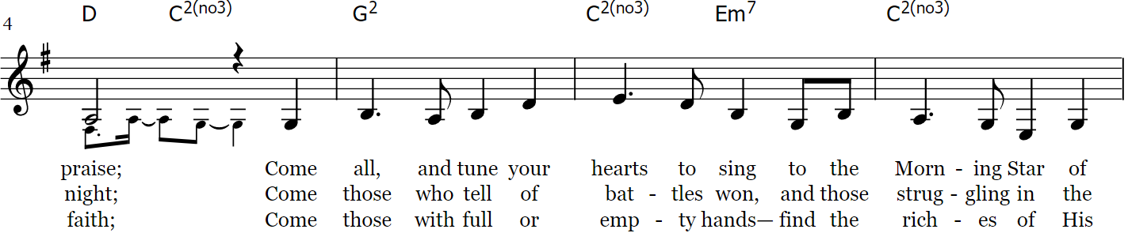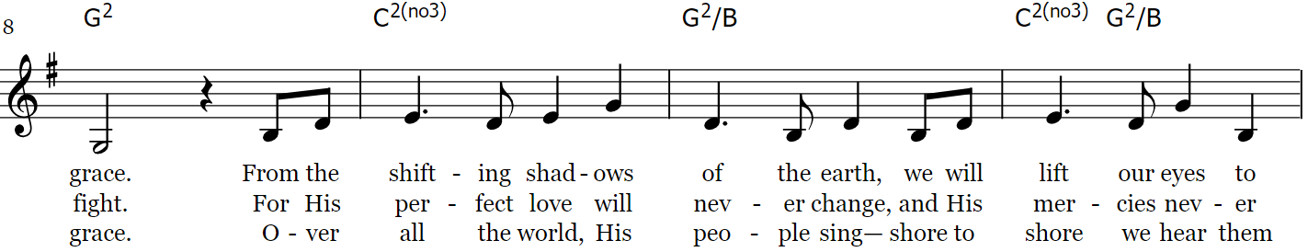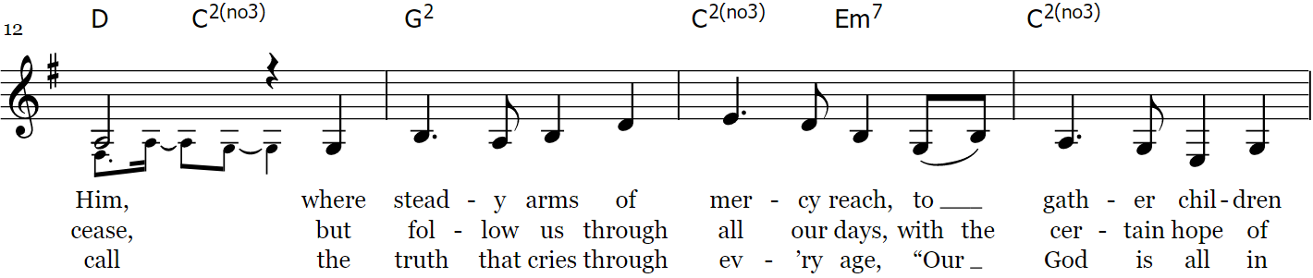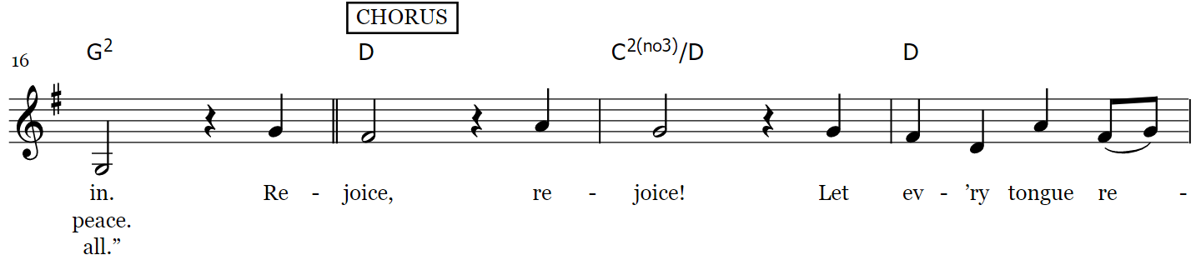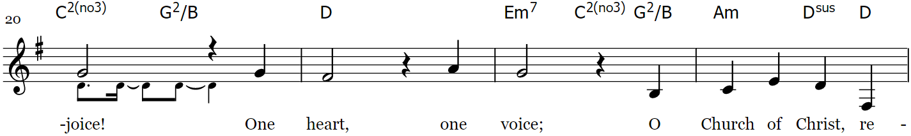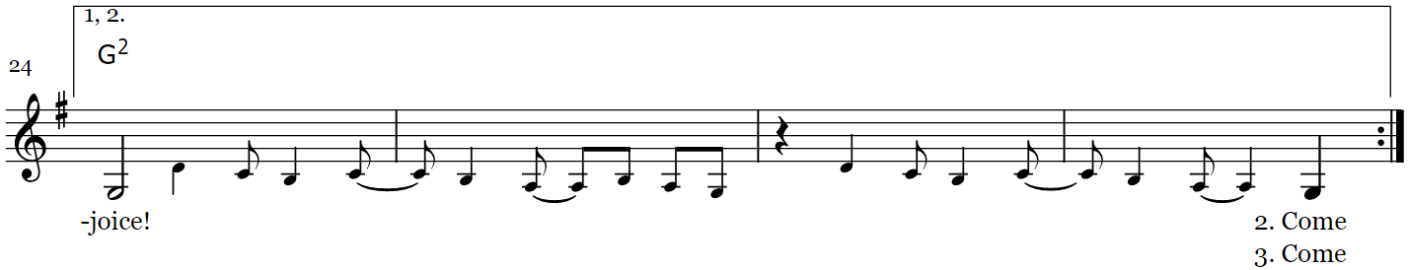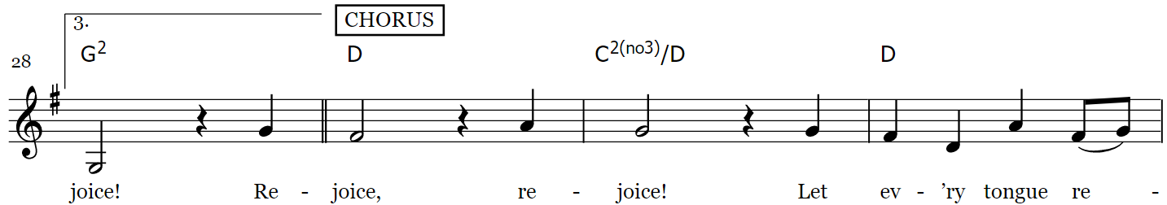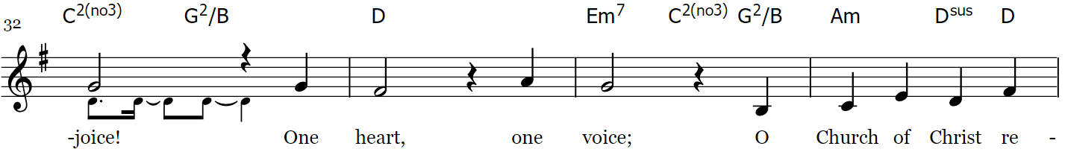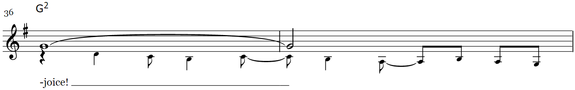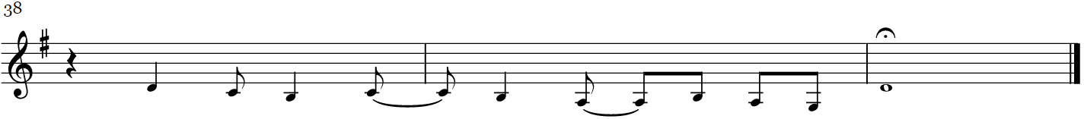

Officiant Send out your light and your truth; let them lead me; let them bring me to your holy hill and to your dwelling!
Psalm 43:3

Confession of Sin
The Officiant says to the People
Dearly beloved, the Scriptures teach us to acknowledge our many sins and offenses, not concealing them from our heavenly Father, but confessing them with humble and obedient hearts that we may obtain forgiveness by his infinite goodness and mercy. We ought at all times humbly to acknowledge our sins before Almighty God, but especially when we come together in his presence to give thanks for the great benefits we have received at his hands, to declare his most worthy praise, to hear his holy Word, and to ask, for ourselves and others, those things necessary for our life and our salvation. Therefore, come with me to the throne of heavenly grace.

Silence is kept. All kneeling, the Officiant and People say
Almighty and most merciful Father, we have erred and strayed from your ways like lost sheep.
we have followed too much the deceits and desires of our own hearts. We have offended against your holy laws. We have left undone those things which we ought to have done, and we have done those things which we ought not to have done; and apart from your grace, there is no health in us.
O Lord, have mercy upon us. Spare those who confess their faults. Restore those who are penitent, according to your promises declared to all people in Christ Jesus our Lord;
And grant, O most merciful Father, for his sake, that we may now live a godly, righteous, and sober life, to the glory of your holy Name. Amen.

Officiant
Grant your faithful people, merciful Lord, pardon and peace; that we may be cleansed from all our sins, and serve you with a quiet mind; through Jesus Christ our Lord. Amen.

The Invitatory
All stand.
Officiant O Lord, open our lips;
People And our mouth shall proclaim your praise.
Officiant O God, make speed to save us;
People O Lord, make haste to help us.
Officiant Glory to the Father, and to the Son, and to the Holy Spirit;
People As it was in the beginning, is now, and ever shall be, world without end. Amen.
Officiant Praise the Lord.
People The Lord’s name be praised.

Officiant Worship the Lord in the beauty of holiness: O Come let us adore him.

Venite O Come Psalm 95:1-7; 8-11
Officiant and People say together
O come, let us sing to the Lord;
Let us make a joyful noise to the rock of our salvation!
Let us come into his presence with thanksgiving;
Let us make a joyful noise to him with songs of praise!
For the Lord is a great God, and a great King above all gods.
In his hand are the depths of the earth;
the heights of the mountains are his also.
The sea is his, for he made it,
and his hands formed the dry land.
O come, let us worship and bow down;
Let us kneel before the Lord, our Maker!
For he is our God, and we are the people of his pasture,
and the sheep of his hand.
O, that today you would hearken to his voice!

Officiant Worship the Lord in the beauty of holiness: O Come let us adore him.

The Psalm Appointed Psalm 119:121-136
The people sit for the psalm and the readings
₁₂₁ I have done what is just and right; *
do not deliver me to my oppressors.
₁₂₂ Be surety for your servant's good; *
let not the proud oppress me.
₁₂₃ My eyes have failed from watching for your salvation *
and for your righteous promise.
₁₂₄ Deal with your servant according to your loving-kindness *
and teach me your statutes.
₁₂₅ I am your servant; grant me understanding, *
that I may know your decrees.
₁₂₆ It is time for you to act, O LORD, *
for they have broken your law.
₁₂₇ Truly, I love your commandments *
more than gold and precious stones.
₁₂₈ I hold all your commandments to be right for me; *
all paths of falsehood I abhor.
₁₂₉ Your decrees are wonderful; *
therefore I obey them with all my heart.
₁₃₀ When your word goes forth it gives light; *
it gives understanding to the simple.
₁₃₁ I open my mouth and pant; *
I long for your commandments.
₁₃₂ Turn to me in mercy, *
as you always do to those who love your Name.
₁₃₃ Steady my footsteps in your word; *
let no iniquity have dominion over me.
₁₃₄ Rescue me from those who oppress me, *
and I will keep your commandments.
₁₃₅ Let your countenance shine upon your servant *
and teach me your statutes.
₁₃₆ My eyes shed streams of tears, *
because people do not keep your law.

Glory to the Father, and to the Son, and to the Holy Spirit; as it was in the beginning, is now, and ever shall be, world without end. Amen.

The Lessons
1 Kings 13 Pew Bible pg. 294, LP Bible pg. 373
Reader The Word of the Lord.
People Thanks be to God.

The Gloria Glory Be To God Maher|Minter|Townend
To You we bring our hymn of praise, Glory be to God
Hearts and hands together raised, Glory be to God
Who spoke before the dawn of time, Glory be to God
Veil of darkness torn by light, Glory be to God
And with unceasing voice all heaven sings, Glory be to God
The anthem of the Lord’s redeemed, Glory be to God.
Father Spirit risen Son, Glory be to God
Who was and is and is to come, Glory be to God
And all Your children cry with loud acclaim, Glory be to God
Sing O church Your sweet refrain, Glory be to God
Glory glory glory glory forever and ever
Glory glory glory glory forever and ever.

Galatians 1:1-10 Pew Bible pg. 972, LP Bible pg. 1235
Reader The Word of the Lord.
People Thanks be to God.

Te Deum Laudamus We Praise You, O God
Officiant and People say together
We praise you, O God,
we acclaim you as Lord;
all creation worships you,
the Father everlasting.
To you all angels, all the powers of heaven,
The cherubim and seraphim, sing in endless praise:
Holy, Holy, Holy, Lord God of power and might,
heaven and earth are full of your glory.
The glorious company of apostles praise you.
The noble fellowship of prophets praise you.
The white-robed army of martyrs praise you.
Throughout the world the holy Church acclaims you:
Father, of majesty unbounded,
your true and only Son, worthy of all praise,
the Holy Spirit, advocate and guide.
You, Christ, are the king of glory,
the eternal Son of the Father.

When you took our flesh to set us free
you humbly chose the Virgin’s womb.
You overcame the sting of death
and opened the kingdom of heaven to all believers.
You are seated at God’s right hand in glory.
We believe that you will come to be our judge.
Come then, Lord, and help your people,
bought with the price of your own blood,
and bring us with your saints
to glory everlasting.
Save your people, Lord, and bless your inheritance;
govern and uphold them now and always.
Day by day we bless you;
we praise your name forever.
Keep us today, Lord, from all sin;
have mercy on us, Lord, have mercy.
Lord, show us your love and mercy,
for we have put our trust in you.
In you, Lord, is our hope,
let us never be put to shame.

The Gospel
the people stand for the reading of the gospel
Celebrant The Holy Gospel of our Lord Jesus Christ according to St. Matthew
People Glory to You, Lord Christ.
Matthew 13:31-33, 44-50
Celebrant The Gospel of the Lord.
People Praise to you, Lord Christ.

The Sermon Mr. Jerry Shriver Jr.

The Apostles’ Creed
Officiant and People together, all standing
I believe in God, the Father almighty, creator of heaven and earth.
I believe in Jesus Christ, his only Son, our Lord. He was conceived by the Holy Spirit and born of the Virgin Mary. He suffered under Pontius Pilate, was crucified, died, and was buried. He descended to the dead. On the third day he rose again. He ascended into heaven, and is seated at the right hand of the Father. He will come again to judge the living and the dead.
I believe in the Holy Spirit, the holy catholic Church, the communion of saints, the forgiveness of sins, the resurrection of the body, and the life everlasting. Amen.

The Prayers
The People kneel if able.
Officiant The Lord be with you.
People And with your spirit.
Officiant Let us pray.

Officiant Lord, have mercy upon us.
People Christ, have mercy upon us.
Officiant Lord, have mercy upon us.

Officiant and People
Our Father, who art in heaven, hallowed be thy Name.
Thy kingdom come, thy will be done, on earth as it is in heaven.
Give us this day our daily bread.
And forgive us our trespasses, as we forgive those who trespass
against us.
And lead us not into temptation, but deliver us from evil.
For thine is the kingdom, and the power, and the glory,
forever and ever. Amen.

Officiant O Lord, show us your mercy;
People And grant us your salvation.
Officiant O Lord, save our nations;
People And guide us in the way of justice and truth.
Officiant Clothe your ministers with righteousness;
People And make your chosen people joyful.
Officiant O Lord, save your people;
People And bless your inheritance.
Officiant Give peace in our time, O Lord;
People For only in you can we live in safety.
Officiant Let not the needy, O Lord, be forgotten;
People Nor the hope of the poor be taken away.
Officiant Create in us clean hearts, O God;
People And take not your Holy Spirit from us.

The Collects
The Collect of the Day
Lord of all power and might, the author and giver of all good things: Graft in our hearts the love of your Name, increase in us true religion, nourish us with all goodness, and bring forth in us the fruit of good works; through Jesus Christ our Lord; who lives and reigns with you and the Holy Spirit, one God, for ever and ever. Amen.

A Collect for Peace
O God, the author of peace and lover of concord, to know you is eternal life and to serve you is perfect freedom: Defend us, your humble servants, in all assaults of our enemies; that we, surely trusting in your defense, may not fear the power of any adversaries, through the might of Jesus Christ our Lord. Amen.

A Collect for Grace
O Lord, our heavenly Father, almighty and everlasting God, you have brought us safely to the beginning of this day: Defend us by your mighty power, that we may not fall into sin nor run into any danger; and that guided by your Spirit, we may do what is righteous in your sight; through Jesus Christ our Lord. Amen.

A Prayer for Mission
O God, you have made of one blood all the peoples of the earth, and sent your blessed Son to preach peace to those who are far off and to those who are near: Grant that people everywhere may seek after you and find you; bring the nations into your fold; pour out your Spirit upon all flesh; and hasten the coming of your kingdom; through Jesus Christ our Lord. Amen.

Announcements
The people may sit for the announcements

The Offertory I Heard the Voice of Jesus Say
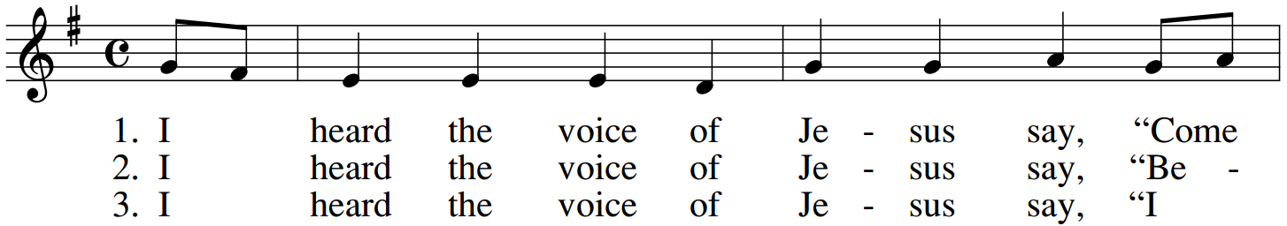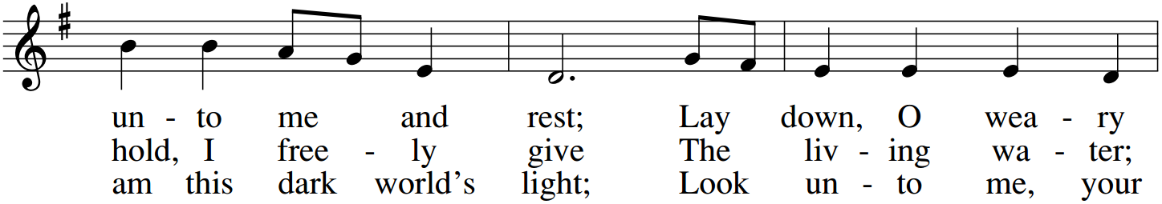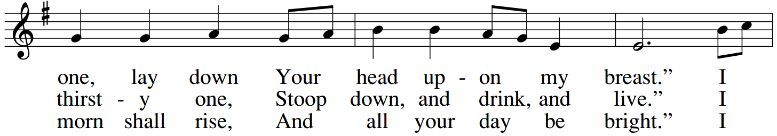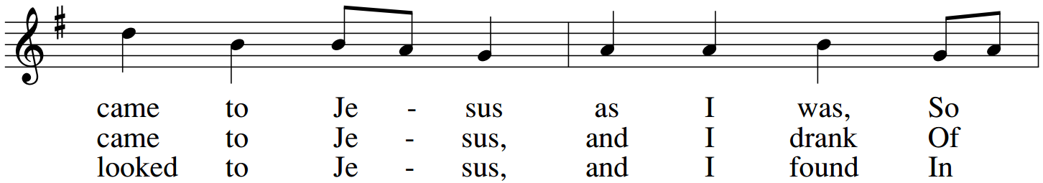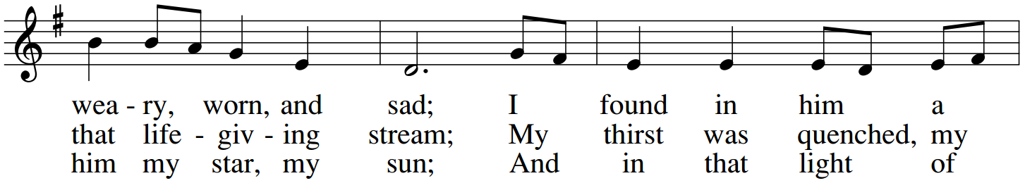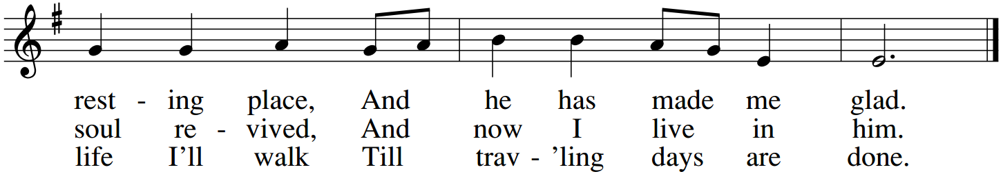
*If you are a guest with us today, please do not feel obligated to give an offering. Instead we invite you to fill out the colored guest card which may be found inserted in your bulletin.

The Presentation of the Gifts
The people stand, if able, and sing
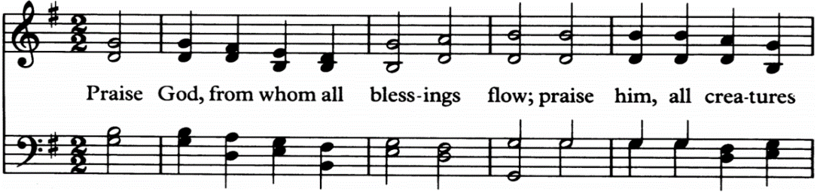
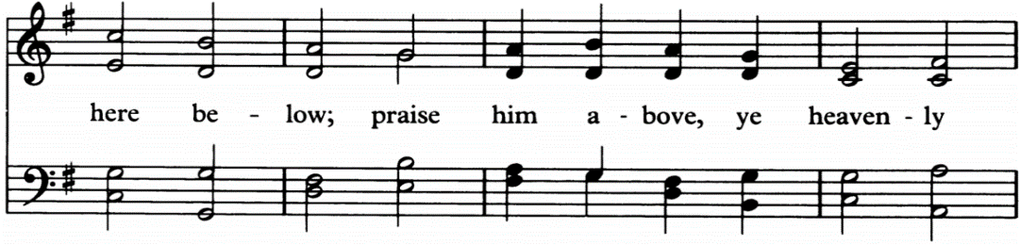
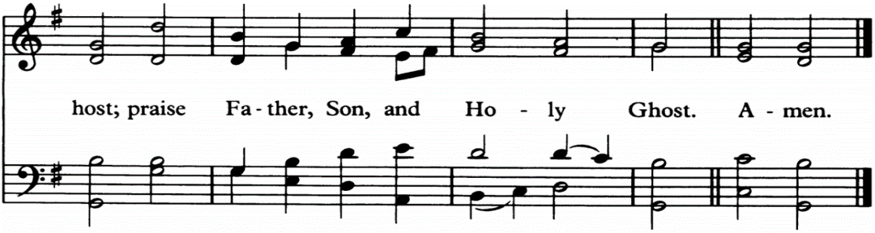

Closing Hymn The Solid Rock Mote|Bradbury
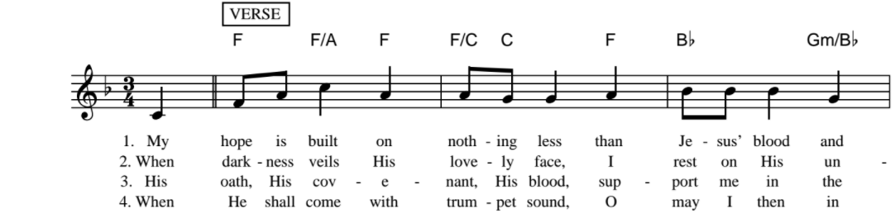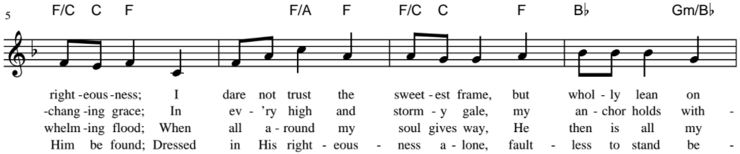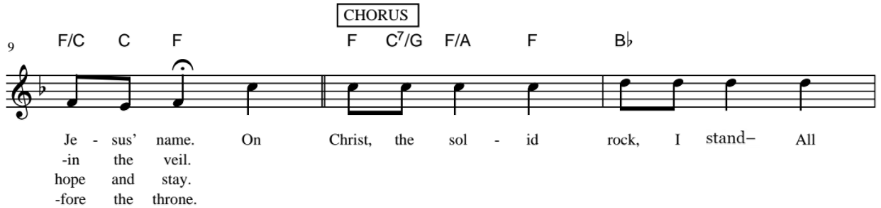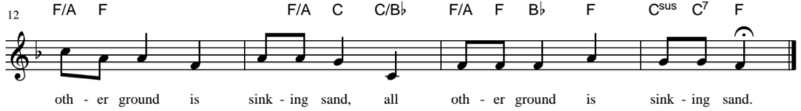

The General Thanksgiving
Officiant and People
Almighty God, Father of all mercies, we your unworthy servants give you humble thanks for all your goodness and loving-kindness to us and to all whom you have made. We bless you for our creation, preservation, and all the blessings of this life; but above all for your immeasurable love
in the redemption of the world by our Lord Jesus Christ; for the means of grace, and for the hope of glory. And, we pray, give us such an awareness of your mercies, that with truly thankful hearts we may show forth your praise, not only with our lips, but in our lives, by giving up our selves to your service, and by walking before you in holiness and righteousness all our days;
through Jesus Christ our Lord, to whom, with you and the Holy Spirit, be honor and glory throughout all ages. Amen.

A Prayer of St. John Chrysostom
Officiant and People
Almighty God, you have given us grace at this time with one accord to make our common supplications to you; and you have promised through your well beloved Son that when two or three are gathered together in his name you will be in the midst of them: Fulfill now, O Lord, our desires and petitions as may be best for us; granting us in this world knowledge of your truth, and in the age to come life everlasting. Amen.
Officiant Let us bless the Lord.
People Thanks be to God.

The Grace
Officiant and people say together
Glory to God whose power, working in us, can do infinitely more than we can ask or imagine: Glory to him from generation to generation in the Church, and in Christ Jesus forever and ever. Amen.
Ephesians 3:20­21

Thank you for worshipping at Anglican Church of The Good Shepherd this morning!

Please join us for coffee and a light snack in the fellowship hall downstairs immediately following the service.

We would be so grateful if you would deposit your used bulletins in one of the recycling bins located near the exits of the sanctuary as you pass by.

Acknowledgments
Music
Hymns: All hymns below are reprinted from The Hymnal, 1982 and The Hymnal 1982, Service Music, © 1985 by The Church Pension Fund. Used by permission. All rights reserved.

“Come People of the Risen King" CCLI Song # 5232617 Keith Getty | Kristyn Getty | Stuart Townend © 2007 Thankyou Music (Admin. by Capitol CMG Publishing) For use solely with the SongSelect Terms of Use. All rights reserved. www.ccli.com CCLI License # 3237915
“Glory be to God” CCLI Song # 5120509 Kelly Minter | Matt Maher | Stuart Townend © 2007
spiritandsong.com (Admin. by Capitol CMG Publishing) Thankyou Music (Admin. by Capitol CMG Publishing) For use solely with the SongSelect Terms of Use. All rights reserved. www.ccli.com CCLI License # 3237915
“I Heard the Voice of Jesus Say” Type: Words and Music Contributors: Public Domain Tune: Harm. by Ralph Vaughan Williams; © Oxford University Press Text: Horatius BonarPress
“The Solid Rock” CCLI Song # 25417 Edward Mote | William Batchelder Bradbury © Words: Public Domain
Music: Public Domain For use solely with the SongSelect® Terms of Use. All rights reserved. www.ccli.com CCLI License # 3237915

Cover Image
“The Leaven” by An etching by Jan Luyken illustrating Matthew 13:30-34 in the Bowyer Bible, Bolton, England.
Photo by Photo by Harry Kossuth
This is a faithful photographic reproduction of a two-dimensional, public domain work of art. The work of art itself is in the public domain and can be viewed at:
<https://commons.wikimedia.org/wiki/File:Teachings_of_Jesus_6_of_40._parable_of_the_leaven._Jan_Luyken_etching._Bowyer_Bible.gif>

Scripture
Old Testament, epistle, and Gospel readings for this service are taken from the Holy Bible, English Standard Version. Any psalms are from the Book of Common Prayer, All liturgy is taken from The Order for the Administration of The Lord’s Supper or Holy Communion, commonly called The Holy Eucharist Standard/Common Text Approved for Provincial Use, The Anglican Church in North America Petertide, A.D. 2013

Flowers
The altar flowers this morning are provided by the generous donations of the congregation of Good Shepherd.

